VISOKA ŠKOLA STRUKOVNIH STUDIJA ZA INFORMACIONE I KOMUNIKACIONE

TEHNOLOGIJE

DOKUMENTACIJA

<https://zaposlise.000webhostapp.com>

Web programiranje PHP1

Đorđe Minić 135/19 Smer: Internet tehnologije Modul: Web programiranje

Predmet: Web programiranje PHP1

Sadržaj

Contents

1. Uvod 3

1.1 Korišćeni tehnologije 3

• HTML 3

• CSS 3

• Javascript 3

• jQuery 3

• Adobe illustrator 3

1.2 Opis funkcionalnosti 3

• Dinamičko ispisivanje navigacionog menija iz baze 3

• Otvaranje eskpandirajućeg menija na manjim rezolucijama klikom na 3

• Sajt predstavlja web aplikacij za informisanje u vezi poslova na IT tržištu kao i pregled kompanije i njihovog poslovanja 3

• Upotreba AJAX-a za čitanje I dohvatanje fajlova koje se realizuje funkcijama. U slučaju dolaska do greške, iste se obradjuju. Filtriranje sortiranje, pretraga po nazivu I paginacija obradjene su na serverskoj strani 3

popunjena, prikazuje se obavestenje u vidu poruke za korisnika 4

prikazuje informacija o istom 4

• Potvrdom slanja podataka I teksta poruke na kontakt strani podaci prolaze validaciju na klijentskoj I serverskoj strani. Ako je sve pravilno uneto poruke se cuvaju u bazi I prikazuju na admin panelu. 4

• Admin panel sa statistickim podacima o izvršenom anketiranju. Admin sajta ima izmenjen sadrzaj za pristup I omogucene alatke za kontrolisanje sadrzaja sajta. Moguca je promena celokupnog izgleda proizvoda kao I deaktivacija I aktivacija naloga. Moguće je obrisati i upravljati porukama pristiglim od strane korisnika 4

• Anketa kojom se beleže odgovori svih korisnika sajta i ispis u admin panelu 4

• Blokiranje korisnika na admin panelu i odgovarajuće poruke tom korisniku kada pokuša da se loguje sledeći put 4

1.3 Template 5

Za izradu nije korišćen gotov template, sajt je ručno pisan uz pomoć Bootstrap framework-a. Kod koji realizuje sajt je priložen u nastavku dokumenta. 5

2. Organizacija 5

2.1. Dizajn baze podataka 5

2.3 Opis funkcionalnosti na stranici 6

2.3.1 views/page/home.php 6

Odmah ispod navigacije vidimo sekciju za logovanje ili registraciju novih korisnika, pri svakom logovanju prikaz se menja i ispisuje ime korisnika koji je trenutno ulogovan. Ako je u pitanju admin pisace Admin Panel. 6

U narednoj sekciji mozemo videti kompanije koji imaju specificnu osobinu “Premium” na osnovu koje se iz baze filtriraju I kao takvi prikazuju. Svaki od njih ima link koji vodi ka detaljima izabrane kompanije. 7

2.3.2 views/pages/jobs.php 8

Ispisivanje oglasa je dinamicki kao I ispisivanje kategorija po kojima se može sortirati I filtrirati sveukupna ponuda. Pri kliku na dugme “Apliciraj” korisnik se redirektuje na stranicu za pounjavanje forme. 8

Moguća je pretraga oglasa po nazivu i po tehnologiji koja se se traži za isti. Moguće je sortiranje po tome da li se radi od kuće ili ne kao i odabir senioriteta. Tu si u checkbox-ovi za dodatno filtriranje po prikazu plate premium oglasa ili prakse 8

Ako prilikom odabira filtera nije moguće naći željeni oglas , prikazuje 8

2.3.3 views/pages/contact.php 9

Prilikom popunjavanja podataka u sekciji slanja poruke, podaci se prilikom klika na dugme proveravaju regularnim izrazima na obe strane kao I broj unetih karaktera sa input Tekstualne poruke. Prilikom greske u pisanju datih podataka ili ostavljanja forme prazne, ispisuju se obavestenja ukazivanja na problem. 9

Kada su podaci pravilno uneti forma se čisti I prikazuje uspesnost slanja. 10

11

2.3.4 views/pages/autor.php 11

Ispisuju se podaci o autoru, njegova slika kao I linkovi ka njegovom LinkedIn profilu, GitHub profilu I portfolio stranici 11

2.3.5 views/pages/register.php 12

2.3.6 views/pages/login.php 13

2.3.7 views/pages/companies.php 14

2.3.8 views/pages/admin.php 18

2.3.9 views/pages/job_application.php 19

2.3.10 views/pages/job_application.php 20

3. Kodovi stranica 22

3.1 index.php 22

3.2 admin.php 23

4.1 autor.php 27

5.1 contact.php 29

6.1 poll.php 31

6.2 pocetna.php 33

8.1 proizvod.php 34

9.1 proizvodi.php 42

9.2 register.php 44

9.3 head.php 45

10.1 footer.php 45

10.2 nav.php 46

11.1 models/functions.php 47

11.2 models/admin 51

11.2.1 changeAbotCompanySection.php 51

11.2.2 changeCompanyContactSection.php 52

11.2.3 changeEmployeeStatus.php 53

11.2.3 changeMessageStatus.php 54

12.2.3 changeJobStatus.php 54

11.2.4 changeMessageStatus.php 55

11.2.5 changeUserStatus.php 55

11.2.6 deleteMessage.php 55

12.2. models/companies 57

12.2.4 get_premium_companies.php 57

12.2.5 get_companies.php 57

13.2 models/user 59

13.2.3 addToFavouriteJob.php 59

13.2.5 doLogin.php 62

13.2.7 doRegister.php 64

13.4.5 get_user.php 65

13.3 views/fixed/footer.php 67

13.4 views/fixed/head.php 67

13.5 views/fixed/nav.php 68

13.6 views/pages 68

13.6.3 admin.php 69

13.6.5 companies.php 74

13.6.7 contact.php 83

13.7 config/ 97

13.7.3 connection.php 97

13.8 assets/js/main.js 98

13.9 assets/css/style.sass 109

# Uvod

## Korišćeni tehnologije

# HTML

* PHP

# CSS

# Javascript

* JSON

# jQuery

* Bootstrap

# Adobe illustrator

Rađeno u PHPStorm. Sajt hostovan na 000Web.

## Opis funkcionalnosti

# Dinamičko ispisivanje navigacionog menija iz baze

# Otvaranje eskpandirajućeg menija na manjim rezolucijama klikom na

‘hamburger’ ikonicu

# Sajt predstavlja web aplikacij za informisanje u vezi poslova na IT tržištu kao i pregled kompanije i njihovog poslovanja

# Upotreba AJAX-a za čitanje I dohvatanje fajlova koje se realizuje funkcijama. U slučaju dolaska do greške, iste se obradjuju. Filtriranje sortiranje, pretraga po nazivu I paginacija obradjene su na serverskoj strani

* Dinamičko ispisivanje proizvoda sa specifičnom kategorijom ‘Premium’ na pocetnoj strani
* Provera unetih podataka u formu nakon submitovanja iste. Validacija se vrši na kljijentskoj i server strani.
* Pritiskom na dugme submit, u slučaju da su sva polja ispravno

# popunjena, prikazuje se obavestenje u vidu poruke za korisnika

* Nakon uspešnog apliciranja za izabrani oglas, korisniku se

# prikazuje informacija o istom

* Responsive sajt uz pomoć media query-ja I bootstrapa

# Potvrdom slanja podataka I teksta poruke na kontakt strani podaci prolaze validaciju na klijentskoj I serverskoj strani. Ako je sve pravilno uneto poruke se cuvaju u bazi I prikazuju na admin panelu.

* Logovanje I registracija se obavljaju sa proverom na front I back strani. Ukoliko je korisnik admin sajta ima izmenjen sadrzaj za pristup I omogucene alatke za kontrolisanje sadrzaja sajta. Moguca je promena podataka za odabrane kompanije kao i aktivacija određenih sekcija.

# Admin panel sa statistickim podacima o izvršenom anketiranju. Admin sajta ima izmenjen sadrzaj za pristup I omogucene alatke za kontrolisanje sadrzaja sajta. Moguca je promena celokupnog izgleda proizvoda kao I deaktivacija I aktivacija naloga. Moguće je obrisati i upravljati porukama pristiglim od strane korisnika

# Anketa kojom se beleže odgovori svih korisnika sajta i ispis u admin panelu

# Blokiranje korisnika na admin panelu i odgovarajuće poruke tom korisniku kada pokuša da se loguje sledeći put

## Template

# Za izradu nije korišćen gotov template, sajt je ručno pisan uz pomoć Bootstrap framework-a. Kod koji realizuje sajt je priložen u nastavku dokumenta.

# Organizacija

## 2.1. Dizajn baze podataka

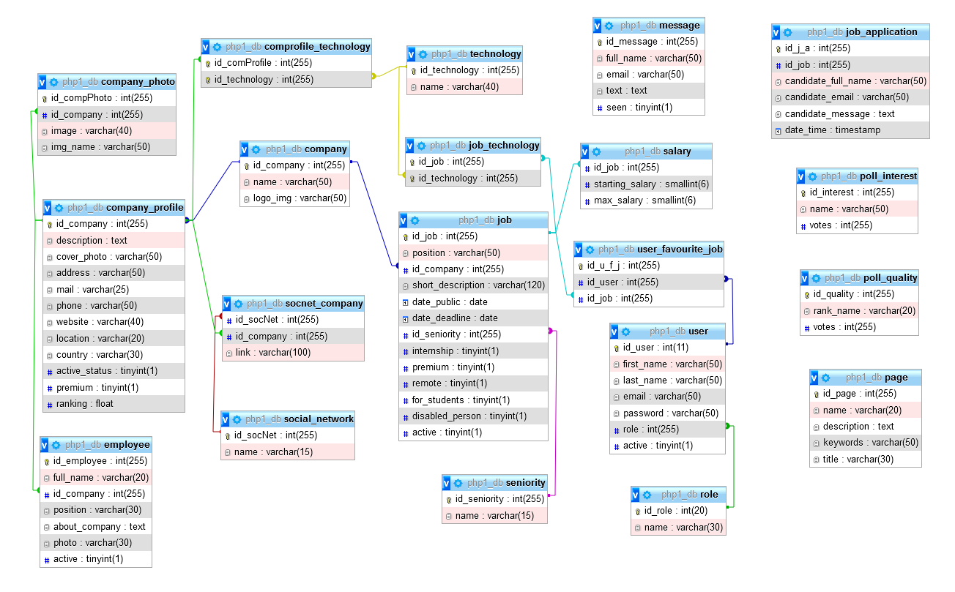

* 1. Mapa sajta

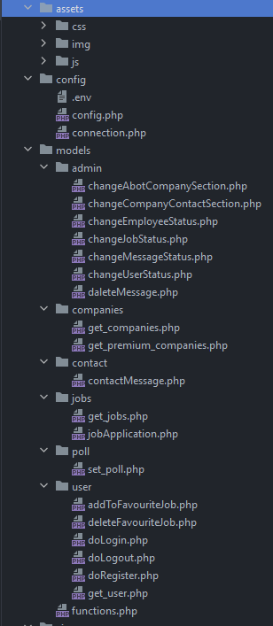 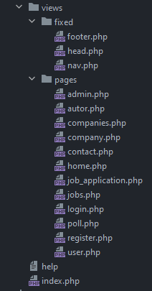

## Opis funkcionalnosti na stranici

### views/page/home.php

# Odmah ispod navigacije vidimo sekciju za logovanje ili registraciju novih korisnika, pri svakom logovanju prikaz se menja i ispisuje ime korisnika koji je trenutno ulogovan. Ako je u pitanju admin pisace Admin Panel.







# U narednoj sekciji mozemo videti kompanije koji imaju specificnu osobinu “Premium” na osnovu koje se iz baze filtriraju I kao takvi prikazuju. Svaki od njih ima link koji vodi ka detaljima izabrane kompanije.

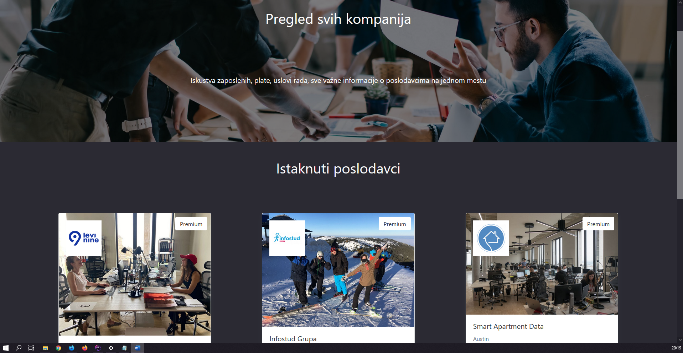

### views/pages/jobs.php

# Ispisivanje oglasa je dinamicki kao I ispisivanje kategorija po kojima se može sortirati I filtrirati sveukupna ponuda. Pri kliku na dugme “Apliciraj” korisnik se redirektuje na stranicu za pounjavanje forme.

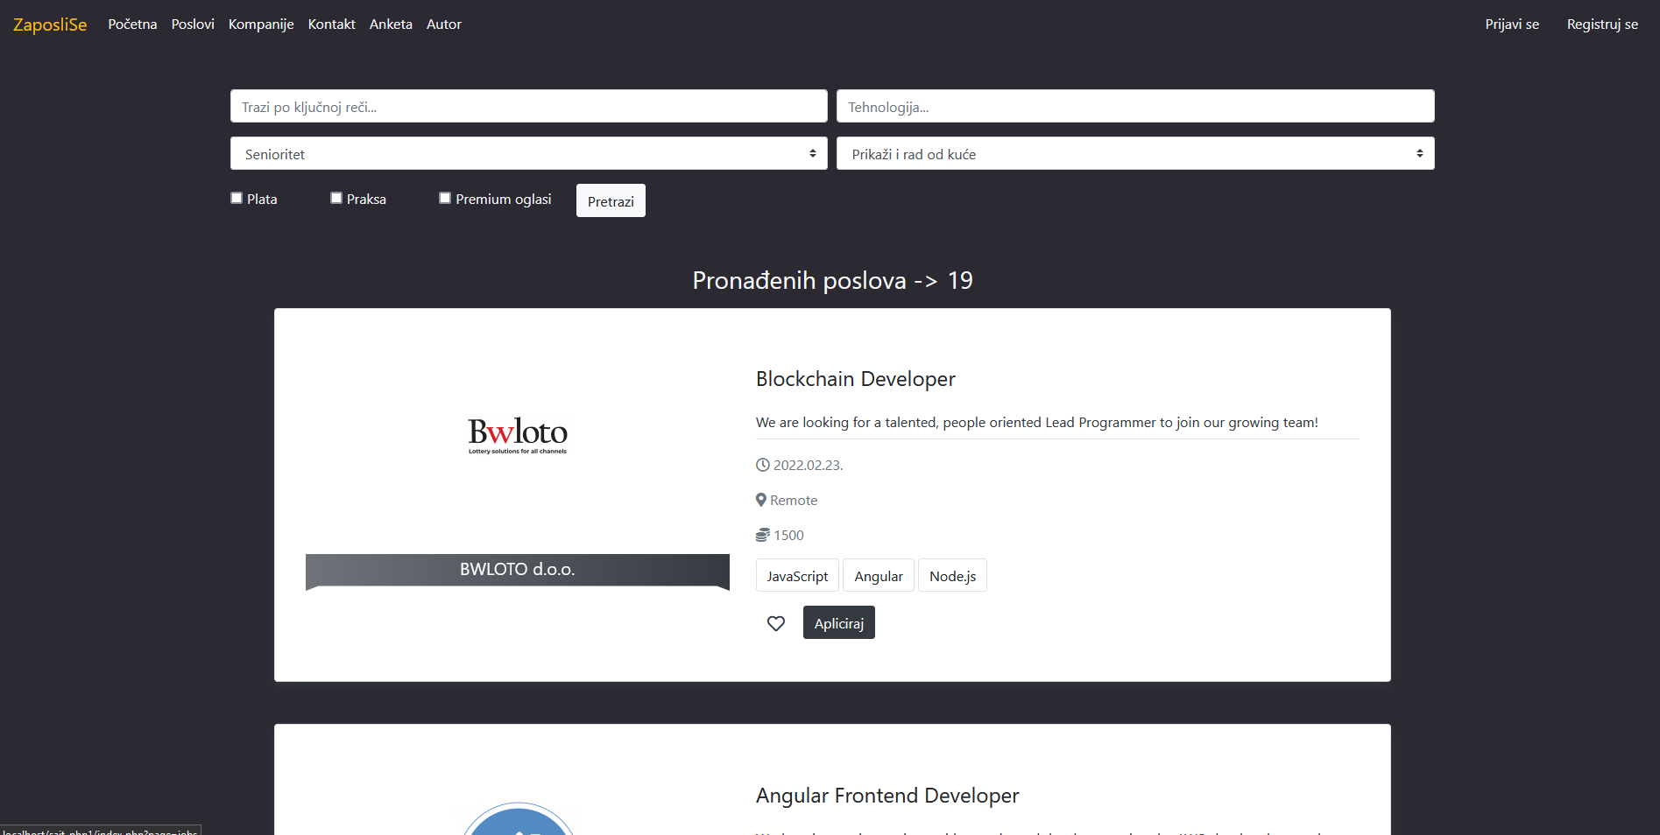

# Moguća je pretraga oglasa po nazivu i po tehnologiji koja se se traži za isti. Moguće je sortiranje po tome da li se radi od kuće ili ne kao i odabir senioriteta. Tu si u checkbox-ovi za dodatno filtriranje po prikazu plate premium oglasa ili prakse

# Ako prilikom odabira filtera nije moguće naći željeni oglas , prikazuje

se informacija o tome.

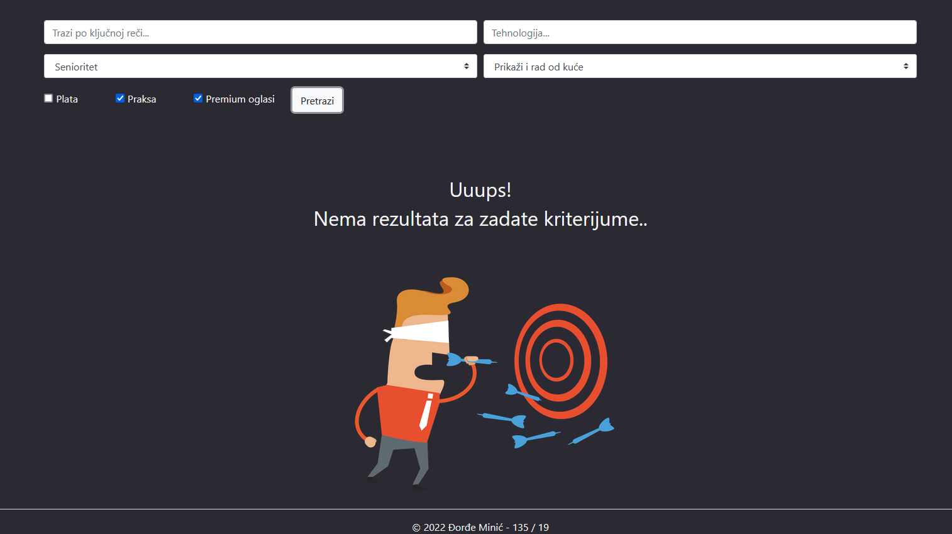

### views/pages/contact.php

# Prilikom popunjavanja podataka u sekciji slanja poruke, podaci se prilikom klika na dugme proveravaju regularnim izrazima na obe strane kao I broj unetih karaktera sa input Tekstualne poruke. Prilikom greske u pisanju datih podataka ili ostavljanja forme prazne, ispisuju se obavestenja ukazivanja na problem.

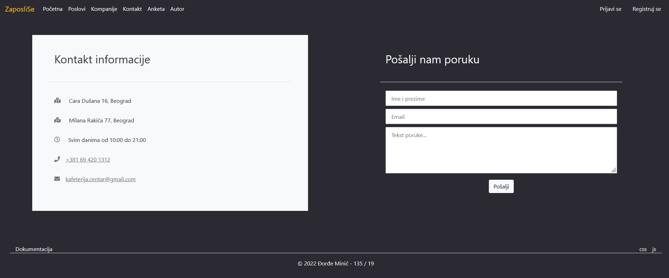

Kada je forma prazna:

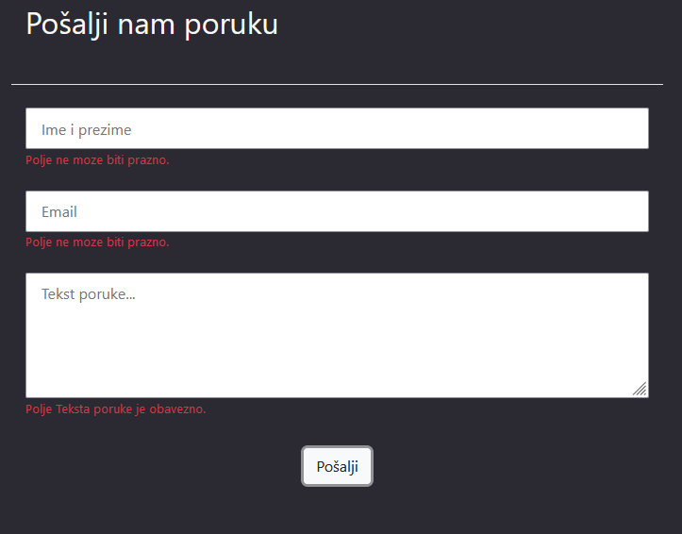

# Kada su podaci pravilno uneti forma se čisti I prikazuje uspesnost slanja.

# 

### views/pages/autor.php

# Ispisuju se podaci o autoru, njegova slika kao I linkovi ka njegovom LinkedIn profilu, GitHub profilu I portfolio stranici

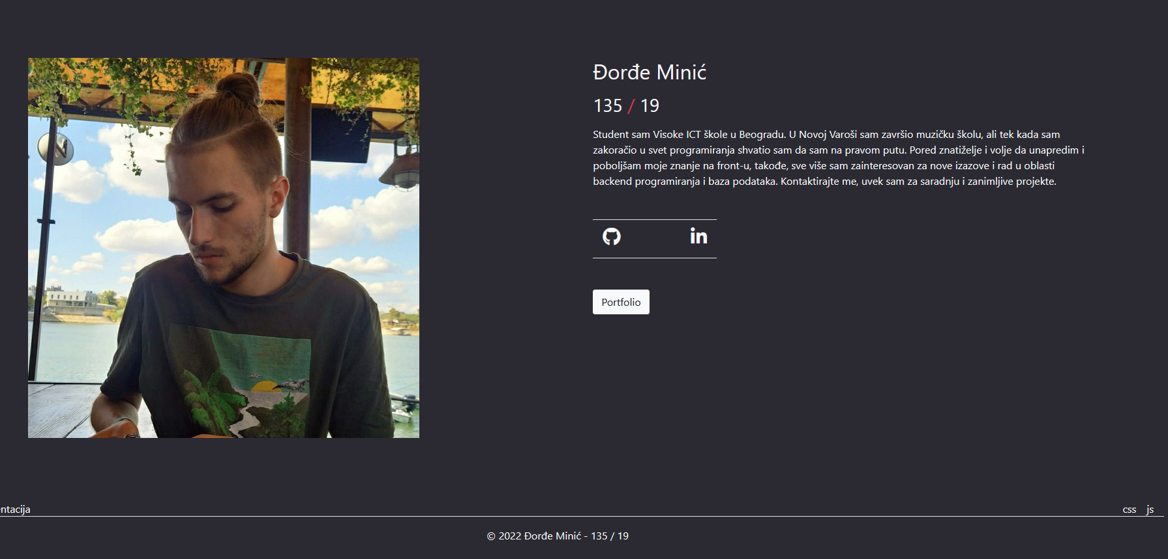

### views/pages/register.php

Za uspesnu registraciju potrebna je potvrda lozinke I pravilno uneti svi ostali prametri.

Ispod forme postoji link kao I kod stranice prijava.php kojim se moze setati izmedju ove dve stranice.

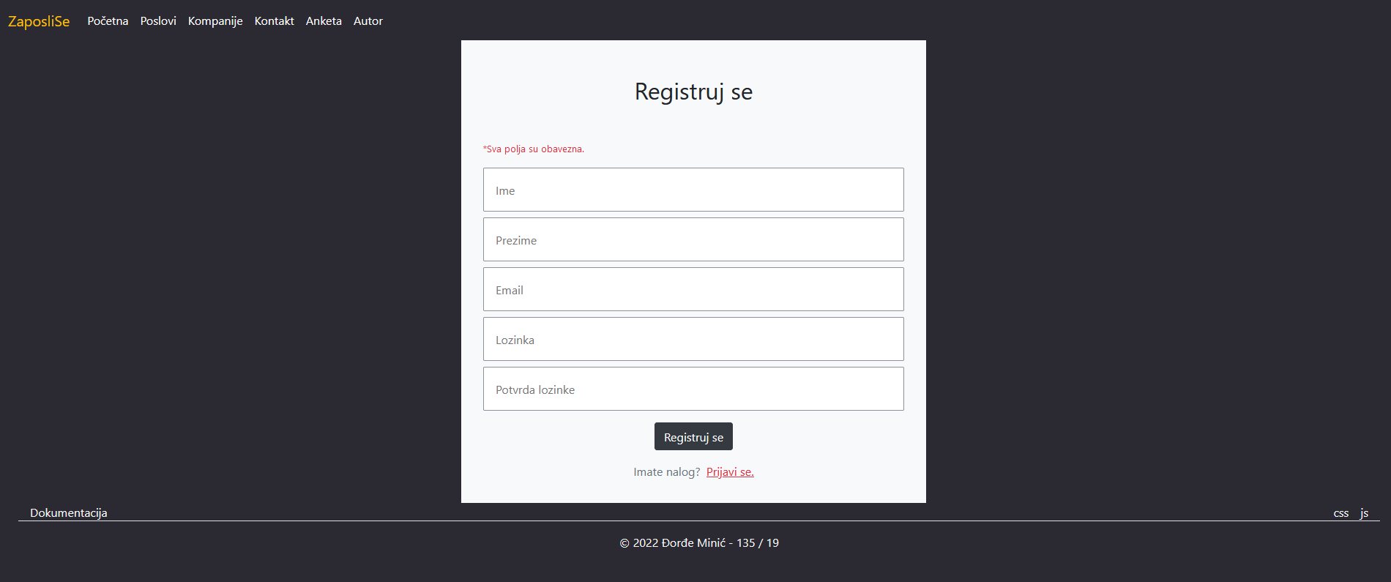

### views/pages/login.php

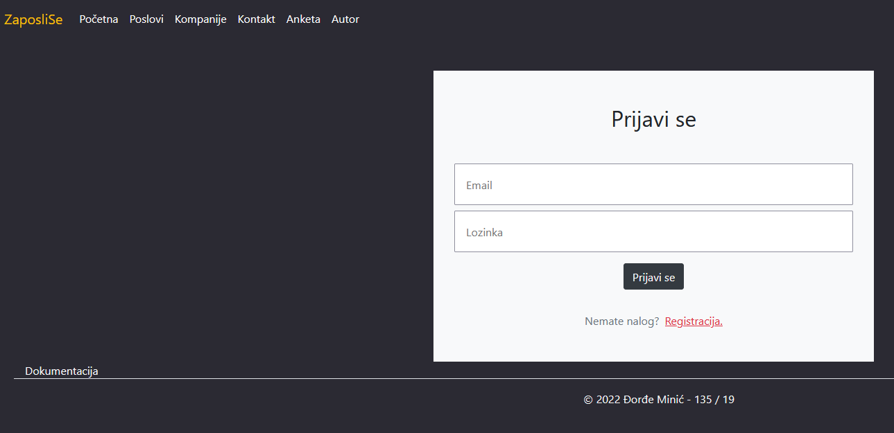

Prilikom prijave proverava se da li uneti email u kombinaciji sa lozinkom postoje u bazi I ako je to slucaj korisnik se redirektuje na pocetnu stranicu.

### views/pages/companies.php

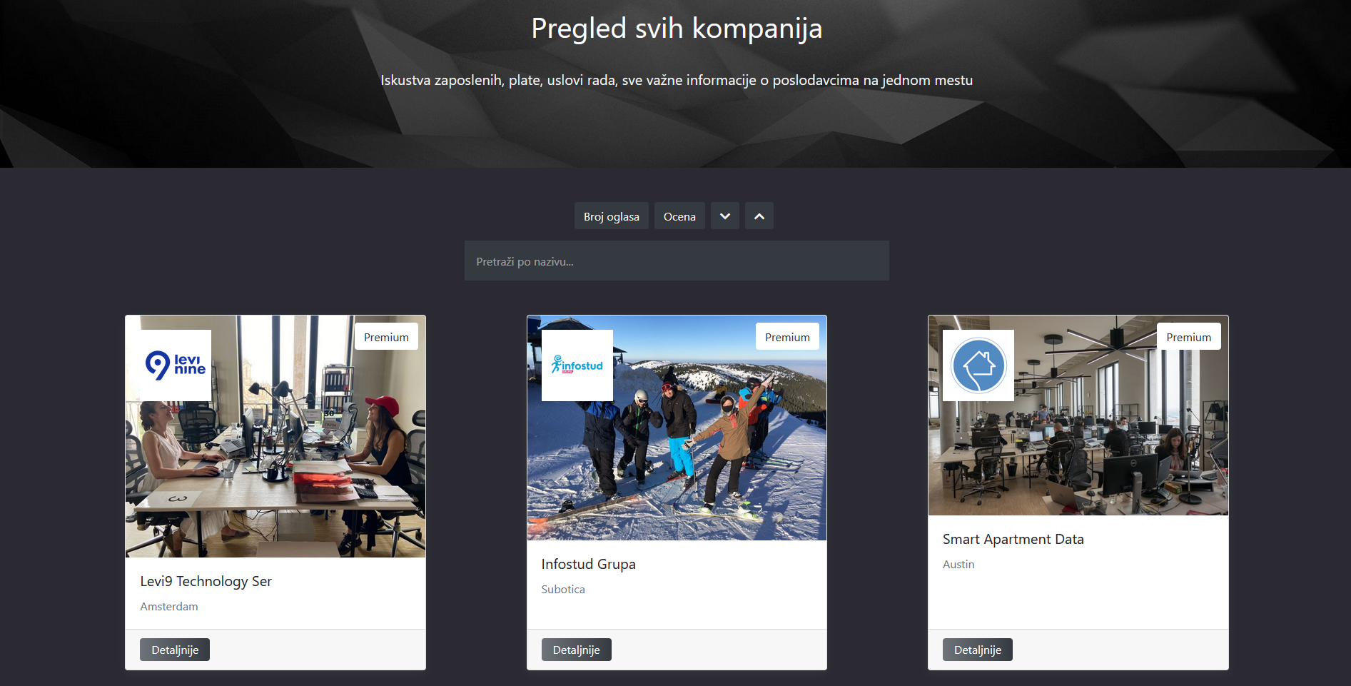

Na stranici companies se prikazuju sve kompanije i sortiranje po proju oglasa kao i po oceni kompanije. Klikom na dugme 'Detaljnije' korisnik se salje na stranicu kompanije na kojoj se nalaze detaljniji opisi rada te kompanije.

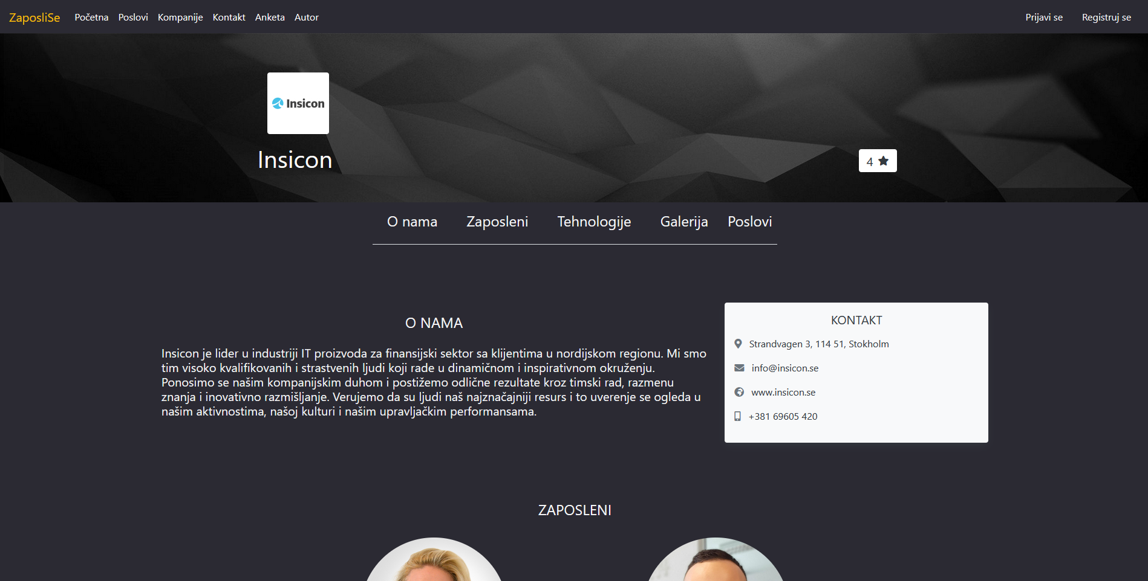

Na stranici company imamo dinamičku navigaciju sekcija te kompanije(neke kompanije mogu imati neke sekcije a druge ne), zajednička im je početna sekcija 'o nama' kao i kontakt sekcija.

Prikaz ostalih sekcija..

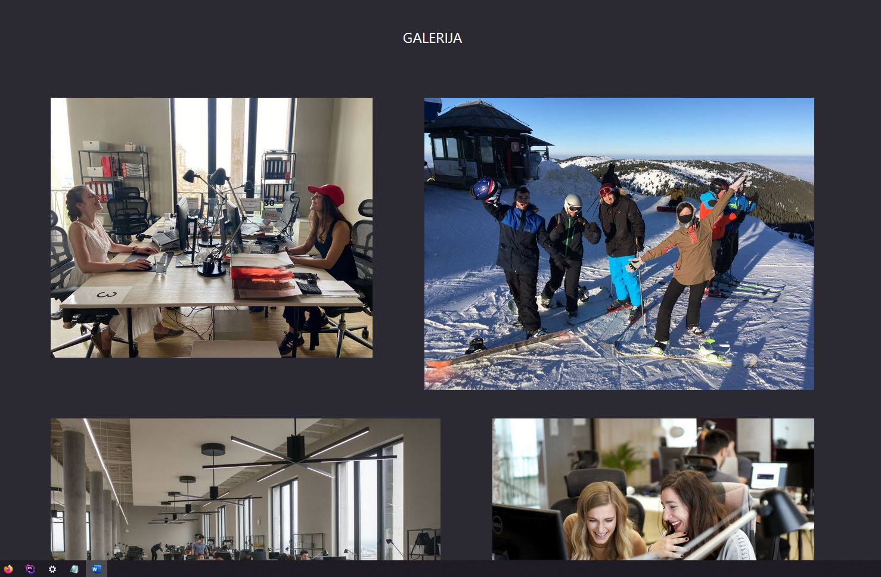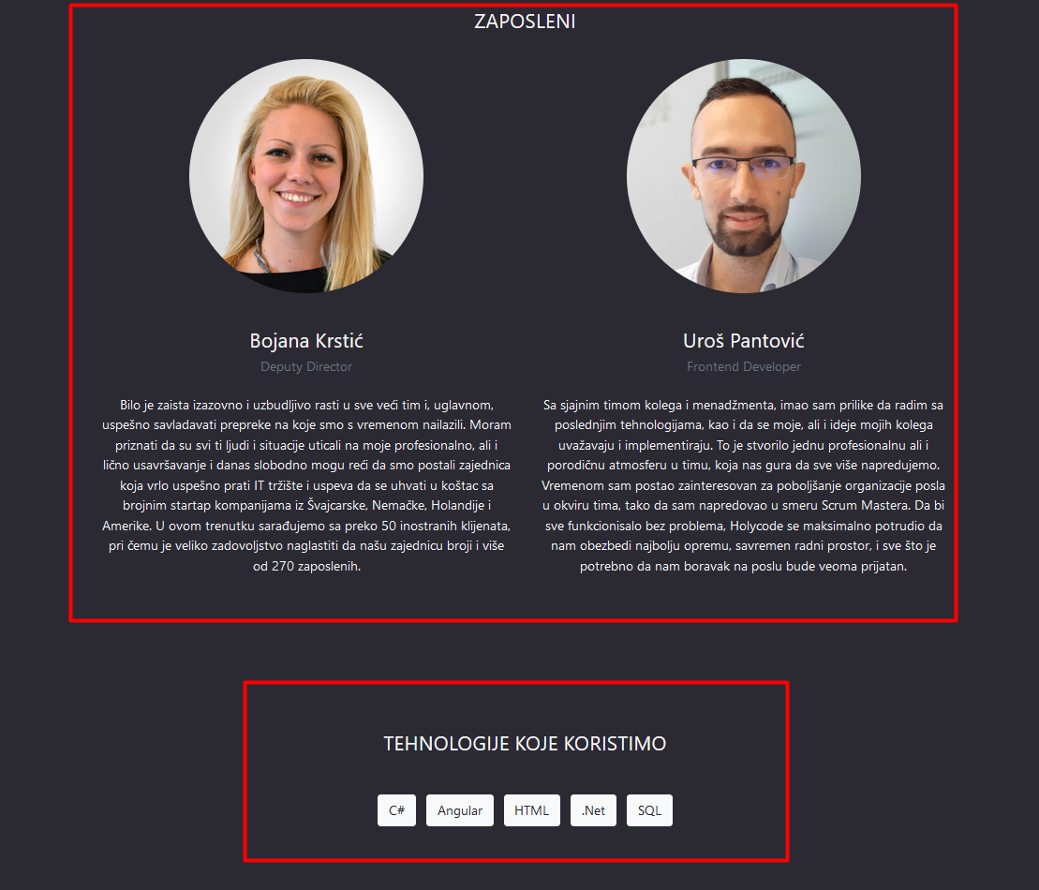

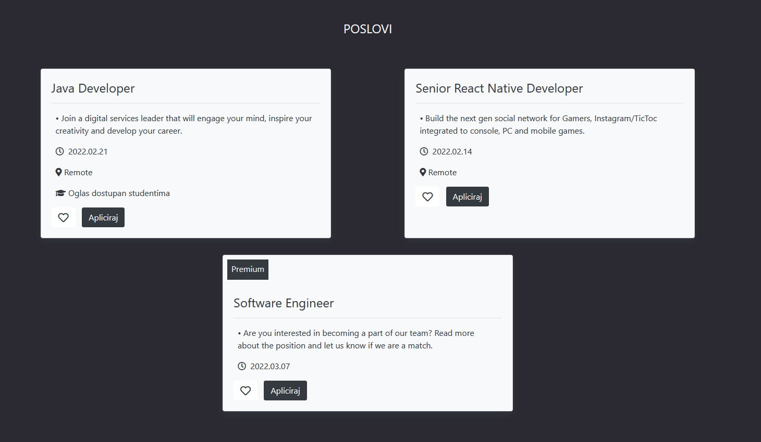

Prikaz za administratora:

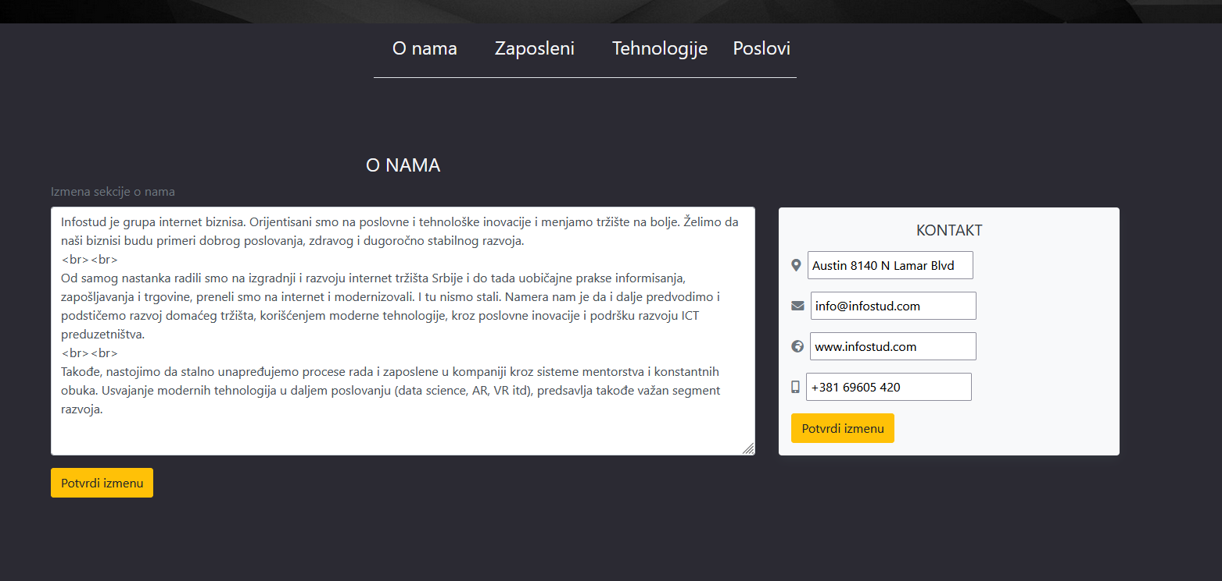

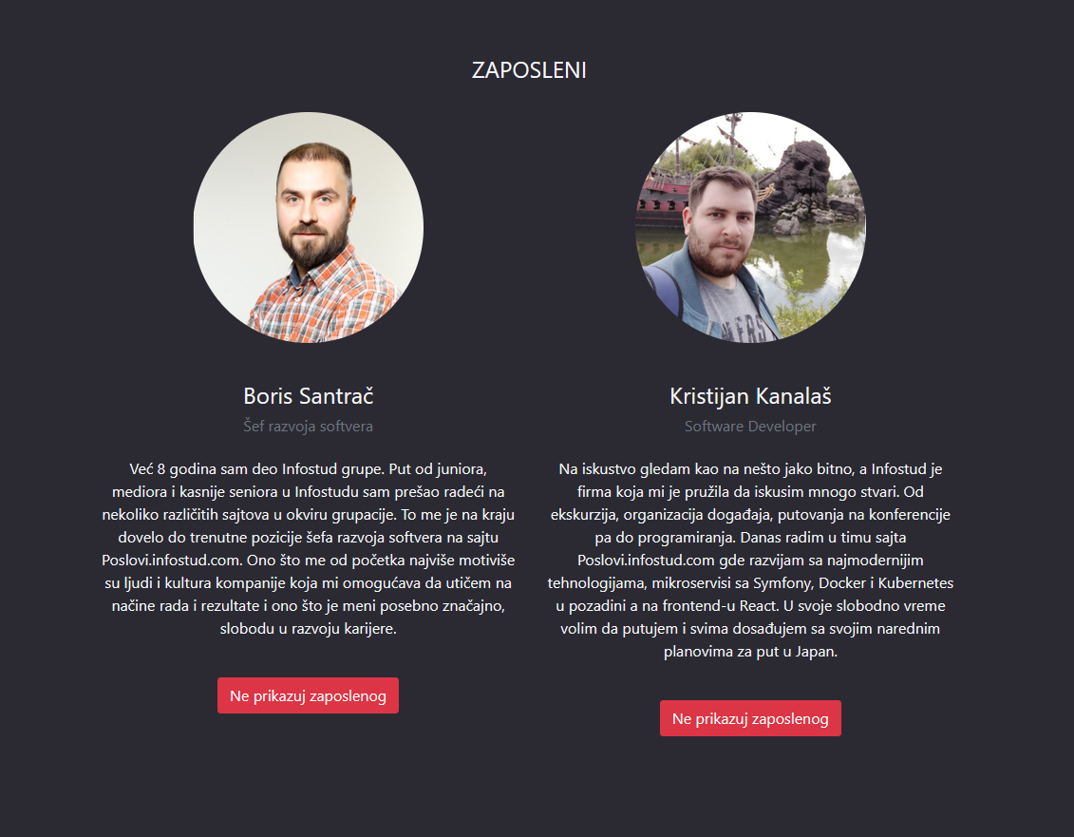

### views/pages/admin.php

Na admin stranici se nalaze podaci za admina sajta. Podmenijima je moguć pristup sekcijama koje Admin panel sadrži.

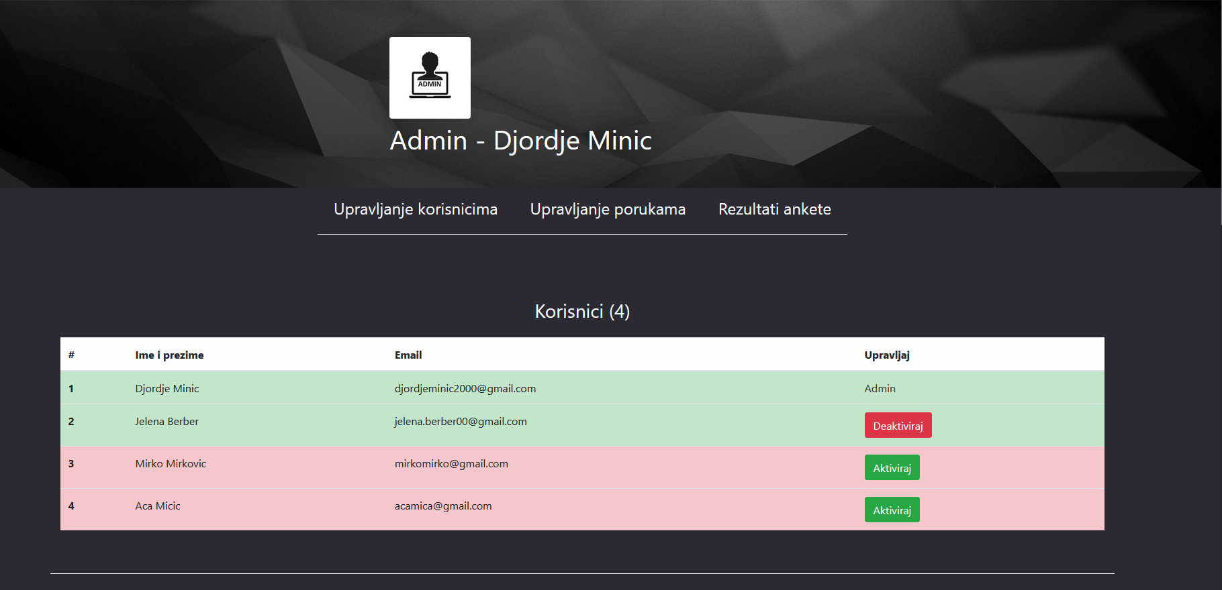

Korisnicima I njihovim podacima kao I mogucnost menjanja aktivnosti naloga odnosno banovanja.

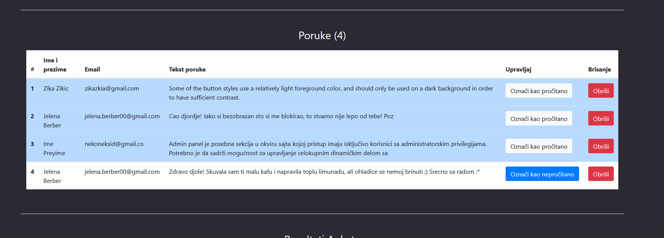 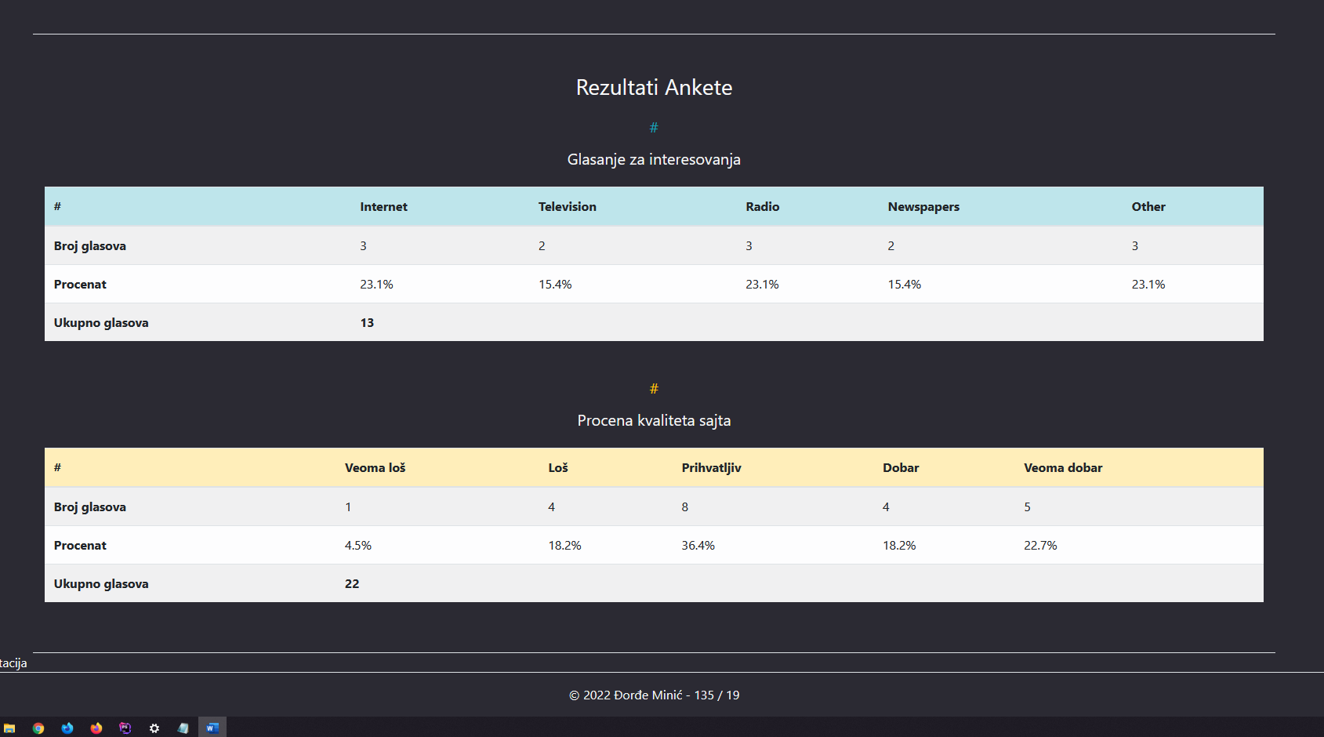

### views/pages/job_application.php

Prikaz strane za apliciranje na određeni posao. Forma prolzi validaciju i ispisuju se greške. Ako je korisnik ulogovan automatski se popunjavaju prva polja.

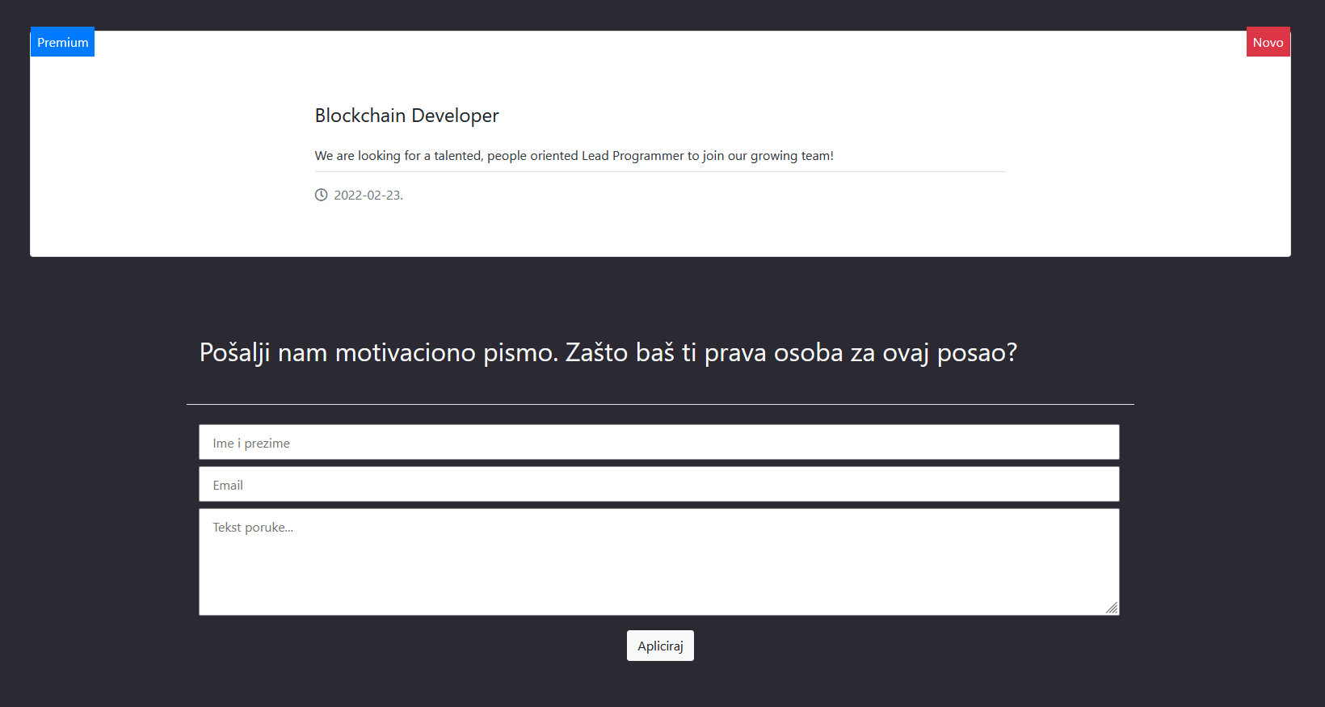

### views/pages/job_application.php

Anketiranje je dostupno svim korisnicima i rezultati se beleže u tabele.

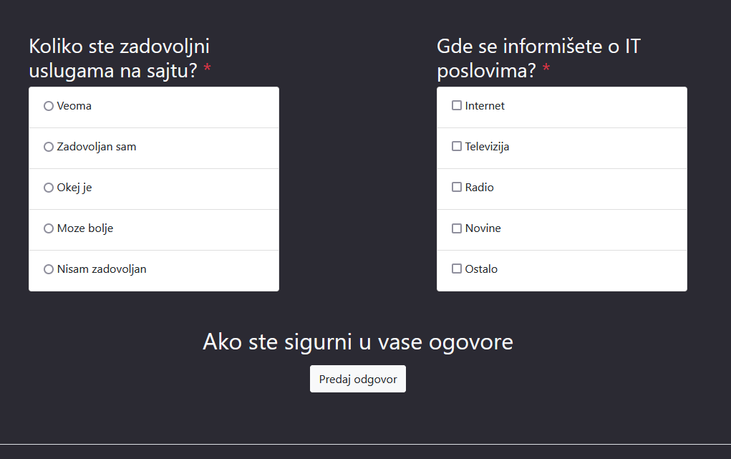

Poruka se ispisuje u slučaju pogrešnog kao i dobrog popunjavanja

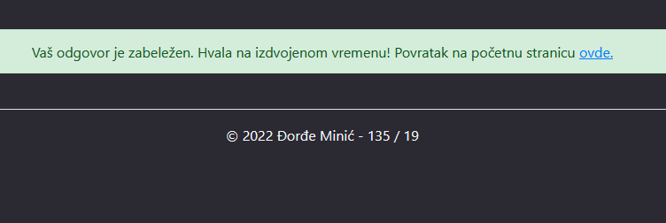

# Kodovi stranica

## index.php

<?php

require_once "config/connection.php"; require_once "models/functions.php";

$page = 'pocetna'; if(isset($_GET['page'])){

$page = $_GET['page'];

}

if(!file_exists("views/pages/$page.php")){ header("Location: index.php?page=pocetna");

}

//ispis stranice

require_once "views/fixed/head.php"; require_once "views/fixed/nav.php";

$infoPage = getPageInfo($page);

if($infoPage):

?>

<div class="naslovna bg-<?=$page?> bg d-flex flex-wrap justiffy-content- center col-12">

<div class="container col-12 col-sm-10 d-flex flex-wrap justify-content- center">

<div class="container-fuid float-center text-light col-10 bg-gray">

<h1 class="col-12 text-center py-5 text-muted"><?=$infoPage[0]-

>naslov?></h1>

</div>

</div>

</div>

<?php

if ($page == 'proizvod') {

echo '<a href="index.php?page=proizvodi" class="text-center text- secondary">

<h4 class="my-5">

<i class="fas fa-long-arrow-alt-left mr-2"></i> Svi proizvodi

</h4>

</a>';

}

<?php  
require_once "config/connection.php";  
require_once "models/functions.php";  
  
  
  
$page = 'home';  
if(isset($_GET['page'])){  
 $page = $_GET['page'];  
}  
if(!file_exists("views/pages/$page.php")){  
 header("Location: index.php?page=home");  
}  
$pageDetails = getPageDetails($page);  
  
require_once "views/fixed/head.php";  
require_once "views/fixed/nav.php";  
  
  
//content  
  
  
require_once "views/pages/$page.php";  
require_once "views/fixed/footer.php";  
?>

## admin.php

1. <?php  
     
   if(!isset($_SESSION['user'])){  
    header("Location: index.php?page=home");  
    die();  
   }  
   else{  
    $user = $_SESSION['user'];  
    if($_SESSION['user']->role != 2){  
    header("Location: index.php?page=home");  
    die();  
    }  
   }  
   require_once "models/functions.php";  
   ?>  
   <!--HEADER-->  
   <div class="col-12 d-flex justify-content-center p-0">  
    <div id="companies-header" class="background-page-header bg-dark-gradient bg-companies d-flex flex-wrap justify-content-center col-12">  
    <div class="col-6 col-sm-4 d-flex flex-wrap align-items-end">  
    <div class="d-flex justify-content-center col-3">  
    <img src="assets/img/admin.jpg" class="responsive-img bg-white rounded p-2 col-12" alt="user">  
    </div>  
    <div class="col-12 d-flex">  
    <h1 class="mb-0">Admin - <?=$user->first_name?> <?=$user->last_name?></h1>  
    </div>  
    </div>  
     
    </div>  
   </div>  
   <!--NAVIGATION-->  
   <div id="admin-n av" class="col-12 d-flex justify-content-center pb-5">  
    <div class="d-flex justify-content-center border-bottom">  
     
    <a href="#admin-user" class="text-light transpBgHover my-3 mx-4">  
    <h4>Upravljanje korisnicima</h4>  
    </a>  
     
    <a href="#admin-message" class="text-light transpBgHover my-3 mx-4">  
    <h4>Upravljanje porukama</h4>  
    </a>  
     
    <a href="#admin-poll" class="text-light transpBgHover my-3 mx-4">  
    <h4>Rezultati ankete</h4>  
    </a>  
    </div>  
   </div>  
     
     
   <!-- USERS -->  
   <div class="col-12 col-md-10 mx-auto py-5 border-bottom" id="admin-user">  
    <?php  
    $users = queryFunction("SELECT * FROM user", true);  
    ?>  
    <h3 class="text-light text-center mb-4">Korisnici (<?=count($users)?>)</h3>  
    <?php  
    if (isset($_GET["userError"])){  
    echo '<p class="alert alert-danger col-12 col-md-6">'.$_GET["userError"].'</p>';  
    }  
    if (isset($_GET["userMessage"])){  
    echo '<p class="alert alert-success col-12 col-md-6">'.$_GET["userMessage"].'</p>';  
    }  
    ?>  
    <table class="table table-striped table-success">  
    <thead>  
    <tr class="table-light">  
    <th scope="col">#</th>  
    <th scope="col">Ime i prezime</th>  
    <th scope="col">Email</th>  
    <th scope="col">Upravljaj</th>  
    </tr>  
    </thead>  
    <tbody>  
    <?php  
    $i = 1;  
    foreach ($users as $u):  
    ?>  
    <tr class="<?=$u->active == 1 ? "table-success" : "table-danger"?>">  
    <th scope="row"><?=$i++?></th>  
    <td><?=$u->first_name?> <?=$u->last_name?></td>  
    <td><?=$u->email?></td>  
    <?php  
    if ($u->role == 2):  
    ?>  
    <td class="text-dark">Admin</td>  
    <?php  
    else:  
    ?>  
    <!-- PROVERA JE LI USER AKTIVAN I U SKLADU SA TIM DEFINISANJE AKCIJE -->  
    <td><a href="models/admin/changeUserStatus.php?id=<?=$u->id_user?>&status=<?=$u->active == 1 ? "1" : "0"?>" class="btn btn-<?=$u->active == 1 ? "danger" : "success"?>"><?=$u->active == 1 ? "Deaktiviraj" : "Aktiviraj"?></a></td>  
    <?php  
    endif;  
    ?>  
    </tr>  
    <?php  
    endforeach;  
    ?>  
    </tbody>  
    </table>  
   </div>  
     
   <!-- MESSAGES -->  
   <div class="col-12 col-md-10 mx-auto py-5 border-bottom" id="admin-message">  
    <?php  
    // prvo se prikazuju poruke koje nisu procitane  
    $messages = queryFunction("SELECT * FROM message ORDER BY seen asc", true);  
    ?>  
    <h3 class="text-light text-center mb-4">Poruke (<?=count($messages)?>)</h3>  
    <?php  
    if (isset($_GET["messageError"])){  
    echo '<p class="alert alert-danger col-12 col-md-6">'.$_GET["messageError"].'</p>';  
    }  
    if (isset($_GET["messageMessage"])){  
    echo '<p class="alert alert-success col-12 col-md-6">'.$_GET["messageMessage"].'</p>';  
    }  
    ?>  
    <table class="table table-striped">  
    <thead>  
    <tr class="table-light">  
    <th scope="col">#</th>  
    <th scope="col">Ime i prezime</th>  
    <th scope="col">Email</th>  
    <th scope="col">Tekst poruke</th>  
    <th scope="col">Upravljaj</th>  
    <th scope="col">Brisanje</th>  
    </tr>  
    </thead>  
    <tbody>  
    <?php  
    $i = 1;  
    foreach ($messages as $m):  
    ?>  
    <tr class="<?=$m->seen == 1 ? "table-light" : "table-primary"?>">  
    <th scope="row"><?=$i++?></th>  
    <td><?=$m->full_name?></td>  
    <td><?=$m->email?></td>  
    <td><?=$m->text?></td>  
    <td><a href="models/admin/changeMessageStatus.php?id=<?=$m->id_message?>&status=<?=$m->seen == 1 ? "1" : "0"?>" class="btn btn-<?=$m->seen == 1 ? "primary" : "light"?>"><?=$m->seen == 1 ? "Označi kao nepročitano" : "Označi kao pročitano"?></a></td>  
    <td><a href="models/admin/daleteMessage.php?id=<?=$m->id_message?>" class="btn btn-danger">Obriši</a></td>  
    </tr>  
    <?php  
    endforeach;  
    ?>  
    </tbody>  
    </table>  
   </div>  
     
     
   <!-- POLL SATISTIC -->  
     
   <div class="col-12 col-md-10 mx-auto py-5 border-bottom" id="admin-poll">  
    <?php  
    $quality = queryFunction("SELECT * FROM poll_quality", true);  
    $interest = queryFunction("SELECT * FROM poll_interest", true);  
    ?>  
    <h3 class="text-light text-center mb-4">Rezultati Ankete</h3>  
    <h5 class="text-light text-center mb-4"><p class="text-info"># </p> Glasanje za interesovanja</h5>  
    <table class="table table-striped table-light">  
    <thead>  
    <tr class="table-info">  
    <th scope="col">#</th>  
    <?php  
    foreach ($interest as $i):  
    ?>  
    <th scope="col"><?= $i->name?></th>  
    <?php endforeach;?>  
    </tr>  
    </thead>  
    <tbody>  
    <tr>  
    <td class="font-weight-bold">Broj glasova</td>  
    <?php  
    $sum = 0;  
    foreach ($interest as $i):  
    $sum += $i->votes;  
    ?>  
    <td><?= $i->votes?></td>  
    <?php endforeach;?>  
    </tr>  
    <tr>  
    <td class="font-weight-bold">Procenat</td>  
    <?php  
    //PRETVARAMO U DRUGOM REDU U PROCENTE  
    $oneOfHundred = $sum / 100;  
    foreach ($interest as $i):  
    ?>  
    <td><?= round($i->votes/$oneOfHundred, 1)?>%</td>  
    <?php endforeach;?>  
    </tr>  
    <tr>  
    <td class="font-weight-bold">Ukupno glasova</td>  
    <td class="font-weight-bold"><?= $sum?></td>  
    <td></td>  
    <td></td>  
    <td></td>  
    <td></td>  
    </tr>  
    </tbody>  
    </table>  
   <!-- SITE QUALITY SECTION-->  
    <h5 class="text-light text-center mt-5 mb-4"><p class="text-warning"># </p> Procena kvaliteta sajta</h5>  
    <table class="table table-striped table-light">  
    <thead>  
    <tr class="table-warning">  
    <th scope="col">#</th>  
    <th scope="col">Veoma loš</th>  
    <th scope="col">Loš</th>  
    <th scope="col">Prihvatljiv</th>  
    <th scope="col">Dobar</th>  
    <th scope="col">Veoma dobar</th>  
    </tr>  
    </thead>  
    <tbody>  
    <tr>  
    <td class="font-weight-bold">Broj glasova</td>  
    <?php  
    $sum = 0;  
    foreach ($quality as $q):  
    $sum += $q->votes;  
    ?>  
    <td><?= $q->votes?></td>  
    <?php endforeach;?>  
    </tr>  
    <tr>  
    <td class="font-weight-bold">Procenat</td>  
    <?php  
    //PRETVARAMO U DRUGOM REDU U PROCENTE  
    $oneOfHundred = $sum / 100;  
    foreach ($quality as $q):  
    ?>  
    <td><?= round($q->votes/$oneOfHundred, 1)?>%</td>  
    <?php endforeach;?>  
    </tr>  
    <tr>  
    <td class="font-weight-bold">Ukupno glasova</td>  
    <td class="font-weight-bold"><?= $sum?></td>  
    <td></td>  
    <td></td>  
    <td></td>  
    <td></td>  
    </tr>  
    </tbody>  
    </table>  
   </div>

## autor.php

1. <div class="container col-12 d-flex justify-content-around flex-wrap py-5">  
    <div class="col-6 col-lg-4 py-5">  
    <img src="assets/img/profile.jpg" alt="Autor" class="img-fluid"/>  
    </div>  
    <div class="col-7 col-md-5 py-5 text-light">  
    <h2 class="mb-3">Đorđe Minić</h2>  
    <h3 class="mb-3">135 <p class="text-danger d-inline">/</p> 19</h3>  
    <p class="mb-3">Student sam Visoke ICT škole u Beogradu. U Novoj Varoši sam završio muzičku školu,  
    ali tek kada sam zakoračio u svet programiranja shvatio sam da sam na pravom putu.  
    Pored znatiželje i volje da unapredim i poboljšam moje znanje na front-u, takođe,  
    sve više sam zainteresovan za nove izazove i rad u oblasti backend programiranja i baza podataka. Kontaktirajte me, uvek sam za saradnju i zanimljive projekte.</p>  
    <div id="mreze" class="col-3 d-flex justify-content-between mx-0 my-5 py-2 border-top border-bottom">  
    <h3><a href="https://github.com/PetUpolaSlukom" target="_blanc"><i class="transpBgHover fab fa-github text-light"></i></a></h3>  
    <h3><a href="https://www.linkedin.com/in/djordje-minic-088343198/" target="_blanc"><i class="transpBgHover fab fa-linkedin-in text-light"></i></a></h3>  
    </div>  
    <div class="mt-5 mx-0">  
    <a href="https://petupolaslukom.github.io/Portfolio/" target="_blanc" class="btn btn-light">Portfolio</a>  
    </div>  
    </div>  
   </div>

## contact.php

1. <div class="d-flex justify-content-around flex-wrap py-5 m-0 col-12">  
    <div id="contact-info" class="col-10 col-md-5 p-5 bg-light d-flex flex-wrap mb-5">  
    <h2 class="col-12 mb-4 text-dark border-bottom pb-5">Kontakt informacije</h2>  
    <div class="col-12">  
    <ul id="contact-info-list" class="p-0">  
    <li class="py-3 d-flex align-items-center">  
    <span class="mr-4 fas fa-map-marked-alt text-muted"></span><p class="text-dark mb-0">Cara Dušana 16, Beograd</p>  
    </li>  
    <li class="py-3 d-flex align-items-center">  
    <span class="mr-4 fas fa-map-marked-alt text-muted"></span><p class="text-dark mb-0"> Milana Rakića 77, Beograd</p>  
    </li>  
    <li class="py-3 d-flex align-items-center">  
    <span class="mr-4 far fa-clock text-muted"></span><p class="text-dark mb-0">Svim danima od 10:00 do 21:00</p>  
    </li>  
    <li class="py-3 d-flex align-items-center">  
    <span class="fas fa-phone mr-3 text-muted"></span><a class="text-muted td-u" href="tel:+381694301312">+381 69 420 1312</a>  
    </li>  
    <li class="py-3 d-flex align-items-center">  
    <span class="fas fa-envelope mr-3 text-muted"></span><a class="text-muted td-u" href="mailto:djordje.minic.135.19@ict.edu.rs">kafeterija.centar@gmail.com</a>  
    </li>  
    </ul>  
    </div>  
    </div>  
    <form name="contact-form" id="contact-form" class="col-10 col-md-5 p-5 pb-0" method="POST" action="models/contact/contactMessage.php">  
    <h2 class="col-12 mb-4 text-light border-bottom pb-5">Pošalji nam poruku</h2>  
    <div class="container-fluid col-12">  
    <div>  
    <input type="text" name="name" id="name" class="container border-bottom-green py-2" placeholder="Ime i prezime">  
    </div>  
    <div>  
    <input type="email" name="email" id="email" class="container border-bottom-green py-2 mt-2" placeholder="Email">  
    </div>  
    <div>  
    <textarea name="text" id="text" cols="22" maxlength="200" rows="4" class="container border-bottom-green py-2 mt-2" placeholder="Tekst poruke..."></textarea>  
    </div>  
    <div class="d-flex align-items-center flex-column py-3">  
    <input type="submit" id="contact-button" name="contact-button" class="btn btn-light" value="Pošalji">  
    </div>  
    </div>  
    <!-- poruka u slucaju greske na serverskoj validaciji -->  
    <?php  
    if (isset($_GET['error'])){  
    echo '<p class="form-error alert alert-danger">'.$_GET['error'].'</p>';  
    }  
    ?>  
    <!-- poruka u slucaju uspeha slanja -->  
    <?php  
    if (isset($_GET['message'])){  
    echo '<p class="form-message alert alert-success">'.$_GET['message'].'</p>';  
    }  
    ?>  
    </form>  
   </div>

## poll.php

<!--<link href="//netdna.bootstrapcdn.com/bootstrap/3.0.3/css/bootstrap.min.css" rel="stylesheet" id="bootstrap-css">-->  
<!--<script src="//netdna.bootstrapcdn.com/bootstrap/3.0.3/js/bootstrap.min.js"></script>-->  
<!--<script src="//code.jquery.com/jquery-1.11.1.min.js"></script>-->  
<!------ Include the above in your HEAD tag ---------->  
  
<div class="container my-5" id="poll">  
<!-- anketa-->  
 <div class="row d-flex justify-content-around align-items-center">  
 <div class="col-md-4">  
 <div class="panel panel-primary">  
 <div class="panel-heading">  
 <h3 class="panel-title text-light">  
 <span class="glyphicon glyphicon-arrow-right"></span>  
 Koliko ste zadovoljni uslugama na sajtu?  
 <span class="text-danger">*</span>  
 </h3>  
 </div>  
 <div class="panel-body">  
 <ul class="list-group" id="radioDiv">  
 <li class="list-group-item">  
 <div class="radio">  
 <label>  
 <input type="radio" class="optionsRadios" name="optionsRadios" value="5">  
 Veoma  
 </label>  
 </div>  
 </li>  
 <li class="list-group-item">  
 <div class="radio">  
 <label>  
 <input type="radio" class="optionsRadios" name="optionsRadios" value="4">  
 Zadovoljan sam  
 </label>  
 </div>  
 </li>  
 <li class="list-group-item">  
 <div class="radio">  
 <label>  
 <input type="radio" class="optionsRadios" name="optionsRadios" value="3">  
 Okej je  
 </label>  
 </div>  
 </li>  
 <li class="list-group-item">  
 <div class="radio">  
 <label>  
 <input type="radio" class="optionsRadios" name="optionsRadios" value="2">  
 Moze bolje  
 </label>  
 </div>  
 </li>  
 <li class="list-group-item">  
 <div class="radio">  
 <label>  
 <input type="radio" class="optionsRadios" name="optionsRadios" value="1">  
 Nisam zadovoljan  
 </label>  
 </div>  
 </li>  
 </ul>  
 </div>  
 </div>  
 </div>  
 <div class="col-md-4">  
 <div class="panel panel-primary">  
 <div class="panel-heading">  
 <h3 class="panel-title text-light">  
 <span class="glyphicon glyphicon-hand-right"></span>  
 Gde se informišete o IT poslovima?  
 <span class="text-danger text-sm">*</span>  
 </h3>  
 </div>  
 <div class="panel-body">  
 <ul class="list-group" id="checkBoxDiv">  
 <li class="list-group-item">  
 <div class="checkbox">  
 <label>  
 <input type="checkbox" class="pollCheckGroup" value="Internet">  
 Internet  
 </label>  
 </div>  
 </li>  
 <li class="list-group-item">  
 <div class="checkbox">  
 <label>  
 <input type="checkbox" class="pollCheckGroup" value="Television">  
 Televizija  
 </label>  
 </div>  
 </li>  
 <li class="list-group-item">  
 <div class="checkbox">  
 <label>  
 <input type="checkbox" class="pollCheckGroup" value="Radio">  
 Radio  
 </label>  
 </div>  
 </li>  
 <li class="list-group-item">  
 <div class="checkbox">  
 <label>  
 <input type="checkbox" class="pollCheckGroup" value="Newspapers">  
 Novine  
 </label>  
 </div>  
 </li>  
 <li class="list-group-item">  
 <div class="checkbox">  
 <label>  
 <input type="checkbox" class="pollCheckGroup" value="Other">  
 Ostalo  
 </label>  
 </div>  
 </li>  
 </ul>  
 </div>  
 </div>  
 </div>  
 </div>  
  
 <!-- dugme -->  
 <div class="text-light text-center mt-5" id="buttonDiv">  
 <h2>Ako ste sigurni u vase ogovore </h2>  
 <button type="button" class="btn btn-light mt-2" id="buttonPoll">  
 Predaj odgovor  
 </button>  
 </div>  
</div>  
<!--error blok-->  
<div class="errorPoll mt-4 text-center">  
  
</div>

## pocetna.php

1. <div id="home-header" class="p-0">  
    <div class="w-100 h-100 bg-darkTransparent d-flex align-items-center flex-wrap">  
    <h1 class="col-12 text-center pb-3 text-white">Pregled svih kompanija</h1>  
     
    <h5 class="col-12 text-center pb-5 text-white">Iskustva zaposlenih, plate, uslovi rada, sve važne informacije o poslodavcima na jednom mestu</h5>  
    </div>  
   </div>  
   <div id="home-main">  
    <h1 class="col-12 text-center py-5 text-light">Istaknuti poslodavci</h1>  
    <div id="home-companies" class="container col-11 d-flex flex-wrap justify-content-around">  
   <!-- ispis-->  
     
    </div>  
   </div>
   1. login.php
2. <?php  
     
    if(isset($_SESSION['user'])){  
    header("Location: index.php?page=home");  
    die();  
    }  
   ?>  
   <div class="col-12 pl-0 d-flex justify-content-around flex-wrap mt-5">  
    <form name="login-form" id="login-form" class="col-8 col-md-4 pt-5 pb-3 bg-light" method="POST" action="models/user/doLogin.php">  
    <h2 class="col-12 mb-5 text-center">Prijavi se</h2>  
    <div class="container-fluid col-12">  
    <div>  
    <input type="email" name="email" id="email" class="container border-bottom-green py-3" placeholder="Email">  
    </div>  
    <div>  
    <input type="password" name="password" id="password" class="container border-bottom-green py-3 mt-2" placeholder="Lozinka">  
    </div>  
    <div class="d-flex align-items-center flex-column py-3">  
    <input type="submit" id="login-button" name="login-button" class="btn btn-dark" value="Prijavi se">  
    </div>  
    </div>  
    <p class='text-center text-muted py-3'>Nemate nalog?<a href="index.php?page=register" class='ml-2 text-danger transpBgHover td-u'>Registracija.</a></p>  
    <p class="form-error text-danger"></p>  
    <?php  
    if(isset($_GET["error"])){  
    echo "<p class='alert alert-danger col-9 mt-3 mx-auto'>".$_GET["error"]."</p>";  
    }  
    if(isset($_GET["message"])){  
    echo "<p class='alert alert-info col-8 mt-3 mx-auto'>".$_GET["message"]."</p>";  
    }  
    if(isset($_GET["BlockError"])){  
    echo "<p class='alert alert-danger col-9 mt-3 mx-auto'>".$_GET["BlockError"]."  
    <a href='index.php?page=contact' class='td-u ml-1'> ovde</a>  
    </p>";  
    }  
    ?>  
    </form>  
   </div>

## proizvod.php

1. <?php  
   require_once "models/functions.php";  
   if (isset($_GET['id'])){  
    $c_id = $_GET['id'];  
   }  
   $company_obj = getCompany($c_id);  
   $company = $company_obj[0];  
   if ($company == null){  
    header('Location: index.php?page=companies');  
   }  
     
   if (isset($_SESSION['user'])){  
    $user = $_SESSION['user'];  
   }else{  
    $user = false;  
   }  
     
     
   $employees_obj = getEmployeesForCompany($c_id);  
   if ($user){  
    if ($user->role == 2)  
    $employees_obj = getEmployeesForCompany($c_id, true);  
   }  
     
   $tech_obj = getTechnologyForCompany($c_id);  
   $photos_obj = getPhotosForCompany($c_id);  
   $jobs_obj = getJobsForCompany($c_id);  
     
   ?>  
   <!--header-->  
   <div class="col-12 d-flex justify-content-center p-0">  
    <div id="companies-header" class="background-page-header bg-dark-gradient bg-companies d-flex flex-wrap justify-content-center col-12">  
    <div class="col-6 col-sm-4 d-flex flex-wrap align-items-end">  
    <div class="col-12 d-flex align-items-end">  
    <div class="d-flex justify-content-center">  
    <img src="assets/img/<?=$company->logo_img?>" class="bg-white rounded p-2 w-75" alt="<?=$company->name?>">  
    </div>  
    </div>  
     
    <div class="col-12 d-flex align-items-end">  
    <h1 class="mb-0"><?=$company->name?></h1>  
    </div>  
    </div>  
    <div class="col-3 d-flex align-items-end justify-content-end">  
    <?php  
    if( $company->ranking):  
    ?>  
    <button class="btn bg-white border-3 mr-2 text-dark mb-0 cursorDefault d-flex align-items-center">  
    <h5 class="mb-0 mr-2"><?= $company->ranking?></h5>  
    <i class="fa fa-star"></i>  
    </button>  
    <?php  
    endif;  
    ?>  
    </div>  
    </div>  
   </div>  
   <?php  
     
   ?>  
   <div id="company-n av" class="col-12 d-flex justify-content-center pb-5">  
    <div class="d-flex justify-content-center border-bottom">  
    <a href="#company-description" class="text-light transpBgHover my-3 mx-4">  
    <h4>O nama</h4>  
    </a>  
    <?php  
    if (count($employees_obj)):  
    ?>  
    <a href="#company-employee" class="text-light transpBgHover my-3 mx-4">  
    <h4>Zaposleni</h4>  
    </a>  
    <?php  
    endif;  
    ?>  
    <?php  
    if (count($tech_obj)):  
    ?>  
    <a href="#company-tech" class="text-light transpBgHover my-3 mx-4">  
    <h4>Tehnologije</h4>  
    </a>  
    <?php  
    endif;  
    ?>  
    <?php  
    if (count($photos_obj)):  
    ?>  
    <a href="#company-gallery" class="text-light transpBgHover my-3 mx-4">  
    <h4>Galerija</h4>  
    </a>  
    <?php  
    endif;  
    ?>  
    <?php  
    if (count($jobs_obj)):  
    ?>  
    <a href="#company-jobs" class="text-light transpBgHover my-3 mx-2">  
    <h4>Poslovi</h4>  
    </a>  
    <?php  
    endif;  
    ?>  
    </div>  
   </div>  
   <!--description and links-->  
   <div id="company-description" class="d-flex justify-content-center py-5">  
    <div class="col-9 d-flex align-items-center">  
    <div class="col-8">  
    <h4 class="text-light text-center">O NAMA</h4>  
    <?php  
    if (isset($_GET["aboutCompanyError"])){  
    echo '<p class="alert alert-danger col-12 col-md-6">'.$_GET["aboutCompanyError"].'</p>';  
    }  
    if (isset($_GET["aboutCompanyMessage"])){  
    echo '<p class="alert alert-success col-12 col-md-6">'.$_GET["aboutCompanyMessage"].'</p>';  
    }  
    ?>  
    <?php  
     
    $role = $user ? $user->role : 0;  
     
    if ($role == 2):?>  
    <form action="models/admin/changeAbotCompanySection.php" method="POST">  
    <div class="form-group">  
    <label for="aboutTextarea" class="text-muted">Izmena sekcije o nama</label>  
    <textarea class="form-control" id="aboutTextarea" name="aboutTextarea" rows="12"><?=$company->description?></textarea>  
    <input type="hidden" value="<?=$company->id_company?>" name="idCompanyHidden">  
    </div>  
    <div class="form-group">  
    <input type="submit" value="Potvrdi izmenu" class="btn btn-warning">  
    </div>  
    </form>  
    <?php  
    else:  
    ?>  
    <h5 class="text-light my-4"><?=$company->description?></h5>  
    <?php endif;?>  
    </div>  
    <div class="col-4">  
    <div class="bg-light text-white rounded p-3 shadow <?= $user->role == 2 ? "d-none" : ""?>">  
    <h5 class="mb-3 text-dark text-center">KONTAKT</h5>  
    <div class="d-block mb-3">  
    <h6 class="d-inline"><i class="fas fa-map-marker-alt mr-1 text-muted"></i></h6>  
    <p class="ml-1 d-inline text-dark"><?=$company->address . ", " . $company->location?></p>  
    </div>  
    <div class="d-block mb-3">  
    <h6 class="d-inline"><i class="fas fa-envelope mr-1 text-muted"></i></h6>  
    <p class="ml-1 d-inline"><a href="mailto:<?=$company->mail?>" class=" text-dark"><?=$company->mail?></a></p>  
    </div>  
    <div class="d-block mb-3">  
    <h6 class="d-inline"><i class="fas fa-globe-africa mr-1 text-muted"></i></h6>  
    <p class="ml-1 d-inline"><a href="https://www.<?=$company->website?>" class="text-dark"><?=$company->website?></a></p>  
    </div>  
    <?php  
    if($company->phone):  
    ?>  
    <div class="d-block mb-3">  
    <h6 class="d-inline"><i class="fas fa-mobile-alt mr-1 text-muted"></i></h6>  
    <p class="ml-1 d-inline"><a href="tel:<?=$company->phone?>" class="text-dark"><?=$company->phone?></a></p>  
    </div>  
    <?php  
    endif;  
    ?>  
    <?php  
    $company_socNet_obj = getCompanySocNetwork($c_id);  
    if ($company_socNet_obj):  
    ?>  
    <h5 class="mt-4 mb-3">  
    <?php  
    foreach ($company_socNet_obj as $socNet):  
    ?>  
    <a href="<?=$socNet->link?>" class="text-dark transpBgHover mr-3"><i class="fab fa-<?=$socNet->name?>"></i></a>  
     
    <?php  
    endforeach;  
    ?>  
    </h5>  
    <?php  
    endif;  
    ?>  
     
    </div>  
    <!-- ADMIN PRIKAZ: -->  
    <?php  
    if (isset($_GET["contactError"])){  
    echo '<p class="alert alert-danger col-12 col-md-6">'.$_GET["contactError"].'</p>';  
    }  
    if (isset($_GET["contactMessage"])){  
    echo '<p class="alert alert-success col-12 col-md-6">'.$_GET["contactMessage"].'</p>';  
    }  
    ?>  
    <div class="bg-light text-white rounded p-3 shadow <?= $user->role == 2 ? "" : "d-none"?>">  
    <h5 class="mb-3 text-dark text-center">KONTAKT</h5>  
    <form action="models/admin/changeCompanyContactSection.php" method="POST">  
    <div class="d-block mb-3">  
    <h6 class="d-inline"><i class="fas fa-map-marker-alt mr-1 text-muted"></i></h6>  
    <input class="p-1" type="text" name="compAddress" id="compAddress" value="<?=$company->address?>">  
   <!-- <p class="ml-1 d-inline text-dark">//=$company->address . ", " . $company->location</p>-->  
    </div>  
    <div class="d-block mb-3">  
    <h6 class="d-inline"><i class="fas fa-envelope mr-1 text-muted"></i></h6>  
    <input class="p-1" type="text" name="compMail" id="compMail" value="<?=$company->mail?>">  
    </div>  
    <div class="d-block mb-3">  
    <h6 class="d-inline"><i class="fas fa-globe-africa mr-1 text-muted"></i></h6>  
    <input class="p-1" type="text" name="compWebsite" id="compWebsite" value="<?=$company->website?>">  
    </div>  
     
    <?php  
    if($company->phone):  
    ?>  
    <div class="d-block mb-3">  
    <h6 class="d-inline"><i class="fas fa-mobile-alt mr-1 text-muted"></i></h6>  
    <input class="p-1" type="text" name="compPhone" id="compPhone" value="<?=$company->phone?>">  
    </div>  
    <?php  
    endif;  
    ?>  
    <input type="hidden" name="idHidden" value="<?=$company->id_company?>">  
    <input type="submit" name="changeCompContact-button" value="Potvrdi izmenu" class="btn btn-warning">  
    </form>  
    </div>  
    </div>  
    </div>  
   </div>  
     
     
   <!--employee-->  
   <?php  
   // $employees_obj = getEmployeesForCompany($c_id);  
    if ($employees_obj):  
   ?>  
   <div id="company-employee" class="d-flex justify-content-center py-5">  
    <div class="col-9 d-flex justify-content-center flex-wrap">  
   <?php  
    if (isset($_GET["employeeError"])) {  
    echo '<p class="alert alert-danger col-12 col-md-6">' . $_GET["employeeError"] . '</p>';  
    }  
    if (isset($_GET["employeeMessage"])) {  
    echo '<p class="alert alert-success col-12 col-md-6">' . $_GET["employeeMessage"] . '</p>';  
    }  
   ?>  
    <h4 class="text-light text-center col-12">ZAPOSLENI</h4>  
    <?php  
    foreach ($employees_obj as $emp):  
    ?>  
    <div class="text-center col-9 col-sm-6 col-md-4 mb-5">  
    <img class="card-img-top rounded-circle mx-auto col-8 mb-3 p-4" src="assets/img/<?=$emp->photo?>" alt="<?=$emp->full_name?>">  
    <div class="pb-4">  
    <h4 class="text-light"><?=$emp->full_name?></h4>  
    <h6 class="text-muted mb-4"><?=$emp->position?></h6>  
    <p class="text-light"><?=$emp->about_company?></p>  
    </div>  
    <?php  
    if (isset($_SESSION['user'])){  
    $user = $_SESSION['user'];  
    if ($user->role == 2):  
    ?>  
    <a href="models/admin/changeEmployeeStatus.php?idCompany=<?=$company->id_company?>&id=<?=$emp->id_employee?>&status=<?=$emp->active == 1 ? "1" : "0"?>" class="btn btn-<?=$emp->active == 1 ? "danger" : "success"?>"><?=$emp->active == 1 ? "Ne prikazuj zaposlenog" : "Prikaži zaposlenog"?></a>  
     
    <?php  
    endif;  
    }  
    ?>  
    </div>  
    <?php  
    endforeach;  
    ?>  
    </div>  
   </div>  
   <?php endif;  
   ?>  
     
     
   <!--tech-->  
   <?php  
   //$tech_obj = getTechnologyForCompany($c_id);  
   if ($tech_obj):  
   ?>  
    <div id="company-tech" class="d-flex justify-content-center py-5">  
    <div class="col-9 d-flex justify-content-center flex-wrap">  
    <h4 class="text-light text-center col-12 mb-5">TEHNOLOGIJE KOJE KORISTIMO</h4>  
    <div class="text-center col-12 col-sm-7 mb-5 autor">  
    <?php  
    foreach ($tech_obj as $tch):  
    ?>  
    <h2 class="btn bg-light cursorDefault mx-1"><?=$tch->name?></h2>  
    <?php  
    endforeach;  
    ?>  
    </div>  
    </div>  
    </div>  
   <?php endif;  
   ?>  
     
     
   <!--gallery-->  
   <?php  
   //$photos_obj = getPhotosForCompany($c_id);  
   if ($photos_obj):  
   ?>  
   <div id="company-gallery" class="d-flex justify-content-center py-5">  
    <div class="col-9 d-flex justify-content-center flex-wrap">  
    <h4 class="text-light text-center col-12 mb-5">GALERIJA</h4>  
    <div class="container d-flex flex-wrap col-12 pt-3 mt-4 mb-5">  
    <div class="col d-flex flex-wrap align-items-between col-12 p-0 ">  
    <!--alt atributes-->  
    <!-- svaka treca slika ima drugaciji stil -->  
    <?php  
    $third=0;  
    foreach ($photos_obj as $photo):  
    if ($third % 3):  
    ?>  
    <div class=" container col-12 col-md-11 col-lg-6 mb-5"><img src="assets/img/<?=$photo->image?>" class="mw-100" alt=""> </div>  
    <?php  
    else:  
    ?>  
    <div class=" container col-12 col-md-6 col-lg-5 mb-5"><img src="assets/img/<?=$photo->image?>" class="mw-100" alt=""> </div>  
    <?php  
    endif;  
    ?>  
     
    <?php  
    $third++;  
    endforeach;  
    ?>  
    </div>  
    </div>  
    </div>  
   </div>  
   <?php endif;  
   ?>  
     
     
   <!--jobs-->  
   <?php  
   if ($jobs_obj):  
   ?>  
   <div id="company-jobs" class="d-flex justify-content-center flex-wrap py-5">  
    <h4 class="text-light text-center col-12 mb-5">POSLOVI</h4>  
    <?php  
    if (isset($_GET["adminError"])) {  
    echo '<p class="alert alert-danger col-12 col-md-6">' . $_GET["adminError"] . '</p>';  
    }  
    if (isset($_GET["adminMessage"])) {  
    echo '<p class="alert alert-success col-12 col-md-6">' . $_GET["adminMessage"] . '</p>';  
    }  
    ?>  
    <div class="col-12 col-sm-9 d-flex justify-content-center flex-wrap">  
     
    <?php  
    foreach ($jobs_obj as $job):  
    if ($role != 2 && !$job->active) continue;  
    ?>  
    <div class="container d-flex justify-content-center flex-wrap col-6 my-3 h-inherit">  
    <div class="card col-12 col-lg-10 shadow bg-light text-dark">  
    <?php  
    if ($job->premium):  
    ?>  
    <div class="d-flex justify-content-between p-0 flex-wrap">  
    <div class=" mx-2 my-2">  
    <h6 class="bg-primary pt-2 pb-1 px-2 h-100 bg-dark text-light">Premium</h6>  
    </div>  
    </div>  
    <?php  
    endif;  
    ?>  
     
    <div class="card-body">  
    <h4 class="card-title"><?=$job->position?></h4><hr>  
    <p class="card-text mx-2 ">• <?=$job->short_description?></p>  
     
    <?php  
    if ($job->active):  
    ?>  
    <p class=" mx-2"><i class="far fa-clock mr-1 text-dark"></i> <?=str_replace("-",".", $job->date_deadline)?></p>  
    <?php  
    else:  
    ?>  
    <p class="text-danger mx-2"><i class="fas fa-ban"></i> Istekao</p>  
    <?php  
    endif;  
    ?>  
    <?php  
    if ($job->remote):  
    ?>  
    <p class=" mx-2"><i class="fas fa-map-marker-alt text-dark"></i> Remote</p>  
    <?php  
    endif;  
    ?>  
    <?php  
    if ($job->for_students):  
    ?>  
    <p class=" mx-2"><i class="fas fa-graduation-cap text-dark"></i> Oglas dostupan studentima</p>  
    <?php  
    endif;  
    ?>  
    <?php  
    if ($job->disabled_person):  
    ?>  
    <p class=" mx-2"><i class="fas fa-wheelchair text-dark"></i> Oglas dostupan osobama sa invaliditetom</p>  
    <?php  
    endif;  
     
    ?>  
    <?php  
    if ($role == 2):?>  
     
    <a href="models/admin/changeJobStatus.php?id=<?=$job->id_job?>&status=<?=$job->active?>&page=<?=$company->id_company?>" class="btn btn-<?=$job->active ? "danger" : "success"?> mr-2"><?=$job->active ? "Deaktiviraj" : "Aktiviraj"?></a>  
    <?php else:?>  
    <a href="models/user/addToFavouriteJob.php?id=<?=$job->id_job?>" class="text-dark btn bg-white border-3 mr-2 transpBgHover">  
    <h5 class="mb-0"><i class="far fa-heart"></i></h5>  
    </a>  
    <a href="index.php?page=job_application&id=<?=$job->id_job?>" class="btn btn-dark mr-2">Apliciraj</a>  
     
    <?php endif;?>  
    </div>  
    </div>  
    </div>  
    <?php  
    endforeach;  
    ?>  
    </div>  
   </div>  
   <?php endif;  
   ?>

## proizvodi.php

<div id="companies-header" class="background-page-header bg-dark-gradient bg-companies d-flex flex-wrap justiffy-content-center col-12">  
 <div class="container col-12 col-sm-10 d-flex flex-wrap justify-content-center">  
 <div class="container-fuid float-center text-light col-10 bg-gray d-flex align-items-center flex-wrap">  
 <h1 class="col-12 text-center pb-3 text-white">Pregled svih kompanija</h1>  
 <h5 class="col-12 text-center pb-5">Iskustva zaposlenih, plate, uslovi rada, sve važne informacije o poslodavcima na jednom mestu</h5>  
 </div>  
 </div>  
</div>  
<div class="col-12 d-flex justify-content-center flex-wrap pt-5">  
 <div class="col-10 d-flex justify-content-center ">  
 <div class="d-flex justify-content-start">  
 <button class="btn btn-dark border-3 mr-2 transpBgHover" id="sortByJob" value="active">Broj oglasa</button>  
 <button class="btn btn-dark border-3 mr-2 transpBgHover" id="sortByRank" value="inactive">Ocena</button>  
 </div>  
 <div class="d-flex justify-content-start">  
 <button class="btn btn-dark border-3 mr-2 transpBgHover" id="orderByDesc" value="inctive"><i class="fa fa-chevron-down"></i></button>  
 <button class="btn btn-dark border-3 mr-2 transpBgHover" id="orderByAsc" value="active"><i class="fa fa-chevron-up"></i></button>  
 </div>  
 </div>  
 <div class="col-4 mt-3 d-flex justify-content-center">  
 <input type="search" class="col-12 p-3 bg-dark text-light border-0" id="search" name="search" placeholder="Pretraži po nazivu...">  
 </div>  
 <div id="companies" class="container col-11 d-flex flex-wrap justify-content-around">  
  
 <!-- ispis -->  
  
 </div>  
</div>

## register.php

<?php  
  
if(isset($_SESSION['user'])){  
 header("Location: index.php?page=home");  
 die();  
}  
?>  
<div class="col-12 pl-0 d-flex justify-content-around">  
 <form name="register-form" id="register-form" class="col-8 col-md-4 pt-5 pb-3 bg-light" method="POST" action="models/user/doRegister.php">  
 <h2 class="col-12 mb-5 text-center">Registruj se</h2>  
 <div class="container-fluid col-12">  
  
 <p class='text-danger'><small>*Sva polja su obavezna.</small></p>  
  
 <div>  
 <input type="text" name="firstName" id="firstName" class="container border-bottom-green py-3" placeholder="Ime">  
 </div>  
 <div>  
 <input type="text" name="lastName" id="lastName" class="container border-bottom-green py-3 mt-2" placeholder="Prezime">  
 </div>  
 <div>  
 <input type="email" name="email" id="email" class="container border-bottom-green py-3 mt-2" placeholder="Email">  
 </div>  
 <div>  
 <input type="password" name="password" id="password" class="container border-bottom-green py-3 mt-2" placeholder="Lozinka">  
 </div>  
 <div>  
 <input type="password" name="confirm-password" id="confirm-password" class="container border-bottom-green py-3 mt-2" placeholder="Potvrda lozinke">  
 </div>  
 <div class="d-flex align-items-center flex-column py-3">  
 <input type="submit" name="register-button" id="register-button" class="btn btn-dark" value="Registruj se">  
 </div>  
 </div>  
 <p class='text-center text-muted'>Imate nalog?<a href="index.php?page=login" class='ml-2 text-danger transpBgHover td-u'>Prijavi se.</a></p>  
 <?php  
 if(isset($_GET["error"])){  
 echo "<p class='alert alert-danger col-9 mt-3 mx-auto'>".$_GET["error"]."</p>";  
 }  
 if(isset($_GET["message"])){  
 echo "<p class='alert alert-info col-8 mt-3 mx-auto'>".$_GET["message"]."</p>";  
 }  
 ?>  
 </form>  
</div>

## head.php

1. <!DOCTYPE html>  
   <html lang="en">  
   <head>  
    <meta charset="UTF-8">  
    <meta http-equiv="X-UA-Compatible" content="IE=edge">  
    <meta name="viewport" content="width=device-width, initial-scale=1.0">  
    <title><?=$pageDetails->title?></title>  
    <link rel="shortcut icon" href="" type="image/ico">  
    <link rel="stylesheet" href="https://maxcdn.bootstrapcdn.com/bootstrap/4.0.0/css/bootstrap.min.css" integrity="sha384-Gn5384xqQ1aoWXA+058RXPxPg6fy4IWvTNh0E263XmFcJlSAwiGgFAW/dAiS6JXm"  
    crossorigin="anonymous"/>  
    <link rel="stylesheet" type="text/css" href="assets/css/style.css"/>  
    <link rel="stylesheet" href="https://use.fontawesome.com/releases/v5.12.1/css/all.css">  
    <meta name="keywords" content="<?=$pageDetails->keywords?>"/>  
    <meta name="description" content="<?=$pageDetails->description?>">  
     
   </head>  
   <body>

## footer.php

<footer class="col-12">  
 <div class="container col-12">  
 <a href="dokumentacija.pdf" class="d-inline text-light ml-3">Dokumentacija</a>  
 <a href="assets/js/main.js" class="d-inline text-light mx-3 float-right">js</a>  
 <a href="assets/css/style.css" class="d-inline text-light float-right">css</a>  
 <p class="text-center text-light border-top pt-3"> © 2022 Đorđe Minić - 135 / 19</p>  
 </div>  
</footer>  
<script src="https://code.jquery.com/jquery-3.2.1.min.js"></script>  
<script src="https://cdnjs.cloudflare.com/ajax/libs/popper.js/1.12.9/umd/popper.min.js" integrity="sha384-ApNbgh9B+Y1QKtv3Rn7W3mgPxhU9K/ScQsAP7hUibX39j7fakFPskvXusvfa0b4Q"  
 crossorigin="anonymous"></script>  
<script src="https://maxcdn.bootstrapcdn.com/bootstrap/4.0.0/js/bootstrap.min.js" integrity="sha384-JZR6Spejh4U02d8jOt6vLEHfe/JQGiRRSQQxSfFWpi1MquVdAyjUar5+76PVCmYl"  
 crossorigin="anonymous"></script>  
<script src="assets/js/main.js"></script>  
  
<script src="https://stackpath.bootstrapcdn.com/bootstrap/4.5.0/js/bootstrap.min.js"></script>  
</body>  
</html>

## nav.php

<nav class="navbar navbar-expand-lg navbar-dark">  
 <a class="navbar-brand text-warning" href="index.php?page=home">ZaposliSe</a>  
 <button class="navbar-toggler" type="button" data-toggle="collapse" data-target="#navbarNavDropdown" aria-controls="navbarNavDropdown" aria-expanded="false" aria-label="Toggle navigation">  
 <span class="navbar-toggler-icon"></span>  
 </button>  
 <div class="collapse navbar-collapse" id="navbarNavDropdown">  
 <ul class="navbar-nav">  
 <?php  
 $pages = queryFunction("SELECT * FROM page", true);  
 foreach ($pages as $p):  
 if ($p->name == "job_application" || $p->name == "login" ||$p->name == "register" ||$p->name == "admin" ||$p->name == "user" ||$p->name == "company"){  
 continue;  
 }  
 ?>  
 <li class="nav-item active">  
 <a class="nav-link" href="index.php?page=<?=$p->name?>"><?=$p->name == "home" ? "Početna" : $p->title?></a>  
 </li>  
 <?php  
 endforeach;  
 ?>  
 </ul>  
 </div>  
 <?php  
 if (isset($_SESSION["user"])):  
 ?>  
 <a class="nav-link float-right text-light" href="models/user/doLogout.php">Odjavi se</a>  
 <?php  
 if ($_SESSION["user"]->role == 2)  
 echo '<a class="btn btn-light float-right px-2 py-1" href="index.php?page=admin"><i class="fas fa-user-cog text-dark mr-2"></i></i>Admin panel</a>';  
 else  
 echo '<a class="nav-link float-right text-light" href="index.php?page=user&id='.$_SESSION["user"]->id_user.'"><i class="fas fa-user-alt mr-2"></i>'.$_SESSION["user"]->first_name.'</a>';  
 ?>  
 <?php  
 else:  
 if ($page != "register" && $page != "login"){  
 echo '<a class="nav-link float-right text-light" href="index.php?page=login">Prijavi se</a>  
 <a class="nav-link float-right text-light" href="index.php?page=register">Registruj se</a>';  
 }  
 endif;  
 ?>  
  
</nav>

1. Kodovi logike

## models/functions.php

<?php  
function getPageDetails($page_name){  
 try {  
 global $conn;  
  
 $result = $conn->prepare("SELECT * FROM page WHERE name LIKE ?");  
 $result->execute([$page_name]);  
  
 return$result->fetch();  
 } catch (PDOException $ex) {  
 //createLog(ERROR_LOG_FAJL, $ex->getMessage());  
 return false;  
 }  
  
}  
function queryFunction($queryString, $fetchAll = false){  
 try {  
 global $conn;  
  
 if ($fetchAll){  
 return $conn->query($queryString)->fetchAll();  
 }  
  
 return $conn->query($queryString)->fetch();  
  
 } catch (PDOException $ex) {  
 //createLog(ERROR_LOG_FAJL, $ex->getMessage());  
 return false;  
 }  
}  
  
function selectQuery($table, $fetchAll = false){  
 try {  
  
 global $conn;  
  
 $query = "SELECT * FROM " . $table;  
 return $conn->query($query)->fetchAll();  
  
 } catch (PDOException $ex) {  
 //createLog(ERROR_LOG_FAJL, $ex->getMessage());  
 return false;  
 }  
}  
  
function getCompany($id){  
 global $conn;  
  
 try {  
 $result = $conn->prepare("SELECT * FROM company c INNER JOIN company_profile cp ON c.id_company = cp.id_company WHERE c.id_company = ?");  
 $result->execute([$id]);  
 return $result->fetchAll();  
  
 } catch (PDOException $ex) {  
 //createLog(ERROR_LOG_FAJL, $ex->getMessage());  
 return false;  
 }  
}  
function getCompanySocNetwork($id){  
 global $conn;  
  
 try {  
 $result = $conn->prepare("SELECT * FROM socnet_company sc INNER JOIN social_network sn ON sc.id_socNet = sn.id_socNet WHERE sc.id_company = ?");  
 $result->execute([$id]);  
 return $result->fetchAll();  
  
 } catch (PDOException $ex) {  
 //createLog(ERROR_LOG_FAJL, $ex->getMessage());  
 return false;  
 }  
}  
function getEmployeesForCompany($id, $adminView = false){  
 global $conn;  
  
 //AKO JE ADMIN PRISUTAN NA STRANICI PRIKAZUJU SE SVI ZAPOSLENI  
 try {  
 $adminViewString = $adminView ? "" : " AND active = 1";  
  
 $result = $conn->prepare("SELECT * FROM employee WHERE id_company = ?" . $adminViewString);  
 $result->execute([$id]);  
 return $result->fetchAll();  
  
 } catch (PDOException $ex) {  
 //createLog(ERROR_LOG_FAJL, $ex->getMessage());  
 return false;  
 }  
}  
function getTechnologyForCompany($id){  
 global $conn;  
  
 try {  
 $result = $conn->prepare("SELECT t.name FROM technology as t INNER JOIN comprofile_technology ct ON t.id_technology = ct.id_technology WHERE ct.id_comProfile = ?");  
 $result->execute([$id]);  
 return $result->fetchAll();  
  
 } catch (PDOException $ex) {  
 return false;  
 }  
}  
  
function getPhotosForCompany($id){  
 global $conn;  
  
 try {  
 $result = $conn->prepare("SELECT image FROM company_photo WHERE id_company = ?");  
 $result->execute([$id]);  
 return $result->fetchAll();  
  
 } catch (PDOException $ex) {  
 return false;  
 }  
}  
function getJobsForCompany($id){  
 global $conn;  
  
 try {  
 $result = $conn->prepare("SELECT * FROM job WHERE id_company = ?");  
 $result->execute([$id]);  
 return $result->fetchAll();  
  
 } catch (PDOException $ex) {  
 return false;  
 }  
}  
function getJob($id){  
 global $conn;  
  
 try {  
 $result = $conn->prepare("SELECT j.*, c.logo_img as img, c.name as company_name, c.id_company as id_company, s.starting_salary, s.max_salary, sen.name as seniority   
 FROM job j   
 INNER JOIN company c ON j.id_company = c.id_company   
 LEFT JOIN salary s ON s.id_job = j.id_job   
 INNER JOIN seniority sen ON sen.id_seniority = j.id_seniority   
 WHERE j.active = 1 AND j.id_job = ?");  
 $result->execute([$id]);  
 return $result->fetchAll();  
  
 } catch (PDOException $ex) {  
 return false;  
 }  
}  
function getTechnologiesForJobs($jobsIds){  
 global $conn;  
  
 $technologies = [];  
  
  
 try {  
 foreach ($jobsIds as $id_job){  
 $result = $conn->prepare("SELECT t.name FROM technology t INNER JOIN job_technology jt ON t.id_technology = jt.id_technology WHERE jt.id_job = ?");  
 $result->execute([$id_job]);  
 $technologies[] = $result->fetchAll();  
 }  
 return $technologies;  
  
 } catch (PDOException $ex) {  
 return false;  
 }  
}  
function getTechnologiesForJob($id){  
 global $conn;  
  
 try {  
 $result = $conn->prepare("SELECT t.name FROM technology t INNER JOIN job_technology jt ON t.id_technology = jt.id_technology WHERE jt.id_job = ?");  
 $result->execute([$id]);  
 $technologies = $result->fetchAll();  
 return $technologies;  
  
 } catch (PDOException $ex) {  
 return false;  
 }  
}  
  
//========= USER =========  
function getUser($id){  
 global $conn;  
  
 try {  
 $result = $conn->prepare("SELECT * FROM user WHERE id_user = ?");  
 $result->execute([$id]);  
 return $result->fetch();  
  
 } catch (PDOException $ex) {  
 return false;  
 }  
}  
function getUserFromUserCompany($id){  
 global $conn;  
  
 try {  
 $result = $conn->prepare("SELECT * FROM user_favourite_company ufc  
 LEFT JOIN company c on c.id_company = ufc.id_company  
 WHERE ufc.id_user = ?");  
 $result->execute([$id]);  
 return $result->fetchAll();  
  
 } catch (PDOException $ex) {  
 return false;  
 }  
}  
function getUserFromUserJob($id){  
 global $conn;  
  
 try {  
 $result = $conn->prepare("SELECT * FROM user_favourite_job ufj  
 LEFT JOIN job j on j.id_job = ufj.id_job  
 WHERE ufj.id_user = ?");  
 $result->execute([$id]);  
 return $result->fetchAll();  
  
 } catch (PDOException $ex) {  
 return false;  
 }  
}  
//========= ADMIN =========  
  
function changeActiveStatusForUser($id, $status){  
 global $conn;  
  
 try {  
 $status = !$status;  
  
 $result = $conn->prepare("UPDATE user SET active = ? WHERE id_user = ?");  
 $result = $result->execute([$status, $id]);  
  
 return $result;  
 } catch (PDOException $ex) {  
 return false;  
 }  
}  
function changeMessageSeenStatus($id, $status){  
 global $conn;  
  
 try {  
 $status = !$status;  
  
 $result = $conn->prepare("UPDATE message SET seen = ? WHERE id_message = ?");  
 $result = $result->execute([$status, $id]);  
  
 return $result;  
 } catch (PDOException $ex) {  
 return false;  
 }  
}

## models/admin

### changeAbotCompanySection.php

<?php  
require_once "../../config/connection.php";  
require_once "../functions.php";  
  
if (!isset($_POST["aboutTextarea"]) || !isset($_POST["idCompanyHidden"])) {  
 header("Location: index.php?page=home");  
 die();  
}  
  
$text = $_POST["aboutTextarea"];  
$id = $_POST["idCompanyHidden"];  
  
try {  
 global $conn;  
  
 $result = $conn->prepare("UPDATE company_profile SET description = ? WHERE id_company = ?");  
 $result = $result->execute([$text, $id]);  
  
 if ($result) {  
 header("Location: ../../index.php?page=company&id=".$id."&aboutCompanyMessage=Uspesna izmena.#company-description");  
 }  
 else {  
 header("Location: ../../index.php?page=company&id=".$id."aboutCompanyError=Trenutno nije moguce uraditi operaciju#company-description");  
 //http_response_code(200);  
 }  
} catch (PDOException $ex) {  
 return false;  
}

### changeCompanyContactSection.php

<?php  
  
include_once "../../config/connection.php";  
  
if (!isset($_POST["changeCompContact-button"])) {  
 header("Location: ../../index.php?page=home");  
}  
  
else {  
 $id = $_POST["idHidden"];  
  
 $regAddress = "/^[\w\.]+(,?\s[\w\.]+){2,8}$/";  
 if(!preg_match($regAddress, $_POST["compAddress"])){  
 header("Location: ../../index.php?page=company&id=".$id."&contactError=Neispravno napisana adresa.");  
 die();  
 }  
  
 $regEmail = "/^[a-z]((\.|-|_)?[a-z0-9]){2,}@[a-z]((\.|-|_)?[a-z0-9]+){2,}\.[a-z]{2,6}$/i";  
 if(!preg_match($regEmail, $_POST["compMail"])){  
 header("Location: ../../index.php?page=company&id=".$id."&contactError=Neispravan%20email.");  
 die();  
 }  
  
 //var_dump($_POST["compWebsite"]);  
 //die();  
 $regUrl = "/(?i)\b((?:https?:|www\d{0,3}[.]|[a-z0-9.\-]+[.][a-z]{2,4})(?:[^\s()<>]+|\(([^\s()<>]+|(\([^\s()<>]+\)))*\))+(?:\(([^\s()<>]+|(\([^\s()<>]+\)))*\)|[^\s`!()\[\]{};:'\".,<>?«»“”‘’]))/";  
 if(!preg_match($regUrl, $_POST["compWebsite"])){  
 header("Location: ../../index.php?page=company&id=".$id."&contactError=Neispravna%20websajt%20putanja.");  
 die();  
 }  
  
 $regPhone = "/[+]*[(]{0,1}[0-9]{1,4}[)]{0,1}[-\s\.0-9]*/";  
 if(!preg_match($regPhone, $_POST["compPhone"])){  
 header("Location: ../../index.php?page=company&id=".$id."&contactError=Neispravan broj telefona.");  
 die();  
 }  
  
 $address = $_POST["compAddress"];  
 $mail = $_POST["compMail"];  
 $website = $_POST["compWebsite"];  
 $phone = $_POST["compPhone"];  
   
 try {  
 global $conn;  
  
 $query = $conn->prepare("UPDATE company_profile SET address = ?,mail = ?,phone = ?,website = ? WHERE id_company = ?");  
 $result = $query->execute([$address, $mail, $phone, $website, $id]);  
 if ($result) {  
 $message = "Uspešna izmena.";  
 header("Location: ../../index.php?page=company&id=".$id."&contactMessage=".$message);  
 }  
 else {  
 $error = "Greška na serveru. Molimo pokušajte malo kasnije.";  
 header("Location: ../../index.php?page=company&id=".$id."&contactError=".$error);  
 }  
 } catch (PDOException $ex) {  
  
 $error = "Greška pri komunikaciji sa serverom, probajte kasnije ponovo.";  
 header("Location: ../../index.php?page=company&id=".$id."&contactError=".$error);  
 die();  
 }  
  
}

### 

### changeEmployeeStatus.php

1. <?php  
   require_once "../../config/connection.php";  
   require_once "../functions.php";  
     
   if (!isset($_GET["id"]) || !isset($_GET["status"]) || !isset($_GET["idCompany"])) {  
    header("Location: index.php?page=home");  
    die();  
   }  
     
   $id = $_GET["id"];  
   $idCompany = $_GET["idCompany"];  
   $status = $_GET["status"] == "0" ? 0 : 1;  
     
   try {  
    global $conn;  
     
    $status = !$status;  
     
    $result = $conn->prepare("UPDATE employee SET active = ? WHERE id_employee = ?");  
    $result = $result->execute([$status, $id]);  
     
    if ($result) {  
    header("Location: ../../index.php?page=company&id=".$idCompany."&employeeMessage=Uspesno menjanje prikaza.#company-employee");  
    //http_response_code(200);  
    }  
    else {  
    header("Location: ../../index.php?page=company&id=".$idCompany."employeeError=Trenutno nije moguce uraditi operaciju#company-employee");  
    //http_response_code(200);  
    }  
   } catch (PDOException $ex) {  
    //createLog(ERROR_LOG_FAJL, $ex->getMessage());  
    return false;  
   }

### changeMessageStatus.php

1. <?php  
   require_once "../../config/connection.php";  
   require_once "../functions.php";  
     
   if (!isset($_GET["id"]) || !isset($_GET["status"])) {  
    header("Location: index.php?page=home");  
    die();  
   }  
     
   $id = $_GET["id"];  
   $status = $_GET["status"] == "0" ? 0 : 1;  
     
   if (changeMessageSeenStatus($id, $status)) {  
    header("Location: ../../index.php?page=admin&messageMessage=Uspesno menjanje statusa.#admin-user");  
    //http_response_code(200);  
   }  
   else {  
    header("Location: ../../index.php?page=admin&messageError=Trenutno nije moguce uraditi operaciju#admin-user");  
    //http_response_code(200);  
   }

### changeJobStatus.php

<?php  
require_once "../../config/connection.php";  
require_once "../functions.php";  
  
if (!isset($_GET["id"]) || !isset($_GET["status"])) {  
 header("Location: index.php?page=home");  
 die();  
}  
//u zavisnosti odakle se salje zahtev za izmenu , vraca se na istu stranicu  
$page = isset($_GET["page"]) ? "company&id=".$_GET["page"] : "jobs";  
$id = $_GET["id"];  
$status = $_GET["status"] == "0" ? 0 : 1;  
  
try {  
 global $conn;  
  
 $status = !$status;  
  
 $result = $conn->prepare("UPDATE job SET active = ? WHERE id_job = ?");  
 $result = $result->execute([$status, $id]);  
  
 if ($result) {  
 header("Location: ../../index.php?page=".$page."&adminMessage=Uspesno menjanje statusa oglasa.");  
  
 }  
 else {  
 header("Location: ../../index.php?page=".$page."&adminError=Trenutno nije moguce uraditi operaciju");  
  
 }  
} catch (PDOException $ex) {  
 return false;  
}

### changeMessageStatus.php

1. <?php  
   require_once "../../config/connection.php";  
   require_once "../functions.php";  
     
   if (!isset($_GET["id"]) || !isset($_GET["status"])) {  
    header("Location: index.php?page=home");  
    die();  
   }  
     
   $id = $_GET["id"];  
   $status = $_GET["status"] == "0" ? 0 : 1;  
     
   if (changeMessageSeenStatus($id, $status)) {  
    header("Location: ../../index.php?page=admin&messageMessage=Uspesno menjanje statusa.#admin-user");  
    //http_response_code(200);  
   }  
   else {  
    header("Location: ../../index.php?page=admin&messageError=Trenutno nije moguce uraditi operaciju#admin-user");  
    //http_response_code(200);  
   }

### 11.2.5 changeUserStatus.php

<?php  
require_once "../../config/connection.php";  
require_once "../functions.php";  
  
if (!isset($_GET["id"]) || !isset($_GET["status"])) {  
 header("Location: index.php?page=home");  
 die();  
}  
  
$id = $_GET["id"];  
$status = $_GET["status"] == "0" ? 0 : 1;  
  
if (changeActiveStatusForUser($id, $status)) {  
 header("Location: ../../index.php?page=admin&userMessage=Uspesno menjanje statusa#admin-user");  
 //http_response_code(200);  
}  
else {  
 header("Location: ../../index.php?page=admin&userError=Trenutno nije moguce uraditi operaciju#admin-user");  
 //http_response_code(200);  
}

### 11.2.6 deleteMessage.php

<?php  
require_once "../../config/connection.php";  
require_once "../functions.php";  
  
if (!isset($_GET["id"])) {  
 header("Location: index.php?page=home");  
 die();  
}  
  
$id = $_GET["id"];  
try {  
 global $conn;  
  
 $result = $conn->prepare("DELETE FROM message WHERE id_message = ?");  
 $result = $result->execute([$id]);  
  
 if ($result) {  
 header("Location: ../../index.php?page=admin&messageMessage=Uspesno brisanje poruke.#admin-message");  
 //http_response_code(200);  
 }  
 else {  
 header("Location: ../../index.php?page=admin&messageError=Trenutno nije moguce uraditi operaciju#admin-message");  
 //http_response_code(200);  
 }  
}  
catch (PDOException $ex){  
 $error = "Greška pri komunikaciji sa serverom, probajte kasnije ponovo.";  
 header("Location: ../../index.php?page=admin&messageError=".$error);  
 die();  
}

# 12.2. models/companies

### get_premium_companies.php

<?php  
header('Content-type: application/json');  
require_once "../../config/connection.php";  
require_once "../functions.php";  
  
try {  
 $premium_companies = queryFunction('SELECT * FROM company c INNER JOIN company_profile cp ON c.id_company = cp.id_company WHERE cp.premium = 1', true);  
 if(!$premium_companies){  
 $premium_companies = [];  
 }  
 $response_code = 200;  
} catch (PDOException $ex) {  
 //createLog(ERROR_LOG_FAJL, $ex->getMessage());  
 $premium_companies = [];  
 $response_code = 500;  
}  
  
echo json_encode(["premium_companies"=>$premium_companies]);  
http_response_code(200);

### get_companies.php

1. <?php  
   //session_start();  
   header('Content-type: application/json');  
   require_once "../../config/connection.php";  
   require_once "../functions.php";  
   //  
   //  
     
   $stringQuery = "";  
   $params_array = [];  
     
   $search = isset($_GET["search"]) ? trim($_GET["search"]) : false;  
   $sort = isset($_GET["sortBy"]) ? $_GET["sortBy"] : false;  
   $direction = isset($_GET["orderDirection"]) ? $_GET["orderDirection"] : false;  
     
   if($search != ""){  
    global $stringQuery, $params_array;  
     
    $stringQuery .= " AND LOWER(name) LIKE ?";  
    $params_array []= "%$search%";  
   }  
     
   if ($sort && $direction){  
     
    $sort == 'job' ? $sort = 'totalJobs' : $sort = 'ranking';  
    $stringQuery .= " ORDER BY $sort $direction";  
     
   }  
     
   try {  
    global $conn;  
     
    $query = 'SELECT *, (select COUNT(*) from job where id_company = c.id_company) totalJobs   
    FROM company c INNER JOIN company_profile cp ON c.id_company = cp.id_company   
    WHERE cp.active_status = 1'.$stringQuery;  
    //$query = 'SELECT * FROM company';  
    $select_query = $conn->prepare($query);  
    $select_query->execute($params_array);  
     
    $companies = $select_query->fetchAll();  
     
     
   //INNER JOIN job j on j.id_company = c.id_company  
    if(!$companies){  
    $companies = [];  
    }  
    $admin = false;  
    if(isset($_SESSION['user'])){  
    $admin = $_SESSION['user']->role == 2;  
    }  
     
    $response_code = 200;  
   } catch (PDOException $ex) {  
    echo json_encode(["companies"=>$ex]);  
    $companies = [];  
    $response_code = 500;  
   }  
     
   echo json_encode([  
    "companies"=>$companies,  
    "admin"=>$admin  
   ]);  
   http_response_code($response_code);

## models/user

### addToFavouriteJob.php

<?php  
include_once "../../config/connection.php";  
  
if(!isset($_SESSION['user'])){  
 header("Location: ../../index.php?page=login&error=Morate biti ulogovani da bi dodavali u listu omiljenih poslova.");  
 die();  
}  
if (!isset($_GET['id'])){  
 header("Location: ../../index.php?page=jobs");  
 die();  
}  
  
// ako zahtev za dodavanje stize sa stranice "user" onda treba da ostane na njoj  
$userPage = false;  
if ($_GET['page'] == "user"){  
 $userPage = true;  
}  
//  
$id_job = $_GET['id'];  
$id_user = $_SESSION['user']->id_user;  
  
//provera postoji li u tabeli  
try {  
 global $conn;  
  
 $query = $conn->prepare("SELECT id_job FROM user_favourite_job WHERE id_user = ? AND id_job = ?");  
 $query->execute([$id_user, $id_job]);  
 $usersFavouriteJob = $query->fetch();  
  
} catch (PDOException $ex) {  
  
 //create_log(ERROR_LOG_FAJL, $ex->getMessage());  
 $error = "Greška pri komunikaciji sa serverom, probajte kasnije ponovo.";  
 header("Location: ../../index.php?page=register&error=".$error);  
}  
  
//ako ne postoji => upis  
if (!$usersFavouriteJob) {  
 try {  
 $query = $conn->prepare("INSERT INTO user_favourite_job(id_user, id_job) VALUES(?,?) ");  
 $result = $query->execute([$id_user, $id_job]);  
  
 if ($result) {  
 if ($userPage){  
 //poseban url za stranicu user  
 $message = "Uspešno opozvano uklanjanje.";  
 header("Location: ../../index.php?page=user&undo=1&id=".$id_user."&id-job=".$id_job."&message=".$message.".#user-job");  
 }  
 else{  
 $message = "Uspešno dodat u omiljene poslove.";  
 header("Location: ../../index.php?page=jobs&message=".$message);  
 }  
 }  
 else {  
 $error = "Greška na serveru. Molimo pokušajte malo kasnije.";  
  
 header("Location: ../../index.php?page=jobs&error=".$error);  
 }  
 } catch (PDOException $ex) {  
  
  
 //create_log(ERROR_LOG_FAJL, $ex->getMessage());  
 $error = "Greška pri komunikaciji sa serverom, probajte kasnije ponovo.";  
 header("Location: ../../index.php?page=jobs&error=".$error);  
 die();  
 }  
}  
else{  
 $message = "Posao se vec nalazi u listi poslova.";  
 header("Location: ../../index.php?page=jobs&error=".$message);  
  
}

* + 1. deleteFavouriteJob.php

<?php  
include_once "../../config/connection.php";  
  
if(!isset($_SESSION['user'])){  
 header("Location: ../../index.php?page=login&error=Morate biti ulogovani da bi dodavali u listu omiljenih poslova.");  
 die();  
}  
  
  
if (!isset($_GET['id'])){  
 header("Location: ../../index.php?page=jobs");  
 die();  
}  
  
$id_job = $_GET['id'];  
$id_user = $_SESSION['user']->id_user;  
  
try {  
 global $conn;  
  
 $query = $conn->prepare("SELECT * FROM user_favourite_job WHERE id_user = ? AND id_job = ?");  
 $result = $query->execute([$id_user, $id_job]);  
 $usersFavouriteJob = $query->fetch();  
  
 if ($usersFavouriteJob != null){  
 try {  
 global $conn;  
  
 $query = $conn->prepare("DELETE FROM user_favourite_job WHERE id_user = ? AND id_job = ?");  
 $result = $query->execute([$id_user, $id_job]);  
  
 if ($result){  
 $message = "Uspesno uklanjanje oglasa sa liste";  
 header("Location: ../../index.php?page=user&id-job=$id_job&id=$id_user&message=".$message."#user-job");  
 }  
 }  
 catch (PDOException $ex) {  
  
 //create_log(ERROR_LOG_FAJL, $ex->getMessage());  
 $error = "Greška pri komunikaciji sa serverom, probajte kasnije ponovo.";  
 header("Location: ../../index.php?page=register&error=".$error);  
 }  
 }  
  
} catch (PDOException $ex) {  
  
 //create_log(ERROR_LOG_FAJL, $ex->getMessage());  
 $error = "Greška pri komunikaciji sa serverom, probajte kasnije ponovo.";  
 header("Location: ../../index.php?page=register&error=".$error);  
}

### doLogin.php

<?php  
//session_start();  
include_once "../../config/connection.php";  
  
  
  
if (!isset($_POST['login-button'])) {  
 header("Location: ../../index.php?page=home");  
}  
else {  
 $regEmail = "/^[a-z]((\.|-|_)?[a-z0-9]){2,}@[a-z]((\.|-|_)?[a-z0-9]+){2,}\.[a-z]{2,6}$/i";  
 if(!preg_match($regEmail, $_POST["email"])){  
 header("Location: ../../index.php?page=login&error=Neispravno napisan email.");  
 die();  
 }  
  
 $regPasswd = "/^[A-z\d]{8,}$/";  
 if(!preg_match($regPasswd, $_POST["password"])){  
 header("Location: ../../index.php?page=login&error=Neispravno napisana lozinka.");  
 die();  
 }  
  
 $email = $_POST["email"];  
 $password = md5($_POST["password"]);  
  
  
 try {  
 global $conn;  
  
 $query = $conn->prepare("SELECT * FROM user WHERE email = ?");  
 $query->execute([$email]);  
 $user = $query->fetch();  
  
 } catch (PDOException $ex) {  
  
 //createLog(ERROR_LOG_FILE, $ex->getMessage());  
 $error = "Greška pri komunikaciji sa serverom, probajte kasnije ponovo.";  
 header("Location: ../../index.php?page=login&error=".$error);  
 }  
  
  
 if($user->password == $password && $user ){  
 if ($user->active == "0"){  
 $error = "Vaš nalog je blokiran. Kontaktirajte administratora ";  
 header("Location: ../../index.php?page=login&BlockError=$error");  
 die();  
 }  
 $_SESSION["user"] = $user;  
 header("Location: ../../index.php?page=home");  
 }  
 else {  
 $error = "Neispravna email adresa ili lozinka.";  
 header("Location: ../../index.php?page=login&error=$error");  
 }  
  
}

* + 1. doLogout.php

<?php  
session_start();  
unset($_SESSION["user"]);  
header("Location: ../../index.php?page=home");

### doRegister.php

<?php  
  
include_once "../../config/connection.php";  
  
if (!isset($_POST["register-button"])) {  
 header("Location: ../../index.php?page=home");  
}  
else {  
 $regName = "/^[A-ZŠĐŽĆČ][a-zšđžćč]{2,15}$/";  
 if(!preg_match($regName, $_POST["firstName"])){  
 header("Location: ../../index.php?page=register&error=Neispravno%20ime.");  
 die();  
 }  
 if(!preg_match($regName, $_POST["lastName"])){  
 header("Location: ../../index.php?page=register&error=Neispravno%20prezime.");  
 die();  
 }  
  
 $regEmail = "/^[a-z]((\.|-|_)?[a-z0-9]){2,}@[a-z]((\.|-|_)?[a-z0-9]+){2,}\.[a-z]{2,6}$/i";  
 if(!preg_match($regEmail, $_POST["email"])){  
 header("Location: ../../index.php?page=register&error=Neispravan%20email.");  
 die();  
 }  
  
 $regPasswd = "/^[A-z\d]{8,}$/";  
 if(!preg_match($regPasswd, $_POST["password"])){  
 header("Location: ../../index.php?page=register&error=Neispravna%20lozinka.");  
 die();  
 }  
  
 $fName = $_POST["firstName"];  
 $lName = $_POST["lastName"];  
 $email = $_POST["email"];  
 $password = md5($_POST["password"]); //MD5  
  
 try {  
 global $conn;  
  
 $query = $conn->prepare("SELECT email FROM user WHERE email = ?");  
 $query->execute([$email]);  
 $user = $query->fetch();  
  
 } catch (PDOException $ex) {  
  
 //create_log(ERROR_LOG_FAJL, $ex->getMessage());  
 $error = "Greška pri komunikaciji sa serverom, probajte kasnije ponovo.";  
 header("Location: ../../index.php?page=register&error=".$error);  
 }  
  
 if ($user) {  
 if($user->email == $email){  
  
 $error = "Email je vec u upotrebi.";  
  
 header("Location: ../../index.php?page=register&error=".$error);  
 }  
 }else {  
 try {  
 $query = $conn->prepare("INSERT INTO user(first_name, last_name, email, password) VALUES(?,?,?,?)");  
 $result = $query->execute([$fName, $lName, $email, $password]);  
 if ($result) {  
 $message = "Uspešna registracija! Sada se možete ulogovati.";  
 header("Location: ../../index.php?page=login&message=".$message);  
 }  
 else {  
 $error = "Greška na serveru. Molimo pokušajte malo kasnije.";  
  
 header("Location: ../../index.php?page=register&error=".$error);  
 }  
 } catch (PDOException $ex) {  
  
  
 //create_log(ERROR_LOG_FAJL, $ex->getMessage());  
 $error = "Greška pri komunikaciji sa serverom, probajte kasnije ponovo.";  
 header("Location: ../../index.php?page=register&error=".$error);  
 die();  
 }  
 }  
}

### 13.4.5 get_user.php

<?php  
header("Content-type: application/json");  
  
  
require_once "../../config/connection.php";  
require_once "../functions.php";  
  
$userObj = false;  
if(isset($_SESSION['user'])) {  
 $userObj = $_SESSION['user'];  
}  
  
http_response_code(200);  
echo json_encode($userObj);

## views/fixed/footer.php

<footer class="col-12">  
 <div class="container col-12">  
 <a href="dokumentacija.pdf" class="d-inline text-light ml-3">Dokumentacija</a>  
 <a href="assets/js/main.js" class="d-inline text-light mx-3 float-right">js</a>  
 <a href="assets/css/style.css" class="d-inline text-light float-right">css</a>  
 <p class="text-center text-light border-top pt-3"> © 2022 Đorđe Minić - 135 / 19</p>  
 </div>  
</footer>  
<script src="https://code.jquery.com/jquery-3.2.1.min.js"></script>  
<script src="https://cdnjs.cloudflare.com/ajax/libs/popper.js/1.12.9/umd/popper.min.js" integrity="sha384-ApNbgh9B+Y1QKtv3Rn7W3mgPxhU9K/ScQsAP7hUibX39j7fakFPskvXusvfa0b4Q"  
 crossorigin="anonymous"></script>  
<script src="https://maxcdn.bootstrapcdn.com/bootstrap/4.0.0/js/bootstrap.min.js" integrity="sha384-JZR6Spejh4U02d8jOt6vLEHfe/JQGiRRSQQxSfFWpi1MquVdAyjUar5+76PVCmYl"  
 crossorigin="anonymous"></script>  
<script src="assets/js/main.js"></script>  
  
<script src="https://stackpath.bootstrapcdn.com/bootstrap/4.5.0/js/bootstrap.min.js"></script>  
</body>  
</html>

## views/fixed/head.php

<!DOCTYPE html>  
<html lang="en">  
<head>  
 <meta charset="UTF-8">  
 <meta http-equiv="X-UA-Compatible" content="IE=edge">  
 <meta name="viewport" content="width=device-width, initial-scale=1.0">  
 <title><?=$pageDetails->title?></title>  
 <link rel="shortcut icon" href="" type="image/ico">  
 <link rel="stylesheet" href="https://maxcdn.bootstrapcdn.com/bootstrap/4.0.0/css/bootstrap.min.css" integrity="sha384-Gn5384xqQ1aoWXA+058RXPxPg6fy4IWvTNh0E263XmFcJlSAwiGgFAW/dAiS6JXm"  
 crossorigin="anonymous"/>  
 <link rel="stylesheet" type="text/css" href="assets/css/style.css"/>  
 <link rel="stylesheet" href="https://use.fontawesome.com/releases/v5.12.1/css/all.css">  
 <meta name="keywords" content="<?=$pageDetails->keywords?>"/>  
 <meta name="description" content="<?=$pageDetails->description?>">  
  
</head>  
<body>

## views/fixed/nav.php

<nav class="navbar navbar-expand-lg navbar-dark">  
 <a class="navbar-brand text-warning" href="index.php?page=home">ZaposliSe</a>  
 <button class="navbar-toggler" type="button" data-toggle="collapse" data-target="#navbarNavDropdown" aria-controls="navbarNavDropdown" aria-expanded="false" aria-label="Toggle navigation">  
 <span class="navbar-toggler-icon"></span>  
 </button>  
 <div class="collapse navbar-collapse" id="navbarNavDropdown">  
 <ul class="navbar-nav">  
 <?php  
 $pages = queryFunction("SELECT * FROM page", true);  
 foreach ($pages as $p):  
 if ($p->name == "job_application" || $p->name == "login" ||$p->name == "register" ||$p->name == "admin" ||$p->name == "user" ||$p->name == "company"){  
 continue;  
 }  
 ?>  
 <li class="nav-item active">  
 <a class="nav-link" href="index.php?page=<?=$p->name?>"><?=$p->name == "home" ? "Početna" : $p->title?></a>  
 </li>  
 <?php  
 endforeach;  
 ?>  
 </ul>  
 </div>  
 <?php  
 if (isset($_SESSION["user"])):  
 ?>  
 <a class="nav-link float-right text-light" href="models/user/doLogout.php">Odjavi se</a>  
 <?php  
 if ($_SESSION["user"]->role == 2)  
 echo '<a class="btn btn-light float-right px-2 py-1" href="index.php?page=admin"><i class="fas fa-user-cog text-dark mr-2"></i></i>Admin panel</a>';  
 else  
 echo '<a class="nav-link float-right text-light" href="index.php?page=user&id='.$_SESSION["user"]->id_user.'"><i class="fas fa-user-alt mr-2"></i>'.$_SESSION["user"]->first_name.'</a>';  
 ?>  
 <?php  
 else:  
 if ($page != "register" && $page != "login"){  
 echo '<a class="nav-link float-right text-light" href="index.php?page=login">Prijavi se</a>  
 <a class="nav-link float-right text-light" href="index.php?page=register">Registruj se</a>';  
 }  
 endif;  
 ?>  
  
</nav>

## views/pages

### admin.php

<?php  
  
if(!isset($_SESSION['user'])){  
 header("Location: index.php?page=home");  
 die();  
}  
else{  
 $user = $_SESSION['user'];  
 if($_SESSION['user']->role != 2){  
 header("Location: index.php?page=home");  
 die();  
 }  
}  
require_once "models/functions.php";  
?>  
<!--HEADER-->  
<div class="col-12 d-flex justify-content-center p-0">  
 <div id="companies-header" class="background-page-header bg-dark-gradient bg-companies d-flex flex-wrap justify-content-center col-12">  
 <div class="col-6 col-sm-4 d-flex flex-wrap align-items-end">  
 <div class="d-flex justify-content-center col-3">  
 <img src="assets/img/admin.jpg" class="responsive-img bg-white rounded p-2 col-12" alt="user">  
 </div>  
 <div class="col-12 d-flex">  
 <h1 class="mb-0">Admin - <?=$user->first_name?> <?=$user->last_name?></h1>  
 </div>  
 </div>  
  
 </div>  
</div>  
<!--NAVIGATION-->  
<div id="admin-n av" class="col-12 d-flex justify-content-center pb-5">  
 <div class="d-flex justify-content-center border-bottom">  
  
 <a href="#admin-user" class="text-light transpBgHover my-3 mx-4">  
 <h4>Upravljanje korisnicima</h4>  
 </a>  
  
 <a href="#admin-message" class="text-light transpBgHover my-3 mx-4">  
 <h4>Upravljanje porukama</h4>  
 </a>  
  
 <a href="#admin-poll" class="text-light transpBgHover my-3 mx-4">  
 <h4>Rezultati ankete</h4>  
 </a>  
 </div>  
</div>  
  
  
<!-- USERS -->  
<div class="col-12 col-md-10 mx-auto py-5 border-bottom" id="admin-user">  
 <?php  
 $users = queryFunction("SELECT * FROM user", true);  
 ?>  
 <h3 class="text-light text-center mb-4">Korisnici (<?=count($users)?>)</h3>  
 <?php  
 if (isset($_GET["userError"])){  
 echo '<p class="alert alert-danger col-12 col-md-6">'.$_GET["userError"].'</p>';  
 }  
 if (isset($_GET["userMessage"])){  
 echo '<p class="alert alert-success col-12 col-md-6">'.$_GET["userMessage"].'</p>';  
 }  
 ?>  
 <table class="table table-striped table-success">  
 <thead>  
 <tr class="table-light">  
 <th scope="col">#</th>  
 <th scope="col">Ime i prezime</th>  
 <th scope="col">Email</th>  
 <th scope="col">Upravljaj</th>  
 </tr>  
 </thead>  
 <tbody>  
 <?php  
 $i = 1;  
 foreach ($users as $u):  
 ?>  
 <tr class="<?=$u->active == 1 ? "table-success" : "table-danger"?>">  
 <th scope="row"><?=$i++?></th>  
 <td><?=$u->first_name?> <?=$u->last_name?></td>  
 <td><?=$u->email?></td>  
 <?php  
 if ($u->role == 2):  
 ?>  
 <td class="text-dark">Admin</td>  
 <?php  
 else:  
 ?>  
 <!-- PROVERA JE LI USER AKTIVAN I U SKLADU SA TIM DEFINISANJE AKCIJE -->  
 <td><a href="models/admin/changeUserStatus.php?id=<?=$u->id_user?>&status=<?=$u->active == 1 ? "1" : "0"?>" class="btn btn-<?=$u->active == 1 ? "danger" : "success"?>"><?=$u->active == 1 ? "Deaktiviraj" : "Aktiviraj"?></a></td>  
 <?php  
 endif;  
 ?>  
 </tr>  
 <?php  
 endforeach;  
 ?>  
 </tbody>  
 </table>  
</div>  
  
<!-- MESSAGES -->  
<div class="col-12 col-md-10 mx-auto py-5 border-bottom" id="admin-message">  
 <?php  
 // prvo se prikazuju poruke koje nisu procitane  
 $messages = queryFunction("SELECT * FROM message ORDER BY seen asc", true);  
 ?>  
 <h3 class="text-light text-center mb-4">Poruke (<?=count($messages)?>)</h3>  
 <?php  
 if (isset($_GET["messageError"])){  
 echo '<p class="alert alert-danger col-12 col-md-6">'.$_GET["messageError"].'</p>';  
 }  
 if (isset($_GET["messageMessage"])){  
 echo '<p class="alert alert-success col-12 col-md-6">'.$_GET["messageMessage"].'</p>';  
 }  
 ?>  
 <table class="table table-striped">  
 <thead>  
 <tr class="table-light">  
 <th scope="col">#</th>  
 <th scope="col">Ime i prezime</th>  
 <th scope="col">Email</th>  
 <th scope="col">Tekst poruke</th>  
 <th scope="col">Upravljaj</th>  
 <th scope="col">Brisanje</th>  
 </tr>  
 </thead>  
 <tbody>  
 <?php  
 $i = 1;  
 foreach ($messages as $m):  
 ?>  
 <tr class="<?=$m->seen == 1 ? "table-light" : "table-primary"?>">  
 <th scope="row"><?=$i++?></th>  
 <td><?=$m->full_name?></td>  
 <td><?=$m->email?></td>  
 <td><?=$m->text?></td>  
 <td><a href="models/admin/changeMessageStatus.php?id=<?=$m->id_message?>&status=<?=$m->seen == 1 ? "1" : "0"?>" class="btn btn-<?=$m->seen == 1 ? "primary" : "light"?>"><?=$m->seen == 1 ? "Označi kao nepročitano" : "Označi kao pročitano"?></a></td>  
 <td><a href="models/admin/daleteMessage.php?id=<?=$m->id_message?>" class="btn btn-danger">Obriši</a></td>  
 </tr>  
 <?php  
 endforeach;  
 ?>  
 </tbody>  
 </table>  
</div>  
  
  
<!-- POLL SATISTIC -->  
  
<div class="col-12 col-md-10 mx-auto py-5 border-bottom" id="admin-poll">  
 <?php  
 $quality = queryFunction("SELECT * FROM poll_quality", true);  
 $interest = queryFunction("SELECT * FROM poll_interest", true);  
 ?>  
 <h3 class="text-light text-center mb-4">Rezultati Ankete</h3>  
 <h5 class="text-light text-center mb-4"><p class="text-info"># </p> Glasanje za interesovanja</h5>  
 <table class="table table-striped table-light">  
 <thead>  
 <tr class="table-info">  
 <th scope="col">#</th>  
 <?php  
 foreach ($interest as $i):  
 ?>  
 <th scope="col"><?= $i->name?></th>  
 <?php endforeach;?>  
 </tr>  
 </thead>  
 <tbody>  
 <tr>  
 <td class="font-weight-bold">Broj glasova</td>  
 <?php  
 $sum = 0;  
 foreach ($interest as $i):  
 $sum += $i->votes;  
 ?>  
 <td><?= $i->votes?></td>  
 <?php endforeach;?>  
 </tr>  
 <tr>  
 <td class="font-weight-bold">Procenat</td>  
 <?php  
 //PRETVARAMO U DRUGOM REDU U PROCENTE  
 $oneOfHundred = $sum / 100;  
 foreach ($interest as $i):  
 ?>  
 <td><?= round($i->votes/$oneOfHundred, 1)?>%</td>  
 <?php endforeach;?>  
 </tr>  
 <tr>  
 <td class="font-weight-bold">Ukupno glasova</td>  
 <td class="font-weight-bold"><?= $sum?></td>  
 <td></td>  
 <td></td>  
 <td></td>  
 <td></td>  
 </tr>  
 </tbody>  
 </table>  
<!-- SITE QUALITY SECTION-->  
 <h5 class="text-light text-center mt-5 mb-4"><p class="text-warning"># </p> Procena kvaliteta sajta</h5>  
 <table class="table table-striped table-light">  
 <thead>  
 <tr class="table-warning">  
 <th scope="col">#</th>  
 <th scope="col">Veoma loš</th>  
 <th scope="col">Loš</th>  
 <th scope="col">Prihvatljiv</th>  
 <th scope="col">Dobar</th>  
 <th scope="col">Veoma dobar</th>  
 </tr>  
 </thead>  
 <tbody>  
 <tr>  
 <td class="font-weight-bold">Broj glasova</td>  
 <?php  
 $sum = 0;  
 foreach ($quality as $q):  
 $sum += $q->votes;  
 ?>  
 <td><?= $q->votes?></td>  
 <?php endforeach;?>  
 </tr>  
 <tr>  
 <td class="font-weight-bold">Procenat</td>  
 <?php  
 //PRETVARAMO U DRUGOM REDU U PROCENTE  
 $oneOfHundred = $sum / 100;  
 foreach ($quality as $q):  
 ?>  
 <td><?= round($q->votes/$oneOfHundred, 1)?>%</td>  
 <?php endforeach;?>  
 </tr>  
 <tr>  
 <td class="font-weight-bold">Ukupno glasova</td>  
 <td class="font-weight-bold"><?= $sum?></td>  
 <td></td>  
 <td></td>  
 <td></td>  
 <td></td>  
 </tr>  
 </tbody>  
 </table>  
</div>

* + 1. autor.php

<div class="container col-12 d-flex justify-content-around flex-wrap py-5">  
 <div class="col-6 col-lg-4 py-5">  
 <img src="assets/img/profile.jpg" alt="Autor" class="img-fluid"/>  
 </div>  
 <div class="col-7 col-md-5 py-5 text-light">  
 <h2 class="mb-3">Đorđe Minić</h2>  
 <h3 class="mb-3">135 <p class="text-danger d-inline">/</p> 19</h3>  
 <p class="mb-3">Student sam Visoke ICT škole u Beogradu. U Novoj Varoši sam završio muzičku školu,  
 ali tek kada sam zakoračio u svet programiranja shvatio sam da sam na pravom putu.  
 Pored znatiželje i volje da unapredim i poboljšam moje znanje na front-u, takođe,  
 sve više sam zainteresovan za nove izazove i rad u oblasti backend programiranja i baza podataka. Kontaktirajte me, uvek sam za saradnju i zanimljive projekte.</p>  
 <div id="mreze" class="col-3 d-flex justify-content-between mx-0 my-5 py-2 border-top border-bottom">  
 <h3><a href="https://github.com/PetUpolaSlukom" target="_blanc"><i class="transpBgHover fab fa-github text-light"></i></a></h3>  
 <h3><a href="https://www.linkedin.com/in/djordje-minic-088343198/" target="_blanc"><i class="transpBgHover fab fa-linkedin-in text-light"></i></a></h3>  
 </div>  
 <div class="mt-5 mx-0">  
 <a href="https://petupolaslukom.github.io/Portfolio/" target="_blanc" class="btn btn-light">Portfolio</a>  
 </div>  
 </div>  
</div>

### companies.php

<div id="companies-header" class="background-page-header bg-dark-gradient bg-companies d-flex flex-wrap justiffy-content-center col-12">  
 <div class="container col-12 col-sm-10 d-flex flex-wrap justify-content-center">  
 <div class="container-fuid float-center text-light col-10 bg-gray d-flex align-items-center flex-wrap">  
 <h1 class="col-12 text-center pb-3 text-white">Pregled svih kompanija</h1>  
 <h5 class="col-12 text-center pb-5">Iskustva zaposlenih, plate, uslovi rada, sve važne informacije o poslodavcima na jednom mestu</h5>  
 </div>  
 </div>  
</div>  
<div class="col-12 d-flex justify-content-center flex-wrap pt-5">  
 <div class="col-10 d-flex justify-content-center ">  
 <div class="d-flex justify-content-start">  
 <button class="btn btn-dark border-3 mr-2 transpBgHover" id="sortByJob" value="active">Broj oglasa</button>  
 <button class="btn btn-dark border-3 mr-2 transpBgHover" id="sortByRank" value="inactive">Ocena</button>  
 </div>  
 <div class="d-flex justify-content-start">  
 <button class="btn btn-dark border-3 mr-2 transpBgHover" id="orderByDesc" value="inctive"><i class="fa fa-chevron-down"></i></button>  
 <button class="btn btn-dark border-3 mr-2 transpBgHover" id="orderByAsc" value="active"><i class="fa fa-chevron-up"></i></button>  
 </div>  
 </div>  
 <div class="col-4 mt-3 d-flex justify-content-center">  
 <input type="search" class="col-12 p-3 bg-dark text-light border-0" id="search" name="search" placeholder="Pretraži po nazivu...">  
 </div>  
 <div id="companies" class="container col-11 d-flex flex-wrap justify-content-around">  
  
 <!-- ispis -->  
  
 </div>  
</div>

* + 1. company.php

<?php  
require_once "models/functions.php";  
if (isset($_GET['id'])){  
 $c_id = $_GET['id'];  
}  
$company_obj = getCompany($c_id);  
$company = $company_obj[0];  
if ($company == null){  
 header('Location: index.php?page=companies');  
}  
  
if (isset($_SESSION['user'])){  
 $user = $_SESSION['user'];  
}else{  
 $user = false;  
}  
  
  
$employees_obj = getEmployeesForCompany($c_id);  
if ($user){  
 if ($user->role == 2)  
 $employees_obj = getEmployeesForCompany($c_id, true);  
}  
  
$tech_obj = getTechnologyForCompany($c_id);  
$photos_obj = getPhotosForCompany($c_id);  
$jobs_obj = getJobsForCompany($c_id);  
  
?>  
<!--header-->  
<div class="col-12 d-flex justify-content-center p-0">  
 <div id="companies-header" class="background-page-header bg-dark-gradient bg-companies d-flex flex-wrap justify-content-center col-12">  
 <div class="col-6 col-sm-4 d-flex flex-wrap align-items-end">  
 <div class="col-12 d-flex align-items-end">  
 <div class="d-flex justify-content-center">  
 <img src="assets/img/<?=$company->logo_img?>" class="bg-white rounded p-2 w-75" alt="<?=$company->name?>">  
 </div>  
 </div>  
  
 <div class="col-12 d-flex align-items-end">  
 <h1 class="mb-0"><?=$company->name?></h1>  
 </div>  
 </div>  
 <div class="col-3 d-flex align-items-end justify-content-end">  
 <?php  
 if( $company->ranking):  
 ?>  
 <button class="btn bg-white border-3 mr-2 text-dark mb-0 cursorDefault d-flex align-items-center">  
 <h5 class="mb-0 mr-2"><?= $company->ranking?></h5>  
 <i class="fa fa-star"></i>  
 </button>  
 <?php  
 endif;  
 ?>  
 </div>  
 </div>  
</div>  
<?php  
  
?>  
<div id="company-n av" class="col-12 d-flex justify-content-center pb-5">  
 <div class="d-flex justify-content-center border-bottom">  
 <a href="#company-description" class="text-light transpBgHover my-3 mx-4">  
 <h4>O nama</h4>  
 </a>  
 <?php  
 if (count($employees_obj)):  
 ?>  
 <a href="#company-employee" class="text-light transpBgHover my-3 mx-4">  
 <h4>Zaposleni</h4>  
 </a>  
 <?php  
 endif;  
 ?>  
 <?php  
 if (count($tech_obj)):  
 ?>  
 <a href="#company-tech" class="text-light transpBgHover my-3 mx-4">  
 <h4>Tehnologije</h4>  
 </a>  
 <?php  
 endif;  
 ?>  
 <?php  
 if (count($photos_obj)):  
 ?>  
 <a href="#company-gallery" class="text-light transpBgHover my-3 mx-4">  
 <h4>Galerija</h4>  
 </a>  
 <?php  
 endif;  
 ?>  
 <?php  
 if (count($jobs_obj)):  
 ?>  
 <a href="#company-jobs" class="text-light transpBgHover my-3 mx-2">  
 <h4>Poslovi</h4>  
 </a>  
 <?php  
 endif;  
 ?>  
 </div>  
</div>  
<!--description and links-->  
<div id="company-description" class="d-flex justify-content-center py-5">  
 <div class="col-9 d-flex align-items-center">  
 <div class="col-8">  
 <h4 class="text-light text-center">O NAMA</h4>  
 <?php  
 if (isset($_GET["aboutCompanyError"])){  
 echo '<p class="alert alert-danger col-12 col-md-6">'.$_GET["aboutCompanyError"].'</p>';  
 }  
 if (isset($_GET["aboutCompanyMessage"])){  
 echo '<p class="alert alert-success col-12 col-md-6">'.$_GET["aboutCompanyMessage"].'</p>';  
 }  
 ?>  
 <?php  
  
 $role = $user ? $user->role : 0;  
  
 if ($role == 2):?>  
 <form action="models/admin/changeAbotCompanySection.php" method="POST">  
 <div class="form-group">  
 <label for="aboutTextarea" class="text-muted">Izmena sekcije o nama</label>  
 <textarea class="form-control" id="aboutTextarea" name="aboutTextarea" rows="12"><?=$company->description?></textarea>  
 <input type="hidden" value="<?=$company->id_company?>" name="idCompanyHidden">  
 </div>  
 <div class="form-group">  
 <input type="submit" value="Potvrdi izmenu" class="btn btn-warning">  
 </div>  
 </form>  
 <?php  
 else:  
 ?>  
 <h5 class="text-light my-4"><?=$company->description?></h5>  
 <?php endif;?>  
 </div>  
 <div class="col-4">  
 <div class="bg-light text-white rounded p-3 shadow <?= $user->role == 2 ? "d-none" : ""?>">  
 <h5 class="mb-3 text-dark text-center">KONTAKT</h5>  
 <div class="d-block mb-3">  
 <h6 class="d-inline"><i class="fas fa-map-marker-alt mr-1 text-muted"></i></h6>  
 <p class="ml-1 d-inline text-dark"><?=$company->address . ", " . $company->location?></p>  
 </div>  
 <div class="d-block mb-3">  
 <h6 class="d-inline"><i class="fas fa-envelope mr-1 text-muted"></i></h6>  
 <p class="ml-1 d-inline"><a href="mailto:<?=$company->mail?>" class=" text-dark"><?=$company->mail?></a></p>  
 </div>  
 <div class="d-block mb-3">  
 <h6 class="d-inline"><i class="fas fa-globe-africa mr-1 text-muted"></i></h6>  
 <p class="ml-1 d-inline"><a href="https://www.<?=$company->website?>" class="text-dark"><?=$company->website?></a></p>  
 </div>  
 <?php  
 if($company->phone):  
 ?>  
 <div class="d-block mb-3">  
 <h6 class="d-inline"><i class="fas fa-mobile-alt mr-1 text-muted"></i></h6>  
 <p class="ml-1 d-inline"><a href="tel:<?=$company->phone?>" class="text-dark"><?=$company->phone?></a></p>  
 </div>  
 <?php  
 endif;  
 ?>  
 <?php  
 $company_socNet_obj = getCompanySocNetwork($c_id);  
 if ($company_socNet_obj):  
 ?>  
 <h5 class="mt-4 mb-3">  
 <?php  
 foreach ($company_socNet_obj as $socNet):  
 ?>  
 <a href="<?=$socNet->link?>" class="text-dark transpBgHover mr-3"><i class="fab fa-<?=$socNet->name?>"></i></a>  
  
 <?php  
 endforeach;  
 ?>  
 </h5>  
 <?php  
 endif;  
 ?>  
  
 </div>  
 <!-- ADMIN PRIKAZ: -->  
 <?php  
 if (isset($_GET["contactError"])){  
 echo '<p class="alert alert-danger col-12 col-md-6">'.$_GET["contactError"].'</p>';  
 }  
 if (isset($_GET["contactMessage"])){  
 echo '<p class="alert alert-success col-12 col-md-6">'.$_GET["contactMessage"].'</p>';  
 }  
 ?>  
 <div class="bg-light text-white rounded p-3 shadow <?= $user->role == 2 ? "" : "d-none"?>">  
 <h5 class="mb-3 text-dark text-center">KONTAKT</h5>  
 <form action="models/admin/changeCompanyContactSection.php" method="POST">  
 <div class="d-block mb-3">  
 <h6 class="d-inline"><i class="fas fa-map-marker-alt mr-1 text-muted"></i></h6>  
 <input class="p-1" type="text" name="compAddress" id="compAddress" value="<?=$company->address?>">  
<!-- <p class="ml-1 d-inline text-dark">//=$company->address . ", " . $company->location</p>-->  
 </div>  
 <div class="d-block mb-3">  
 <h6 class="d-inline"><i class="fas fa-envelope mr-1 text-muted"></i></h6>  
 <input class="p-1" type="text" name="compMail" id="compMail" value="<?=$company->mail?>">  
 </div>  
 <div class="d-block mb-3">  
 <h6 class="d-inline"><i class="fas fa-globe-africa mr-1 text-muted"></i></h6>  
 <input class="p-1" type="text" name="compWebsite" id="compWebsite" value="<?=$company->website?>">  
 </div>  
  
 <?php  
 if($company->phone):  
 ?>  
 <div class="d-block mb-3">  
 <h6 class="d-inline"><i class="fas fa-mobile-alt mr-1 text-muted"></i></h6>  
 <input class="p-1" type="text" name="compPhone" id="compPhone" value="<?=$company->phone?>">  
 </div>  
 <?php  
 endif;  
 ?>  
 <input type="hidden" name="idHidden" value="<?=$company->id_company?>">  
 <input type="submit" name="changeCompContact-button" value="Potvrdi izmenu" class="btn btn-warning">  
 </form>  
 </div>  
 </div>  
 </div>  
</div>  
  
  
<!--employee-->  
<?php  
// $employees_obj = getEmployeesForCompany($c_id);  
 if ($employees_obj):  
?>  
<div id="company-employee" class="d-flex justify-content-center py-5">  
 <div class="col-9 d-flex justify-content-center flex-wrap">  
<?php  
 if (isset($_GET["employeeError"])) {  
 echo '<p class="alert alert-danger col-12 col-md-6">' . $_GET["employeeError"] . '</p>';  
 }  
 if (isset($_GET["employeeMessage"])) {  
 echo '<p class="alert alert-success col-12 col-md-6">' . $_GET["employeeMessage"] . '</p>';  
 }  
?>  
 <h4 class="text-light text-center col-12">ZAPOSLENI</h4>  
 <?php  
 foreach ($employees_obj as $emp):  
 ?>  
 <div class="text-center col-9 col-sm-6 col-md-4 mb-5">  
 <img class="card-img-top rounded-circle mx-auto col-8 mb-3 p-4" src="assets/img/<?=$emp->photo?>" alt="<?=$emp->full_name?>">  
 <div class="pb-4">  
 <h4 class="text-light"><?=$emp->full_name?></h4>  
 <h6 class="text-muted mb-4"><?=$emp->position?></h6>  
 <p class="text-light"><?=$emp->about_company?></p>  
 </div>  
 <?php  
 if (isset($_SESSION['user'])){  
 $user = $_SESSION['user'];  
 if ($user->role == 2):  
 ?>  
 <a href="models/admin/changeEmployeeStatus.php?idCompany=<?=$company->id_company?>&id=<?=$emp->id_employee?>&status=<?=$emp->active == 1 ? "1" : "0"?>" class="btn btn-<?=$emp->active == 1 ? "danger" : "success"?>"><?=$emp->active == 1 ? "Ne prikazuj zaposlenog" : "Prikaži zaposlenog"?></a>  
  
 <?php  
 endif;  
 }  
 ?>  
 </div>  
 <?php  
 endforeach;  
 ?>  
 </div>  
</div>  
<?php endif;  
?>  
  
  
<!--tech-->  
<?php  
//$tech_obj = getTechnologyForCompany($c_id);  
if ($tech_obj):  
?>  
 <div id="company-tech" class="d-flex justify-content-center py-5">  
 <div class="col-9 d-flex justify-content-center flex-wrap">  
 <h4 class="text-light text-center col-12 mb-5">TEHNOLOGIJE KOJE KORISTIMO</h4>  
 <div class="text-center col-12 col-sm-7 mb-5 autor">  
 <?php  
 foreach ($tech_obj as $tch):  
 ?>  
 <h2 class="btn bg-light cursorDefault mx-1"><?=$tch->name?></h2>  
 <?php  
 endforeach;  
 ?>  
 </div>  
 </div>  
 </div>  
<?php endif;  
?>  
  
  
<!--gallery-->  
<?php  
//$photos_obj = getPhotosForCompany($c_id);  
if ($photos_obj):  
?>  
<div id="company-gallery" class="d-flex justify-content-center py-5">  
 <div class="col-9 d-flex justify-content-center flex-wrap">  
 <h4 class="text-light text-center col-12 mb-5">GALERIJA</h4>  
 <div class="container d-flex flex-wrap col-12 pt-3 mt-4 mb-5">  
 <div class="col d-flex flex-wrap align-items-between col-12 p-0 ">  
 <!--alt atributes-->  
 <!-- svaka treca slika ima drugaciji stil -->  
 <?php  
 $third=0;  
 foreach ($photos_obj as $photo):  
 if ($third % 3):  
 ?>  
 <div class=" container col-12 col-md-11 col-lg-6 mb-5"><img src="assets/img/<?=$photo->image?>" class="mw-100" alt=""> </div>  
 <?php  
 else:  
 ?>  
 <div class=" container col-12 col-md-6 col-lg-5 mb-5"><img src="assets/img/<?=$photo->image?>" class="mw-100" alt=""> </div>  
 <?php  
 endif;  
 ?>  
  
 <?php  
 $third++;  
 endforeach;  
 ?>  
 </div>  
 </div>  
 </div>  
</div>  
<?php endif;  
?>  
  
  
<!--jobs-->  
<?php  
if ($jobs_obj):  
?>  
<div id="company-jobs" class="d-flex justify-content-center flex-wrap py-5">  
 <h4 class="text-light text-center col-12 mb-5">POSLOVI</h4>  
 <?php  
 if (isset($_GET["adminError"])) {  
 echo '<p class="alert alert-danger col-12 col-md-6">' . $_GET["adminError"] . '</p>';  
 }  
 if (isset($_GET["adminMessage"])) {  
 echo '<p class="alert alert-success col-12 col-md-6">' . $_GET["adminMessage"] . '</p>';  
 }  
 ?>  
 <div class="col-12 col-sm-9 d-flex justify-content-center flex-wrap">  
  
 <?php  
 foreach ($jobs_obj as $job):  
 if ($role != 2 && !$job->active) continue;  
 ?>  
 <div class="container d-flex justify-content-center flex-wrap col-6 my-3 h-inherit">  
 <div class="card col-12 col-lg-10 shadow bg-light text-dark">  
 <?php  
 if ($job->premium):  
 ?>  
 <div class="d-flex justify-content-between p-0 flex-wrap">  
 <div class=" mx-2 my-2">  
 <h6 class="bg-primary pt-2 pb-1 px-2 h-100 bg-dark text-light">Premium</h6>  
 </div>  
 </div>  
 <?php  
 endif;  
 ?>  
  
 <div class="card-body">  
 <h4 class="card-title"><?=$job->position?></h4><hr>  
 <p class="card-text mx-2 ">• <?=$job->short_description?></p>  
  
 <?php  
 if ($job->active):  
 ?>  
 <p class=" mx-2"><i class="far fa-clock mr-1 text-dark"></i> <?=str_replace("-",".", $job->date_deadline)?></p>  
 <?php  
 else:  
 ?>  
 <p class="text-danger mx-2"><i class="fas fa-ban"></i> Istekao</p>  
 <?php  
 endif;  
 ?>  
 <?php  
 if ($job->remote):  
 ?>  
 <p class=" mx-2"><i class="fas fa-map-marker-alt text-dark"></i> Remote</p>  
 <?php  
 endif;  
 ?>  
 <?php  
 if ($job->for_students):  
 ?>  
 <p class=" mx-2"><i class="fas fa-graduation-cap text-dark"></i> Oglas dostupan studentima</p>  
 <?php  
 endif;  
 ?>  
 <?php  
 if ($job->disabled_person):  
 ?>  
 <p class=" mx-2"><i class="fas fa-wheelchair text-dark"></i> Oglas dostupan osobama sa invaliditetom</p>  
 <?php  
 endif;  
  
 ?>  
 <?php  
 if ($role == 2):?>  
  
 <a href="models/admin/changeJobStatus.php?id=<?=$job->id_job?>&status=<?=$job->active?>&page=<?=$company->id_company?>" class="btn btn-<?=$job->active ? "danger" : "success"?> mr-2"><?=$job->active ? "Deaktiviraj" : "Aktiviraj"?></a>  
 <?php else:?>  
 <a href="models/user/addToFavouriteJob.php?id=<?=$job->id_job?>" class="text-dark btn bg-white border-3 mr-2 transpBgHover">  
 <h5 class="mb-0"><i class="far fa-heart"></i></h5>  
 </a>  
 <a href="index.php?page=job_application&id=<?=$job->id_job?>" class="btn btn-dark mr-2">Apliciraj</a>  
  
 <?php endif;?>  
 </div>  
 </div>  
 </div>  
 <?php  
 endforeach;  
 ?>  
 </div>  
</div>  
<?php endif;  
?>

### contact.php

<div class="d-flex justify-content-around flex-wrap py-5 m-0 col-12">  
 <div id="contact-info" class="col-10 col-md-5 p-5 bg-light d-flex flex-wrap mb-5">  
 <h2 class="col-12 mb-4 text-dark border-bottom pb-5">Kontakt informacije</h2>  
 <div class="col-12">  
 <ul id="contact-info-list" class="p-0">  
 <li class="py-3 d-flex align-items-center">  
 <span class="mr-4 fas fa-map-marked-alt text-muted"></span><p class="text-dark mb-0">Cara Dušana 16, Beograd</p>  
 </li>  
 <li class="py-3 d-flex align-items-center">  
 <span class="mr-4 fas fa-map-marked-alt text-muted"></span><p class="text-dark mb-0"> Milana Rakića 77, Beograd</p>  
 </li>  
 <li class="py-3 d-flex align-items-center">  
 <span class="mr-4 far fa-clock text-muted"></span><p class="text-dark mb-0">Svim danima od 10:00 do 21:00</p>  
 </li>  
 <li class="py-3 d-flex align-items-center">  
 <span class="fas fa-phone mr-3 text-muted"></span><a class="text-muted td-u" href="tel:+381694301312">+381 69 420 1312</a>  
 </li>  
 <li class="py-3 d-flex align-items-center">  
 <span class="fas fa-envelope mr-3 text-muted"></span><a class="text-muted td-u" href="mailto:djordje.minic.135.19@ict.edu.rs">kafeterija.centar@gmail.com</a>  
 </li>  
 </ul>  
 </div>  
 </div>  
 <form name="contact-form" id="contact-form" class="col-10 col-md-5 p-5 pb-0" method="POST" action="models/contact/contactMessage.php">  
 <h2 class="col-12 mb-4 text-light border-bottom pb-5">Pošalji nam poruku</h2>  
 <div class="container-fluid col-12">  
 <div>  
 <input type="text" name="name" id="name" class="container border-bottom-green py-2" placeholder="Ime i prezime">  
 </div>  
 <div>  
 <input type="email" name="email" id="email" class="container border-bottom-green py-2 mt-2" placeholder="Email">  
 </div>  
 <div>  
 <textarea name="text" id="text" cols="22" maxlength="200" rows="4" class="container border-bottom-green py-2 mt-2" placeholder="Tekst poruke..."></textarea>  
 </div>  
 <div class="d-flex align-items-center flex-column py-3">  
 <input type="submit" id="contact-button" name="contact-button" class="btn btn-light" value="Pošalji">  
 </div>  
 </div>  
 <!-- poruka u slucaju greske na serverskoj validaciji -->  
 <?php  
 if (isset($_GET['error'])){  
 echo '<p class="form-error alert alert-danger">'.$_GET['error'].'</p>';  
 }  
 ?>  
 <!-- poruka u slucaju uspeha slanja -->  
 <?php  
 if (isset($_GET['message'])){  
 echo '<p class="form-message alert alert-success">'.$_GET['message'].'</p>';  
 }  
 ?>  
 </form>  
</div>

* + 1. poll.php

<!--<link href="//netdna.bootstrapcdn.com/bootstrap/3.0.3/css/bootstrap.min.css" rel="stylesheet" id="bootstrap-css">-->  
<!--<script src="//netdna.bootstrapcdn.com/bootstrap/3.0.3/js/bootstrap.min.js"></script>-->  
<!--<script src="//code.jquery.com/jquery-1.11.1.min.js"></script>-->  
<!------ Include the above in your HEAD tag ---------->  
  
<div class="container my-5" id="poll">  
<!-- anketa-->  
 <div class="row d-flex justify-content-around align-items-center">  
 <div class="col-md-4">  
 <div class="panel panel-primary">  
 <div class="panel-heading">  
 <h3 class="panel-title text-light">  
 <span class="glyphicon glyphicon-arrow-right"></span>  
 Koliko ste zadovoljni uslugama na sajtu?  
 <span class="text-danger">*</span>  
 </h3>  
 </div>  
 <div class="panel-body">  
 <ul class="list-group" id="radioDiv">  
 <li class="list-group-item">  
 <div class="radio">  
 <label>  
 <input type="radio" class="optionsRadios" name="optionsRadios" value="5">  
 Veoma  
 </label>  
 </div>  
 </li>  
 <li class="list-group-item">  
 <div class="radio">  
 <label>  
 <input type="radio" class="optionsRadios" name="optionsRadios" value="4">  
 Zadovoljan sam  
 </label>  
 </div>  
 </li>  
 <li class="list-group-item">  
 <div class="radio">  
 <label>  
 <input type="radio" class="optionsRadios" name="optionsRadios" value="3">  
 Okej je  
 </label>  
 </div>  
 </li>  
 <li class="list-group-item">  
 <div class="radio">  
 <label>  
 <input type="radio" class="optionsRadios" name="optionsRadios" value="2">  
 Moze bolje  
 </label>  
 </div>  
 </li>  
 <li class="list-group-item">  
 <div class="radio">  
 <label>  
 <input type="radio" class="optionsRadios" name="optionsRadios" value="1">  
 Nisam zadovoljan  
 </label>  
 </div>  
 </li>  
 </ul>  
 </div>  
 </div>  
 </div>  
 <div class="col-md-4">  
 <div class="panel panel-primary">  
 <div class="panel-heading">  
 <h3 class="panel-title text-light">  
 <span class="glyphicon glyphicon-hand-right"></span>  
 Gde se informišete o IT poslovima?  
 <span class="text-danger text-sm">*</span>  
 </h3>  
 </div>  
 <div class="panel-body">  
 <ul class="list-group" id="checkBoxDiv">  
 <li class="list-group-item">  
 <div class="checkbox">  
 <label>  
 <input type="checkbox" class="pollCheckGroup" value="Internet">  
 Internet  
 </label>  
 </div>  
 </li>  
 <li class="list-group-item">  
 <div class="checkbox">  
 <label>  
 <input type="checkbox" class="pollCheckGroup" value="Television">  
 Televizija  
 </label>  
 </div>  
 </li>  
 <li class="list-group-item">  
 <div class="checkbox">  
 <label>  
 <input type="checkbox" class="pollCheckGroup" value="Radio">  
 Radio  
 </label>  
 </div>  
 </li>  
 <li class="list-group-item">  
 <div class="checkbox">  
 <label>  
 <input type="checkbox" class="pollCheckGroup" value="Newspapers">  
 Novine  
 </label>  
 </div>  
 </li>  
 <li class="list-group-item">  
 <div class="checkbox">  
 <label>  
 <input type="checkbox" class="pollCheckGroup" value="Other">  
 Ostalo  
 </label>  
 </div>  
 </li>  
 </ul>  
 </div>  
 </div>  
 </div>  
 </div>  
  
 <!-- dugme -->  
 <div class="text-light text-center mt-5" id="buttonDiv">  
 <h2>Ako ste sigurni u vase ogovore </h2>  
 <button type="button" class="btn btn-light mt-2" id="buttonPoll">  
 Predaj odgovor  
 </button>  
 </div>  
</div>  
<!--error blok-->  
<div class="errorPoll mt-4 text-center">  
  
</div>

* + 1. login.php

<?php  
  
 if(isset($_SESSION['user'])){  
 header("Location: index.php?page=home");  
 die();  
 }  
?>  
<div class="col-12 pl-0 d-flex justify-content-around flex-wrap mt-5">  
 <form name="login-form" id="login-form" class="col-8 col-md-4 pt-5 pb-3 bg-light" method="POST" action="models/user/doLogin.php">  
 <h2 class="col-12 mb-5 text-center">Prijavi se</h2>  
 <div class="container-fluid col-12">  
 <div>  
 <input type="email" name="email" id="email" class="container border-bottom-green py-3" placeholder="Email">  
 </div>  
 <div>  
 <input type="password" name="password" id="password" class="container border-bottom-green py-3 mt-2" placeholder="Lozinka">  
 </div>  
 <div class="d-flex align-items-center flex-column py-3">  
 <input type="submit" id="login-button" name="login-button" class="btn btn-dark" value="Prijavi se">  
 </div>  
 </div>  
 <p class='text-center text-muted py-3'>Nemate nalog?<a href="index.php?page=register" class='ml-2 text-danger transpBgHover td-u'>Registracija.</a></p>  
 <p class="form-error text-danger"></p>  
 <?php  
 if(isset($_GET["error"])){  
 echo "<p class='alert alert-danger col-9 mt-3 mx-auto'>".$_GET["error"]."</p>";  
 }  
 if(isset($_GET["message"])){  
 echo "<p class='alert alert-info col-8 mt-3 mx-auto'>".$_GET["message"]."</p>";  
 }  
 if(isset($_GET["BlockError"])){  
 echo "<p class='alert alert-danger col-9 mt-3 mx-auto'>".$_GET["BlockError"]."  
 <a href='index.php?page=contact' class='td-u ml-1'> ovde</a>  
 </p>";  
 }  
 ?>  
 </form>  
</div>

* + 1. register.php

<?php  
  
if(isset($_SESSION['user'])){  
 header("Location: index.php?page=home");  
 die();  
}  
?>  
<div class="col-12 pl-0 d-flex justify-content-around">  
 <form name="register-form" id="register-form" class="col-8 col-md-4 pt-5 pb-3 bg-light" method="POST" action="models/user/doRegister.php">  
 <h2 class="col-12 mb-5 text-center">Registruj se</h2>  
 <div class="container-fluid col-12">  
  
 <p class='text-danger'><small>*Sva polja su obavezna.</small></p>  
  
 <div>  
 <input type="text" name="firstName" id="firstName" class="container border-bottom-green py-3" placeholder="Ime">  
 </div>  
 <div>  
 <input type="text" name="lastName" id="lastName" class="container border-bottom-green py-3 mt-2" placeholder="Prezime">  
 </div>  
 <div>  
 <input type="email" name="email" id="email" class="container border-bottom-green py-3 mt-2" placeholder="Email">  
 </div>  
 <div>  
 <input type="password" name="password" id="password" class="container border-bottom-green py-3 mt-2" placeholder="Lozinka">  
 </div>  
 <div>  
 <input type="password" name="confirm-password" id="confirm-password" class="container border-bottom-green py-3 mt-2" placeholder="Potvrda lozinke">  
 </div>  
 <div class="d-flex align-items-center flex-column py-3">  
 <input type="submit" name="register-button" id="register-button" class="btn btn-dark" value="Registruj se">  
 </div>  
 </div>  
 <p class='text-center text-muted'>Imate nalog?<a href="index.php?page=login" class='ml-2 text-danger transpBgHover td-u'>Prijavi se.</a></p>  
 <?php  
 if(isset($_GET["error"])){  
 echo "<p class='alert alert-danger col-9 mt-3 mx-auto'>".$_GET["error"]."</p>";  
 }  
 if(isset($_GET["message"])){  
 echo "<p class='alert alert-info col-8 mt-3 mx-auto'>".$_GET["message"]."</p>";  
 }  
 ?>  
 </form>  
</div>

* + 1. user.php

<?php  
require_once "models/functions.php";  
  
if(isset($_GET['id'])){  
 $u_id = $_GET['id'];  
}  
else{  
 header('Location: index.php?page=home');  
 die();  
}  
  
$user = getUser($u_id);  
  
if ($user == null){  
 header('Location: index.php?page=home');  
 die();  
}  
if (isset($_SESSION['user'])){  
 if (!($user->id_user == $_SESSION['user']->id_user)){  
 header('Location: index.php?page=home');  
 die();  
 }  
}  
  
  
  
//$companies = getUserFromUserCompany($u_id);  
$jobs = getUserFromUserJob($u_id);  
  
?>  
<!--HEADER-->  
<div class="col-12 d-flex justify-content-center p-0">  
 <div id="companies-header" class="background-page-header bg-dark-gradient bg-companies d-flex flex-wrap justify-content-center col-12">  
 <div class="col-6 col-sm-4 d-flex flex-wrap align-items-end">  
 <div class="d-flex justify-content-center col-3">  
 <img src="assets/img/user.jpg" class="responsive-img bg-white rounded p-2 col-12" alt="user">  
 </div>  
 <div class="col-12 d-flex">  
 <h1 class="mb-0"><?=$user->first_name?></h1>  
 <h1 class="mb-0 ml-2"><?=$user->last_name?></h1>  
 </div>  
 </div>  
  
 </div>  
</div>  
  
<!--NAVIGATION-->  
<div id="company-n av" class="col-12 d-flex justify-content-center pb-5">  
 <div class="d-flex justify-content-center border-bottom">  
 <?php  
 if (count($jobs)):  
 ?>  
 <a href="#user-job" class="text-light transpBgHover my-3 mx-4">  
 <h4>Sačuvani poslovi</h4>  
 </a>  
 <?php  
 endif;  
 ?>  
 </div>  
</div>  
  
  
<!--saved jobs-->  
<?php  
if (isset($_GET['message'])) {  
 if(isset($_GET['id-job']) && !isset($_GET['undo'])){  
 echo "<p class='alert alert-success col-8 mt-3 mx-auto text-center'>"  
 .$_GET["message"]  
 ."<a class='td-u ml-2' href='models/user/addToFavouriteJob.php?page=user&id=".$_GET['id-job']. "'>Opozovi brisanje.</a>"  
 ."</p>";  
 }  
 else{  
 echo "<p class='alert alert-success col-8 mt-3 mx-auto text-center'>"  
 .$_GET["message"]  
 ."</p>";  
 }  
}  
  
if ($jobs):  
 ?>  
 <div id="user-job" class="d-flex justify-content-center flex-wrap py-5">  
 <h4 class="text-light text-center col-12 mb-5">Sačuvani poslovi (<?=count($jobs)?>)</h4>  
 <div class="col-12 col-sm-9 d-flex justify-content-center flex-wrap">  
  
 <?php  
  
 foreach ($jobs as $job):  
 ?>  
 <div class="container d-flex justify-content-center flex-wrap col-6 my-3 h-inherit">  
 <div class="card col-12 col-lg-10 shadow bg-light text-dark">  
 <?php  
 if ($job->premium):  
 ?>  
 <div class="d-flex justify-content-between p-0 flex-wrap">  
 <div class=" mx-2 my-2">  
 <h6 class="bg-primary pt-2 pb-1 px-2 h-100 bg-dark text-light">Premium</h6>  
 </div>  
 </div>  
 <?php  
 endif;  
 ?>  
  
 <div class="card-body">  
 <h4 class="card-title"><?=$job->position?></h4><hr>  
 <p class="card-text mx-2 ">• <?=$job->short_description?></p>  
  
 <?php  
 if ($job->active):  
 ?>  
 <p class=" mx-2"><i class="far fa-clock mr-1 text-dark"></i> <?=str_replace("-",".", $job->date_deadline)?></p>  
 <?php  
 else:  
 ?>  
 <p class="text-danger mx-2"><i class="fas fa-ban"></i> Istekao</p>  
 <?php  
 endif;  
 ?>  
 <?php  
 if ($job->remote):  
 ?>  
 <p class=" mx-2"><i class="fas fa-map-marker-alt text-dark"></i> Remote</p>  
 <?php  
 endif;  
 ?>  
 <?php  
 if ($job->for_students):  
 ?>  
 <p class=" mx-2"><i class="fas fa-graduation-cap text-dark"></i> Oglas dostupan studentima</p>  
 <?php  
 endif;  
 ?>  
 <?php  
 if ($job->disabled_person):  
 ?>  
 <p class=" mx-2"><i class="fas fa-wheelchair text-dark"></i> Oglas dostupan osobama sa invaliditetom</p>  
 <?php  
 endif;  
  
 ?>  
 <a href="models/user/deleteFavouriteJob.php?id=<?=$job->id_job?>" class="btn btn-danger mt-3 mr-3 mx-auto">Ukloni sa liste</a>  
 <a href="#" class="btn btn-dark mt-3">Detaljnije</a>  
 </div>  
 </div>  
 </div>  
 <?php  
 endforeach;  
 ?>  
 </div>  
 </div>  
<?php endif;  
?>

* + 1. home.php

<div id="home-header" class="p-0">  
 <div class="w-100 h-100 bg-darkTransparent d-flex align-items-center flex-wrap">  
 <h1 class="col-12 text-center pb-3 text-white">Pregled svih kompanija</h1>  
  
 <h5 class="col-12 text-center pb-5 text-white">Iskustva zaposlenih, plate, uslovi rada, sve važne informacije o poslodavcima na jednom mestu</h5>  
 </div>  
</div>  
<div id="home-main">  
 <h1 class="col-12 text-center py-5 text-light">Istaknuti poslodavci</h1>  
 <div id="home-companies" class="container col-11 d-flex flex-wrap justify-content-around">  
<!-- ispis-->  
  
 </div>  
</div>

* + 1. jobs.php

<div class="col-12 d-flex justify-content-center flex-wrap pt-5">  
 <form class="needs-validation col-9" action="" method="get" id="formFilterJobs">  
 <div class="form-row">  
 <div class="col-md-6 mb-3">  
 <input type="text" class="form-control" id="tbKeyword" name="tbKeyword" placeholder="Trazi po ključnoj reči...">  
 <div class="valid-feedback">  
 Looks good!  
 </div>  
 </div>  
 <div class="col-md-6 mb-3">  
 <input type="text" class="form-control" id="tbTech" name="tbTech" placeholder="Tehnologija...">  
 <div class="valid-feedback">  
 Looks good!  
 </div>  
 </div>  
 </div>  
 <div class="form-row">  
 <div class="col-md-6 mb-3">  
 <select class="custom-select" id="DDSeniority">  
 <option selected value="">Senioritet</option>  
 <option value="1">Junior</option>  
 <option value="2">Medior</option>  
 <option value="3">Senior</option>  
 </select>  
 <div class="invalid-feedback">  
 Please provide a valid city.  
 </div>  
 </div>  
 <div class="col-md-6 mb-3">  
 <select class="custom-select" id="DDRemote">  
 <option value="0" selected>Prikaži i rad od kuće</option>  
 <option value="noremote">Ne prikazuj rad od kuće</option>  
 <option value="remote">Prikaži samo rad od kuće</option>  
 </select>  
 <div class="invalid-feedback">  
 Please provide a valid zip.  
 </div>  
 </div>  
 </div>  
 <div class="form-group form-check-inline">  
 <div class="form-check form-check-inline" id="salaryFilter">  
 <input class="form-check-input" type="checkbox" name="chSalary" value="chSalary" id="chSalary">  
 <label class="form-check-label text-light" for="chInternship">  
 Plata  
 </label>  
 </div>  
 <div class="form-check form-check-inline"id="internshipFilter">  
 <input class="form-check-input ml-5" type="checkbox" name="chInternship" value="chInternship" id="chInternship">  
 <label class="form-check-label text-light" for="chInternship">  
 Praksa  
 </label>  
 <div class="invalid-feedback">  
 You must agree before submitting.  
 </div>  
 </div>  
 <div class="form-check form-check-inline"id="internshipFilter">  
 <input class="form-check-input ml-5" type="checkbox" name="chPremium" value="chPremium" id="chPremium">  
 <label class="form-check-label text-light" for="chPremium">  
 Premium oglasi  
 </label>  
 <div class="invalid-feedback">  
 You must agree before submitting.  
 </div>  
 </div>  
 </div>  
 <input type="submit" id="jobFilterSubmit" name="jobFilterSubmit" value="Pretrazi" class="btn btn-light transpBgHover">  
 </form>  
 <?php  
 if(isset($_GET['adminError'])){  
 $e = $_GET['adminError'];  
 echo '<div class="alert alert-danger col-5 mx-auto text-center mt-5" role="alert">'.  
 $e  
 .'</div>';  
 }  
 ?>  
 <?php  
 if(isset($_GET['adminMessage'])){  
 $m = $_GET['adminMessage'];  
 echo '<div class="alert alert-success col-5 mx-auto text-center mt-5" role="alert">'.  
 $m  
 .'</div>';  
 }  
 ?>  
  
 <?php  
 if(isset($_GET['error'])){  
 $e = $_GET['error'];  
 echo '<div class="alert alert-danger col-5 mx-auto text-center mt-5" role="alert">'.  
 $e . '<a class="ml-1 td-u" href="index.php?page=user&id='. $_SESSION["user"]->id_user .'#user-job">Pogledaj listu.</a>'  
 .'</div>';  
 }  
 ?>  
 <?php  
 if(isset($_GET['message'])){  
 $m = $_GET['message'];  
 echo '<div class="alert alert-success col-5 mx-auto text-center mt-5" role="alert">'.  
 $m . '<a class="ml-1 td-u" href="index.php?page=user&id='. $_SESSION["user"]->id_user .'#user-job">Pogledaj listu.</a>'  
 .'</div>';  
 }  
 ?>  
  
  
  
  
 <div id="jobs" class="mt-5 col-12 col-lg-10 d-flex justify-content-center flex-wrap">  
<!-- ispis-->  
  
 </div>  
<!--</div>-->

Job_application.php

<?php  
require_once "models/functions.php";  
if (isset($_GET['id'])){  
 $j_id = $_GET['id'];  
}  
$job_obj = getJob($j_id);  
$job = $job_obj[0];  
  
if ($job == null){  
 header('Location: index.php?page=companies');  
}  
  
if (isset($_SESSION['user'])){  
 $user = $_SESSION['user'];  
}else{  
 $user = false;  
}  
?>  
<div class="col-12 d-flex justify-content-center p-0">  
 <div id="companies-header" class="background-page-header bg-dark-gradient bg-companies d-flex flex-wrap justify-content-center col-12">  
 <div class="col-6 col-sm-4 d-flex flex-wrap align-items-center">  
 <div class="col-12 d-flex">  
 <h1 class="mb-0">APLICIRAJ ZA POSAO</h1>  
 </div>  
 </div>  
  
 </div>  
</div>  
<div class="col-12 d-flex justify-content-center">  
 <div class="card col-10 mb-5 mt-5 d-flex justify-content-center">  
 <div class="d-flex justify-content-between p-0 flex-wrap">  
  
 <div>  
 <h6 class="bg-primary py-2 px-2 h-100 text-white d-inline">Premium</h6>  
 </div>  
 <div>  
 <h6 class="bg-danger py-2 px-2 h-100 text-white d-inline">Novo</h6>  
 </div>  
 </div>  
 <div class="card-body d-flex justify-content-center py-5 flex-wrap">  
 <div class="col-12 col-sm-7">  
 <h4 class="card-title text-left col-12 mt-3 mb-4 ml-0 pl-0"><?= $job->position?></h4>  
 <p class="card-text text-dark border-bottom pb-2"><?= $job->short_description?></p></hr>  
 <p class="text-muted"><i class="far fa-clock mr-2"></i><?= $job->date_deadline?>.</p>  
 </div>  
 </div>  
 </div>  
</div>  
  
<!-- poruka u slucaju greske na serverskoj validaciji -->  
<?php  
if (isset($_GET['error'])){  
 echo '<p class="form-error alert alert-danger">'.$_GET['error'].'</p>';  
}  
?>  
<!-- poruka u slucaju uspeha slanja -->  
<?php  
$show = true;  
if (isset($_GET['message'])){  
 $show = false;  
 echo '<p class="form-message alert alert-success">'.$_GET['message'].'</p>';  
}  
?>  
<form name="application-form" id="application-form" class="col-10 col-md-8 p-5 pb-0 mx-auto <?=$show ? "" : "d-none"?>" method="POST" action="models/jobs/jobApplication.php">  
 <h2 class="col-12 mb-4 text-light border-bottom pb-5">Pošalji nam motivaciono pismo. Zašto baš ti prava osoba za ovaj posao?</h2>  
 <div class="container-fluid col-12">  
  
 <div>  
 <input type="text" name="name" id="name" class="container border-bottom-green py-2" placeholder="Ime i prezime" value="<?=$user ? $user->first_name." ".$user->last_name : ""?>">  
 </div>  
 <div>  
 <input type="email" name="email" id="email" class="container border-bottom-green py-2 mt-2" placeholder="Email" value="<?=$user ? $user->email : ""?>">  
 </div>  
 <div>  
 <textarea name="text" id="text" cols="22" maxlength="200" rows="4" class="container border-bottom-green py-2 mt-2" placeholder="Tekst poruke..."></textarea>  
 </div>  
 <input type="hidden" name="hidden-job" value="<?=$job->id_job?>">  
 <div class="d-flex align-items-center flex-column py-3">  
 <input type="submit" id="job-application-button" name="job-application-button" class="btn btn-light" value="Apliciraj">  
 </div>  
 </div>  
</form>

## config/

### connection.php

<?php  
  
require_once "config.php";  
  
session_start();  
global $user;  
if(isset($_SESSION["user"])){  
 $user = $_SESSION["user"];  
}  
else{  
 $user = false;  
}  
try {  
 $conn = new PDO("mysql:host=".*SERVER*.";dbname=".*DATABASE*.";charset=utf8", *USERNAME*, *PASSWORD*);  
 $conn->setAttribute(PDO::*ATTR_DEFAULT_FETCH_MODE*, PDO::*FETCH_OBJ*);  
 $conn->setAttribute(PDO::*ATTR_ERRMODE*, PDO::*ERRMODE_EXCEPTION*);  
  
}  
catch(PDOException $ex){  
 echo $ex->getMessage();  
}

* + 1. config.php

<?php  
define("ABSOLUTE_PATH", $_SERVER["DOCUMENT_ROOT"] . "/sajt_php1");  
  
define("ENV_FAJL", *ABSOLUTE_PATH* . "/config/.env");  
  
// Podesavanja za bazu  
define("SERVER", env("SERVER"));  
define("DATABASE", env("DBNAME"));  
define("USERNAME", env("USERNAME"));  
define("PASSWORD", env("PASSWORD"));  
  
  
function env($naziv)  
{  
 $open = fopen(*ENV_FAJL*, "r");  
 $podaci = file(*ENV_FAJL*);  
 $vrednost = "";  
 foreach ($podaci as $key => $value) {  
 $konfig = explode("=", $value);  
 if ($konfig[0] == $naziv) {  
 $vrednost = trim($konfig[1]);  
 }  
 }  
 return $vrednost;  
}

## assets/js/main.js

***window***.onload = () => {  
 let today = new ***Date***();  
  
 if ($('#companies').length) {  
 loadCompanies();  
 sortCompany();  
 }  
 if ($('#home-companies').length) {  
 loadPremiumCompanies();  
 }  
 if ($('#jobs').length) {  
 loadJobs();  
 checkJobsFilter();  
 }  
 if ($('#poll').length) {  
 Poll();  
 }  
 //ajax  
 function ajaxFunction(url, method, fun, data = {}) {  
 $.ajax({  
 url: url,  
 method: method,  
 data: data,  
 success: fun,  
 error: function (xhr) {  
 ***console***.log(xhr)  
 }  
 })  
 }  
 //======= POLL CODE ==========================================================================================================================//  
  
  
 //$("#checkBoxDiv").change(loadPoll);  
 //$("#radioDiv").change(loadPoll);  
 function Poll() {  
 ***document***.querySelector("#buttonPoll").onclick = function(e){  
 ***console***.log(123)  
 let qualityRadios = false  
 let interestArray = []  
 $("#checkBoxDiv input:checked").get().map(x => interestArray.push(x.value))  
 qualityRadios = $("input:radio[name='optionsRadios']:checked").val()  
  
 let ajaxData = {  
 "interest": interestArray,  
 "quality": qualityRadios  
 };  
  
 if (qualityRadios && interestArray.length){  
 $(".errorPoll").html('');  
 ajaxFunction("models/poll/set_poll.php", "get", function (data) {  
 $("#poll").html('');  
 $(".errorPoll").html('<p class="alert alert-success">Vaš odgovor je zabeležen. Hvala na izdvojenom vremenu! Povratak na početnu stranicu <a href="index.php?page=home" class="td-u"> ovde.</a></p>');  
 }, ajaxData)  
 }  
 else{  
 $(".errorPoll").html('<p class="alert alert-danger">Oba polja su obavezna</p>');  
 e.preventDefault();  
 }  
 }  
 }  
  
  
 //======= USER CODE ==========================================================================================================================//  
  
 //LOGIN  
 var validationError = false;  
  
 $("#login-form").submit(function (event) {  
 resetFormMessages();  
 validationError = false;  
  
 if ($("#email").val().length < 3) {  
 formErrorMessage("Unesite ispravanu email adresu.", $("#email"));  
 }  
 if ($("#password").val().length < 8) {  
 formErrorMessage("Unesite ispravnu lozinku.", $("#password"));  
 }  
 if (validationError) {  
 event.preventDefault();  
 }  
 });  
 //REGISTER  
 $("#register-form").submit(function (event) {  
 resetFormMessages();  
 validationError = false;  
  
  
 let firstName = $("#firstName").val();  
 let lastName = $("#lastName").val();  
 let email = $("#email").val();  
 let password = $("#password").val();  
 let confPassword = $("#confirm-password").val();  
  
 regexValidate(firstName, regexName, $("#firstName"));  
 regexValidate(lastName, regexName, $("#lastName"));  
 regexValidate(email, regexEmail, $("#email"));  
 regexValidate(password, regexPassword, $("#password"), true);  
  
  
 if(!confPassword.length){  
 formErrorMessage("Polje ne moze biti prazno.", $("#confirm-password"));  
 }  
 else{  
 if (password !== confPassword) {  
 formErrorMessage("Neispravno uneta potvrda lozinke.", $("#confirm-password"))  
 }  
 }  
  
 if (validationError) {  
 event.preventDefault();  
 }  
  
 });  
  
 ////////////// REGULAR EXPRESSION //////////////////  
 let regexName = /^[A**-**ZŠĐŽĆČ][a**-**zšđžćč]{2,15}(\s[A**-**ZŠĐŽĆČ][a**-**zšđžćč]{2,15})?$/;  
 let regexEmail = /^[a**-**z]((\.|-|_)?[a**-**z0**-**9]){2,}@[a**-**z]((\.|-|_)?[a**-**z0**-**9]+){2,}\.[a**-**z]{2,6}$/i;  
 let regexPassword = /^(?=.*[a**-**z])(?=.*[A**-**Z])(?=.*\d)[A**-**Za**-**z\d]{8,}$/;  
 let regexFullName = /^[A**-**ZŠĐŽĆČ][a**-**zšđžćč]{2,15}(\s[A**-**ZŠĐŽĆČ][a**-**zšđžćč]{2,15}){0,2}$/;  
 let regexAddress = /^[\w\.]+(,?\s[\w\.]+){2,8}$/;  
  
 //////////////// LOGIN & REGISTER FUNCTIONS ////////////////  
 // validation functions  
 function regexValidate(string, regex, htmlElement, pass = false) {  
 if (string == "") {  
 return formErrorMessage("Polje ne moze biti prazno.", htmlElement);  
 }  
 else if (!regex.test(string)) {  
 if(pass){  
 return formErrorMessage("Lozinka mora da sadrzi minimum 8 karaktera, bar jedno malo slovo, veliko slovo i cifru.", htmlElement);  
 }  
 return formErrorMessage("Neispravno unet podatak.", htmlElement);  
 }  
 }  
 function textboxValidate(string, htmlElement) {  
 if (string == "") {  
 return formErrorMessage("Polje Teksta poruke je obavezno.", htmlElement);  
 }  
 if (string.length < 15) {  
 return formErrorMessage("Tekst je prekratak za poruku.", htmlElement);  
 }  
 }  
  
 function resetFormMessages() {  
 validationError = false;  
 $(".form-error").remove();  
 $(".form-success").remove();  
 }  
  
 function formErrorMessage(message, element) {  
 validationError = true;  
 $(`<p class="form-error small text-danger">${message}</p>`).insertAfter($(element));  
 }  
  
  
 //======CONTACT MESSAGE VALIDATION =========================================================================================================================//  
 $("#contact-form").submit(function (event) {  
 resetFormMessages();  
 validationError = false;  
  
  
 let fullName = $("#name").val();  
 let email = $("#email").val();  
 let text = $("#text").val();  
  
 regexValidate(fullName, regexFullName, $("#name"));  
 regexValidate(email, regexEmail, $("#email"));  
 textboxValidate(text, $("#text"));  
  
 if (validationError) {  
 ***console***.log('greska ima');  
 event.preventDefault();  
 }  
 //event.preventDefault();  
 });  
  
 //======= JOBS CODE ==========================================================================================================================//  
 function loadJobs(ajaxData = {}) {  
 ajaxFunction("models/jobs/get_jobs.php", "get", function (data) {  
 ***console***.log(data)  
 printJobs(data)  
 }, ajaxData)  
 }  
  
 function printJobs(data) {  
 let admin = data.admin  
 let jobs = data.jobs  
 const activeJobs = jobs.filter(job => job.active == 1);  
 let technologies = data.technologies  
 let html = '';  
  
 if (!jobs.length) {  
 html = getFilterError()  
 }  
 else if (!activeJobs.length && !admin){  
 html = getFilterError()  
 }  
 else {  
 let i = 0;  
 if (admin) html += `<h3 class="text-light col-12 text-center mb-3">Pronađenih poslova -> ${jobs.length}</h3>`  
 else html += `<h3 class="text-light col-12 text-center mb-3">Pronađenih poslova -> ${activeJobs.length}</h3>`  
  
  
 for (const job of jobs) {  
 if(job.active == "0" && !admin){  
 continue;  
 }  
 html += `<div class="card col-10 mb-5 shadow">  
 <div class="d-flex justify-content-between p-0 flex-wrap">`  
 if (job.premium != 0) {  
 html += `  
 <div>  
 <h6 class="bg-primary py-2 px-2 h-100 text-white d-inline">Premium</h6>  
 </div>`  
 }  
 if (isJobNew(job.date_public)) {  
 html += `<div>  
 <h6 class="bg-danger py-2 px-2 h-100 text-white d-inline">Novo</h6>  
 </div>`  
 }  
 html += `</div>  
 <div class="card-body d-flex justify-content-center py-5 flex-wrap">  
 <div class="col-12 col-sm-5 d-flex flex-wrap align-items-center">  
 <a href="index.php?page=company&id=${job.id_company}" class="ml-auto mr-auto transpBgHover">  
 <img src="assets/img/${job.img}" alt="${job.company_name}" class="">  
 </a>  
 <div class=" pt-1 pb-4 px-2 shadow col-12 bg-dark fora bg-dark-gradient">  
 <h5 class="text-center">  
 <a href="#" class="card-title job-comapny-name text-white transpBgHover">${job.company_name}</a>  
 </h5>  
 </div>  
 </div>  
 <div class="col-12 col-sm-7">  
   
 <h4 class="card-title text-left col-12 mt-3 mb-4 ml-0 pl-0">${job.position}</h4>  
 <p class="card-text text-dark border-bottom pb-2">${job.short_description}</p></hr>  
 <p class="text-muted"><i class="far fa-clock"></i> ${job.date_deadline.replace(/-/g, '.')}.</p>`  
  
 html += getJobDetails(job)  
 for (const tech of technologies[i]) {  
 html += `<h2 class="btn bg-outline-dark border cursorDefault mr-1">${tech.name}</h2>`  
 }  
 html += `<div class="d-flex mt-2">`  
  
 ***console***.log(job.active == "1")  
 if (admin){  
 if(job.active == "1"){  
 html += `<a href="models/admin/changeJobStatus.php?id=${job.id_job}&status=${job.active}" class="btn btn-danger mr-2">Deaktiviraj</a>`  
 }  
 else{  
 html += `<a href="models/admin/changeJobStatus.php?id=${job.id_job}&status=${job.active}" class="btn btn-success mr-2">Aktiviraj</a>`  
 }  
 }  
 else{  
 html += `<a href="models/user/addToFavouriteJob.php?id=${job.id_job}" class="text-dark btn bg-white border-3 mr-2 transpBgHover d-flex align-items-center">  
 <h5 class="mb-0"><i class="far fa-heart"></i></h5>  
 </a>  
 <a href="index.php?page=job_application&id=${job.id_job}" class="btn btn-dark mr-2">Apliciraj</a>`  
 }  
 html += `  
 </div>  
 </div>  
 </div>  
 </div>`  
  
 i++;  
 }  
 }  
 ***document***.querySelector("#jobs").innerHTML = html  
 }  
  
 function checkJobsFilter() {  
 ***document***.querySelector("#formFilterJobs").onsubmit = function (e) {  
 e.preventDefault();  
 ***console***.log(1)  
 let salaryCheck = "no"  
 let internshipCheck = "no"  
 let premiumCheck = "no"  
 if (***document***.querySelector('#chSalary').checked) {  
 salaryCheck = "yes"  
 }  
 if (***document***.querySelector('#chInternship').checked) {  
 internshipCheck = "yes"  
 }  
 if (***document***.querySelector('#chPremium').checked) {  
 premiumCheck = "yes"  
 }  
  
 let dataForAjax = {  
 "keyword": ***document***.querySelector("#tbKeyword").value,  
 "tech": ***document***.querySelector("#tbTech").value,  
 "seniority": ***document***.querySelector("#DDSeniority").value,  
 //"publicDate": document.querySelector("#DDPublicDate").value,  
 "remote": ***document***.querySelector("#DDRemote").value,  
 "salary": salaryCheck,  
 "internship": internshipCheck,  
 "premium" : premiumCheck  
 }  
 //console.log(dataForAjax)  
 loadJobs(dataForAjax);  
  
 }  
 }  
  
 $("#application-form").submit(function (event) {  
 ***console***.log(123)  
 resetFormMessages();  
 validationError = false;  
  
  
 let fullName = $("#name").val();  
 let email = $("#email").val();  
 let text = $("#text").val();  
  
 regexValidate(fullName, regexFullName, $("#name"));  
 regexValidate(email, regexEmail, $("#email"));  
 textboxValidate(text, $("#text"));  
  
 if (validationError) {  
 ***console***.log('greska ima');  
 event.preventDefault();  
 }  
 //event.preventDefault();  
 });  
  
 // JOB FUNCTIONS  
 function getJobDetails(job){  
 let html = '';  
 if (job.remote != 0){  
 html +=`<p class="text-muted"><i class="fas fa-map-marker-alt text-muted"></i> Remote</p>`  
 }  
 if (job.starting_salary != null){  
 html +=`<p class="text-muted"><i class="fa fa-coins text-muted"></i> ${job.starting_salary}${job.max_salary != null ? " - "+job.max_salary : ""}</p>`  
 }  
 if (job.internship != 0){  
 html +=`<p class="text-muted"><i class="fas fa-briefcase text-muted"></i> Praksa</p>`  
 }  
 if (job.for_students != 0){  
 html +=`<p class="text-muted"><i class="fas fa-graduation-cap text-muted"></i> Oglas dostupan studentima</p>`  
 }  
 if (job.disabled_person != 0){  
 html +=`<p class="text-muted"><i class="fas fa-wheelchair text-muted"></i> Oglas dostupan osobama sa invaliditetom</p>`  
 }  
 return html;  
 }  
  
 function isJobNew(jobDatePublic) {  
 let jobDate = new ***Date***(jobDatePublic);  
 let newJob = false;  
  
 if (jobDate.getFullYear() === today.getFullYear())  
 if (jobDate.getMonth() === today.getMonth()) {  
 newJob = true  
 }  
 if (jobDate.getMonth() === today.getMonth() - 1){  
 if ((30 - jobDate.getDate()) + today.getDate() < 31)  
 newJob = true  
 }  
 if (jobDate.getFullYear() === today.getFullYear() - 1){  
 if (jobDate.getMonth() === 11 && today.getMonth() === 0){  
 if ((30 - jobDate.getDate() + today.getDate()) < 31)  
 newJob = true  
 }  
 }  
 return newJob;  
 }  
  
  
 //===== COMPANIES CODE ===================================================================================================================//  
 function loadCompanies(data = {}) {  
 ajaxFunction("models/companies/get_companies.php", "get", function (data) {  
 //console.log(data.companies)  
 printCompanies(data)  
 }, data)  
 }  
  
 function sortCompany(){  
 //search  
 $("#search").on('change input', checkCompaniesFilter);  
  
 //sort companies by  
 ***document***.getElementById('sortByJob').onclick = function (){  
 ***document***.getElementById('sortByJob').classList.add("btn-light")  
 ***document***.getElementById('sortByJob').classList.remove("btn-dark")  
 ***document***.getElementById('sortByJob').setAttribute("value", "active")  
  
 ***document***.getElementById('sortByRank').classList.add("btn-dark")  
 ***document***.getElementById('sortByRank').classList.remove("btn-light")  
 ***document***.getElementById('sortByRank').setAttribute("value", "inactive")  
  
 checkCompaniesFilter()  
 }  
 ***document***.getElementById('sortByRank').onclick = function (){  
 ***document***.getElementById('sortByRank').classList.add("btn-light")  
 ***document***.getElementById('sortByRank').classList.remove("btn-dark")  
 ***document***.getElementById('sortByRank').setAttribute("value", "active")  
  
 ***document***.getElementById('sortByJob').classList.add("btn-dark")  
 ***document***.getElementById('sortByJob').classList.remove("btn-light")  
 ***document***.getElementById('sortByJob').setAttribute("value", "inactive")  
  
 checkCompaniesFilter()  
 }  
  
 //order companies by  
 ***document***.getElementById('orderByAsc').onclick = function (){  
 ***document***.getElementById('orderByAsc').classList.remove("btn-dark")  
 ***document***.getElementById('orderByAsc').classList.add("btn-light")  
 ***document***.getElementById('orderByAsc').setAttribute("value", "active")  
  
 ***document***.getElementById('orderByDesc').classList.remove("btn-light")  
 ***document***.getElementById('orderByDesc').classList.add("btn-dark")  
 ***document***.getElementById('orderByDesc').setAttribute("value", "inactive")  
  
 checkCompaniesFilter()  
 }  
 ***document***.getElementById('orderByDesc').onclick = function (){  
 ***document***.getElementById('orderByDesc').classList.remove("btn-dark")  
 ***document***.getElementById('orderByDesc').classList.add("btn-light")  
 ***document***.getElementById('orderByDesc').setAttribute("value", "active")  
  
 ***document***.getElementById('orderByAsc').classList.remove("btn-light")  
 ***document***.getElementById('orderByAsc').classList.add("btn-dark")  
 ***document***.getElementById('orderByAsc').setAttribute("value", "inactive")  
  
 checkCompaniesFilter()  
 }  
 }  
  
 function checkCompaniesFilter(){  
 let search = ***document***.getElementById('search').value  
 let sortType;  
 ***document***.getElementById('sortByJob').getAttribute("value") == "active" ? sortType = "job" : sortType = "ranking";  
 let orderDirection  
 ***document***.getElementById('orderByDesc').getAttribute("value") == "active" ? orderDirection = "desc" : orderDirection = "asc";  
 filterChange(sortType, orderDirection, search)  
 }  
  
 function filterChange(sortBy, orderBy, search) {  
  
 let dataForAjax = {  
 "search": search,  
 "sortBy" : sortBy,  
 "orderDirection" : orderBy  
 };  
  
  
 loadCompanies(dataForAjax);  
 }  
  
 function printCompanies(data) {  
 //console.log(data.length)  
 let admin = data.admin  
 data = data.companies  
 let html = '';  
 if(data.length == 0){  
 html = getFilterError()  
 }  
 else{  
 for (let company of data) {  
 if(!company.active_status) continue;  
 html += `  
 <div class="card col-9 col-md-5 col-lg-3 mx-4 my-5 shadow">  
 <div class="cardCompLogo position-absolute">  
 <a href="index.php?page=company&id=${company.id_company}"><img src="assets/img/${company.logo_img}" class="card-img-top p-2 transpBgHover" alt="${company.name}"></a>  
 </div>`  
  
 if(company.premium){  
 html+= "<div class=\"premiumTagHome position-absolute\">" +  
 "<h4 class=\"btn bg-white text-dark cursorDefault\">Premium</h4>" +  
 "</div>"  
 }  
  
 html += `  
 <img src="assets/img/${company.cover_photo}" class="card-img-top img-fluid" alt="${company.name}">  
 <div class="card-body">  
 <h5 class="card-title">${company.name}</h5>  
 <p class="card-text text-muted">${company.location}</p>  
 </div>  
 <div class="card-footer d-flex justify-content-between">`  
  
 ***console***.log(admin)  
 if (admin){  
 html += `<a href="index.php?page=company&id=${company.id_company}" class="btn btn-danger">Upravljaj</a>`  
 }  
 else{  
 html += `  
 <div class="bg-dark-gradient d-flex justify-content-center align-items-center transpBgHover pointer rounded">  
 <a href="index.php?page=company&id=${company.id_company}" class="text-white px-3 py-1">Detaljnije</a>  
 </div>`  
 }  
  
 html +=`</div>  
 </div>`  
 }  
 }  
 ***document***.getElementById("companies").innerHTML = html  
 }  
  
 //======HOME=========================================================================================================================//  
 function loadPremiumCompanies(){  
 ajaxFunction("models/companies/get_premium_companies.php", "get", function (data) {  
 //console.log(data.premium_companies)  
 printPremiumCompanies(data.premium_companies)  
 })  
 }  
  
 function printPremiumCompanies(data) {  
  
 let html = ''  
 let iterator = 0  
 for (let company of data) {  
 if (iterator>5)break  
 iterator++  
 if(!company.active_status) continue;  
 html += `  
 <div class="card col-9 col-md-5 col-lg-3 mx-4 my-5 pr-0 shadow">  
 <div class="cardCompLogo position-absolute">  
 <a href="index.php?page=company&id=${company.id_company}"><img src="assets/img/${company.logo_img}" class="card-img-top p-2 transpBgHover" alt="${company.name}"></a>  
 </div>  
 <div class="premiumTagHome position-absolute">  
 <h4 class="btn bg-white text-dark cursorDefault">Premium</h4>   
 </div>  
 <div class="starTagHome position-absolute">  
 <h4 class="btn bg-white text-dark cursorDefault">4.6 <i class="fa fa-star"></i></h4>   
 </div>  
 <img src="assets/img/${company.cover_photo}" class="card-img-top img-fluid" alt="${company.name}">  
 <div class="card-body">  
 <a href="index.php?page=company&id=${company.id_company}" class="text-dark transpBgHover"><h5 class="card-title">${company.name}</h5></a>  
 <p class="card-text text-muted">${company.location}</p>  
 </div>  
   
 </div>`  
 }  
 $('#home-companies').html(html)  
 }  
   
 //======FUNCTIONS=========================================================================================================================//  
  
 function getFilterError(){  
 let errorElement = `  
 <div class="row">  
 <h2 class="text-light text-center col-12 pt-5">Uuups!</h2>  
 <h2 class="text-light text-center col-12">Nema rezultata za zadate kriterijume..</h2>  
 <div class="d-flex justify-content-around col-12 pt-5">  
 <img src="assets/img/cantFindCompany.png" alt="Nema proizvoda" class="col-4">  
 </div>  
 </div>  
 `  
 return errorElement  
 }  
  
  
  
  
  
  
  
  
  
  
}

## assets/css/style.sass

*{  
 margin: 0px;  
 padding: 0px;  
 scroll-behavior: smooth;  
}  
body{  
 background-color: rgb(43, 42, 51);  
}  
textarea:focus, input:focus{  
 outline: none;  
}  
a{  
 text-decoration: none**!important**;  
}  
.td-u{  
 text-decoration: underline**!important**;  
}  
.transpBgHover:hover{  
 opacity: 0.7;  
}  
.cursorDefault{  
 cursor: default **!important**;  
}  
.pointer {  
 cursor: pointer;  
}  
.premiumTag{  
 height: 5px;  
 background: rgb(0,123,255);  
 background: linear-gradient(90deg, rgba(0,123,255,1) 10%, rgba(255,255,255,1) 45%, rgba(255,255,255,1) 55%, rgba(255,193,7,1) 90%);  
}  
.card{  
 padding-left: 0px;  
 padding-right: 0px;  
}  
.cardCompLogo{  
 top: 20px;  
 left: 20px;  
 width: 100px;  
 height: 100px;  
 background-color: white;  
}  
.premiumTagHome{  
 top: 10px;  
 right: 10px;  
}  
.starTagHome{  
 right: 10px;  
 bottom: 10px;  
}  
.hover-tr-zoom:hover{  
 transform: scale(1.02);  
 transition-duration: 0.5s;  
}  
.icon-like {  
 width: 35px;  
 height: 35px;  
}  
.bg-dark-gradient{  
 border: none;  
 color: white;  
 background: rgba(100,106,112, 0.3);  
 background: linear-gradient(90deg, rgba(110,116,122,1) 0%, rgba(52,58,64,1) 100%);  
}  
.card-img-height{  
 height: 220px;  
}  
.background-page-header{  
 height: 280px;  
 padding: 50px 0px 50px 0px;  
 background-size: cover;  
 background-repeat: no-repeat;  
 background-position: top;  
}  
.bg-companies{  
 background-image: url('../img/main_bg.jpg');  
}  
.shadow{  
 -webkit-box-shadow: 0px 5px 14px -3px #343a40;  
 box-shadow: 0px 5px 14px -3px #343a40;  
}  
#home-header{  
 background-image: url('../img/home-hover1.jpg');  
 height: 480px;  
 background-size: cover;  
 background-repeat: no-repeat;  
 background-position: center;  
}  
.bg-darkTransparent{  
 padding: 50px 0px 50px 0px;  
 background-color: rgba(0, 0, 0, 0.5);  
}  
.jobLogo{  
 top: 60px;  
 right: 60px;  
}  
.fontBlog{  
 font-size: large;  
}  
.fora{  
 clip-path: polygon(0 0, 100% 0, 100% 30%, 100% 70%, 97% 61%, 3% 61%, 0% 70%, 0% 30%);  
}